PRECALCULUS · UNIT 3: CONICS  Science Museum Conics  Design a science museum exhibit with a parabolic dish, an elliptical whispering gallery, and a hyperbolic tower. | CP2  2–3 class periods

Name: ________________________________ Date: ______________ Period: ______
The Scenario
The city science museum is adding a "Shapes of Science" wing. Each exhibit is built around a conic section: a round planetarium, a parabolic dish, an elliptical whispering room, and a hyperbolic cooling tower model.
You will write the equations, locate the foci, and make the measurements the builders need.
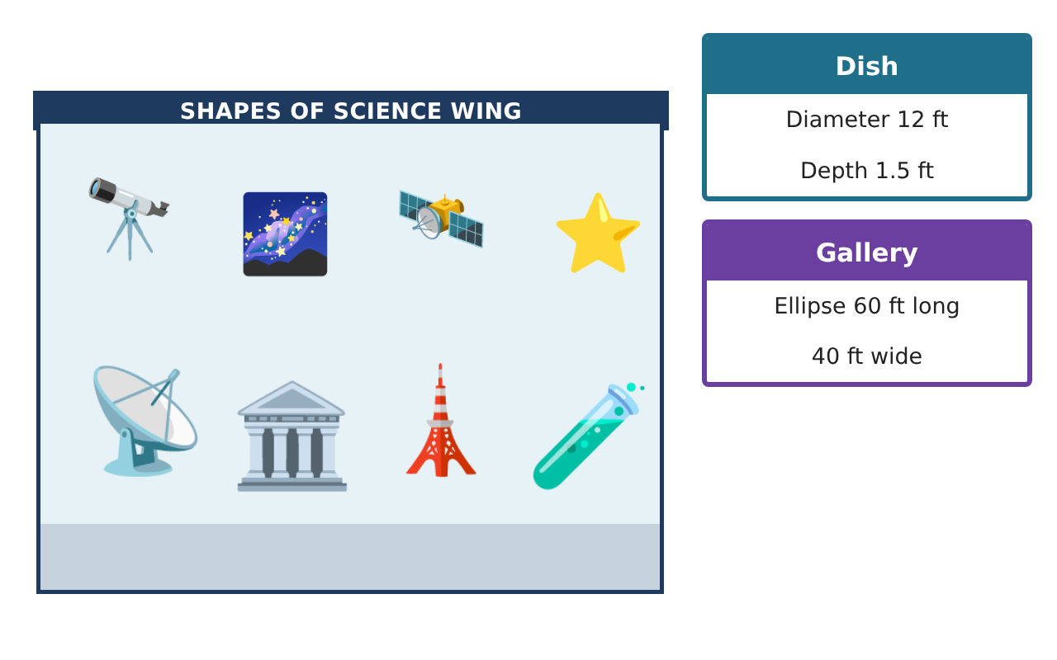
Learning Goals
- I can write and graph the equation of a circle.
- I can find the focus of a parabola.
- I can identify ellipses and hyperbolas from equations.
Project Timeline
When | What you will do
Day 1 | Planetarium Circle
Day 2 | Parabolic Dish
Day 3 | Ellipse & Hyperbola
Final | Exhibit Design Packet + reflection
Part 1: Planetarium Circle
Day 1 · Use the Specification Cards.
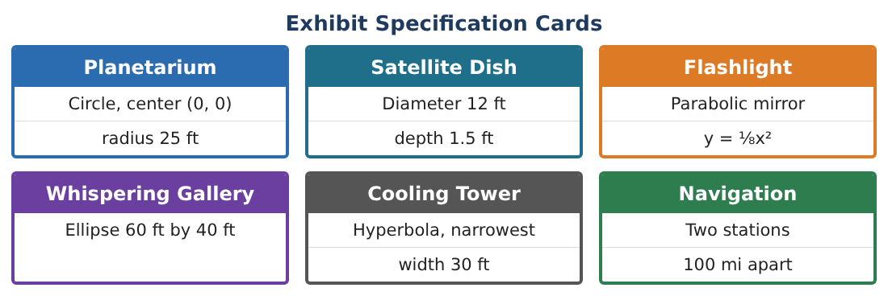
1. Write the equation of the planetarium floor (center (0, 0), radius 25 ft).
Starter: x² + y² = ___²

2. Is the point (15, 20) on the edge of the floor? Show your check.

3. The projector is moved to (3, −2). Write the equation of a circle of radius 25 centered there.

4. Find the center and radius of (x + 1)² + (y − 4)² = 49.

Part 2: Parabolic Dish
Day 2 · A parabola x² = 4py has its focus at (0, p).
5. The flashlight mirror is y = $\frac{1}{8}$x², or x² = 8y. Find p and the focus.

6. Where should the bulb go? Why?

7. The dish passes through (6, 1.5). Find p using x² = 4py.

8. Write the equation of the dish.

Part 3: Ellipse & Hyperbola
Day 3 · Identify each conic.
9. Identify the conic: $\frac{x²}{900}$ + $\frac{y²}{400}$ = 1. What are its length and width?

10. Identify the conic: $\frac{x²}{225}$ − $\frac{y²}{400}$ = 1.

11. Sketch your favorite exhibit and label its key points.

Final Product: Exhibit Design Packet
Your final product must include:
- Circle equations for the planetarium
- Dish and flashlight equations with foci
- Conics identified
- A labeled exhibit sketch
- Exhibit packet
Reflection
R1. Why is the receiver of a satellite dish placed at the focus?

R2. How can you tell a hyperbola from an ellipse in an equation?

Scoring Rubric
Criteria | 4 – Exceeds | 3 – Meets | 2 – Approaching | 1 – Beginning
Mathematical Accuracy | All calculations and solutions are correct; answers include units and are checked. | Nearly all work is correct; minor errors do not change conclusions. | Several errors; some conclusions are affected. | Many errors or missing work.
Reasoning & Justification | Clear, complete explanations connect every answer to the situation; uses precise vocabulary. | Explanations are mostly clear and connected to the situation. | Explanations are brief or partly unclear. | Little or no explanation.
Application & Design | Conic equations, foci, and measurements are correct and used to design working exhibits. Goes beyond the minimum with a creative, realistic choice. | Conic equations, foci, and measurements are correct and used to design working exhibits. | Design is incomplete or only partly uses the math from the unit. | Design is missing or unrelated to the unit math.
Communication & Presentation | Exhibit packet includes equations, labeled sketches, and builder measurements. Polished, organized, and visually engaging. | Exhibit packet includes equations, labeled sketches, and builder measurements. Organized and easy to follow. | Product is missing required parts or is hard to follow. | Product is mostly missing.

