PRECALCULUS · UNIT 5: TRIGONOMETRY OF GENERAL TRIANGLES  Search and Rescue  Use the Laws of Sines and Cosines and bearings to locate a lost hiker. | CP2  2–3 class periods

Name: ________________________________ Date: ______________ Period: ______
The Scenario
A hiker is lost in the White Mountains. Two ranger towers spot a signal flare, a helicopter is on the way, and search teams need to know how far to travel and how much area each team must cover.
You will use the trigonometry of all triangles, not just right triangles, to find the hiker and plan the search.
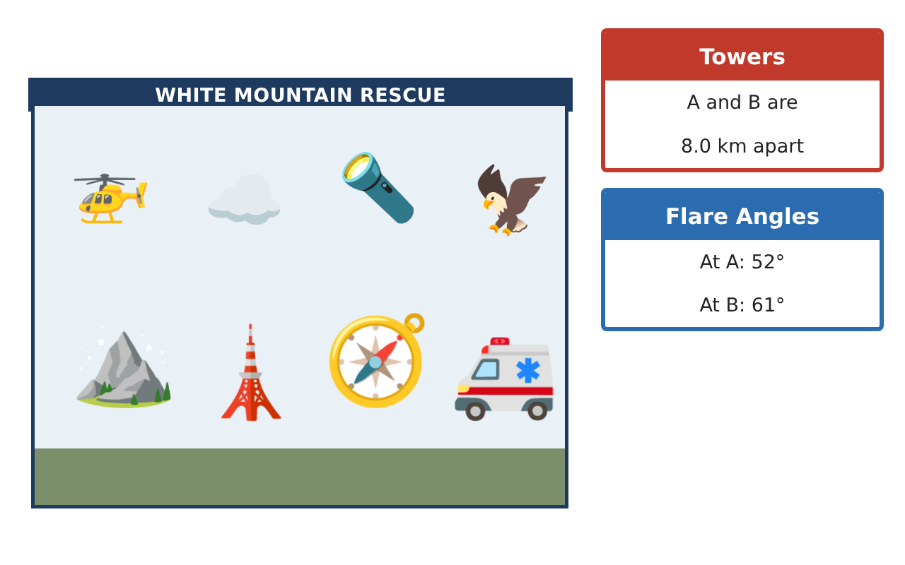
Learning Goals
- I can use right-triangle trig to find heights and distances.
- I can use the Law of Sines to find a missing side.
- I can use the Law of Cosines to find a distance.
Project Timeline
When | What you will do
Day 1 | Tower Heights
Day 2 | Find the Flare
Day 3 | Team Distances
Final | Rescue Operations Brief + reflection
Part 1: Tower Heights
Day 1 · Use SOH-CAH-TOA.
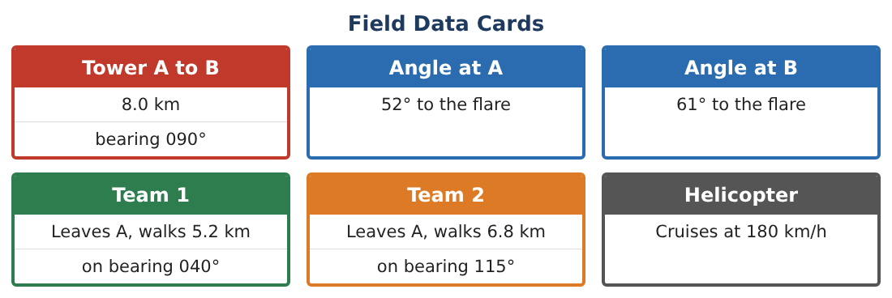
1. From 200 m away, the angle of elevation to the top of Tower A is 14°. How tall is the tower?
Starter: tan 14° = $\frac{h}{200}$

2. A ranger in Tower A (50 m up) sees a tent at an angle of depression of 5°. How far away is the tent horizontally?

3. A rope from the top of a 30 m cliff to the ground makes a 62° angle with the ground. How long is the rope?

4. Explain the difference between angles of elevation and depression.

Part 2: Find the Flare
Day 2 · Towers A and B are 8.0 km apart. The flare F makes 52° at A and 61° at B.
5. Find the angle at the flare.

6. Use the Law of Sines to find the distance from Tower A to the flare.
Starter: $\frac{AF}{sin 61°}$ = $\frac{8}{sin 67°}$

7. Find the distance from Tower B to the flare.

8. Which tower should send its team? Why?

Part 3: Team Distances
Day 3 · Use the Law of Cosines: c² = a² + b² − 2ab cos C.
9. Two teams leave camp. One walks 5 km and the other 7 km, with 60° between their paths. How far apart are they?

10. Find the area of the triangle formed by the camp and the two teams. Use $\frac{1}{2}$ab sin C.

11. Draw and label a map of the search with all distances you found.

Final Product: Rescue Operations Brief
Your final product must include:
- Tower and rope calculations
- Flare location with the Law of Sines
- Team distance with the Law of Cosines
- Search area
- Labeled rescue map
Reflection
R1. When do you need the Law of Sines or Cosines instead of SOH-CAH-TOA?

R2. Why did you find the third angle first?

Scoring Rubric
Criteria | 4 – Exceeds | 3 – Meets | 2 – Approaching | 1 – Beginning
Mathematical Accuracy | All calculations and solutions are correct; answers include units and are checked. | Nearly all work is correct; minor errors do not change conclusions. | Several errors; some conclusions are affected. | Many errors or missing work.
Reasoning & Justification | Clear, complete explanations connect every answer to the situation; uses precise vocabulary. | Explanations are mostly clear and connected to the situation. | Explanations are brief or partly unclear. | Little or no explanation.
Application & Design | Triangles are solved correctly with the appropriate law, and results locate the hiker and divide the search. Goes beyond the minimum with a creative, realistic choice. | Triangles are solved correctly with the appropriate law, and results locate the hiker and divide the search. | Design is incomplete or only partly uses the math from the unit. | Design is missing or unrelated to the unit math.
Communication & Presentation | Brief includes a labeled map, calculations, bearings, and team assignments. Polished, organized, and visually engaging. | Brief includes a labeled map, calculations, bearings, and team assignments. Organized and easy to follow. | Product is missing required parts or is hard to follow. | Product is mostly missing.

