PRECALCULUS · UNIT 8: PROBABILITY  Sports Draft Analytics  Use counting, conditional probability, and expected value to run a basketball team’s draft room. | CP1  2–3 class periods

Name: ________________________________ Date: ______________ Period: ______
The Scenario
The Boston Comets just hired you as their lead analyst. The coach needs lineups, the general manager wants to know the team’s draft lottery odds, and the owner wants to know whether a trade is worth it.
You will use probability and counting to give data-driven answers.
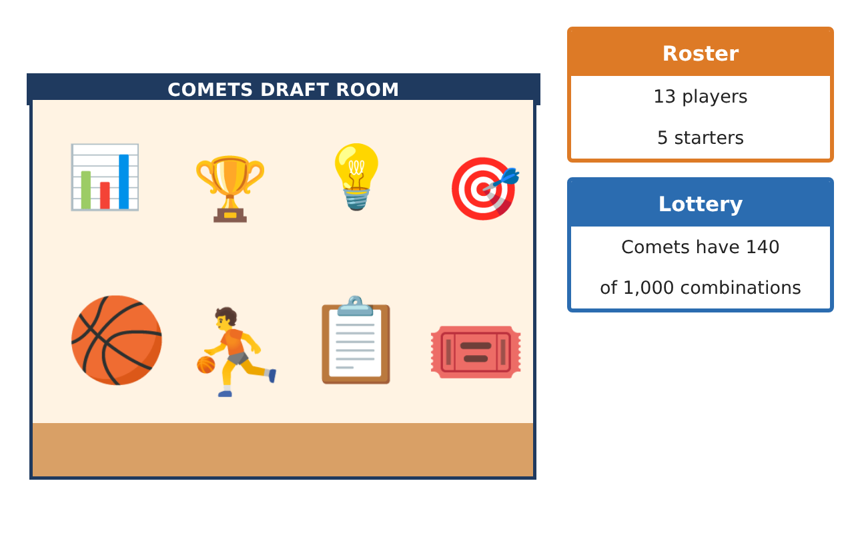
Learning Goals
- I can use permutations and combinations to find probabilities.
- I can find conditional probabilities and test independence.
- I can use the binomial distribution and expected value.
Project Timeline
When | What you will do
Day 1 | Lineups
Day 2 | Conditional Probability
Day 3 | Free Throws & Trades
Final | Draft Room Report + reflection
Part 1: Lineups
Day 1 · The roster has 13 players: 5 guards, 5 forwards, 3 centers.
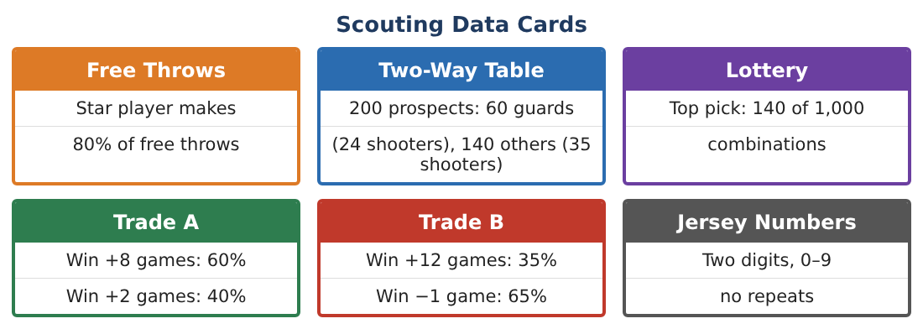
1. How many starting lineups have 2 guards, 2 forwards, and 1 center?

2. If 5 players are chosen at random, what is the probability of getting exactly that mix?

3. In how many orders can the 5 starters be introduced?

4. What is the probability that a random 5-player group includes the star and the backup point guard?

Part 2: Conditional Probability
Day 2 · Use the Two-Way Table card.
5. Find P(guard | shooter).

6. Are "guard" and "shooter" independent? Compare P(shooter | guard) with P(shooter).

7. The top pick is 14%. If the Comets miss the top pick, they have 134 of the remaining 860 combinations for the second pick. Find P(top 2).

8. Find P(not in the top 2).

Part 3: Free Throws & Trades
Day 3 · The star makes 80% of free throws.
9. Find the probability the star makes exactly 8 of 10 free throws.

10. Find the probability of making at least 9 of 10.

11. Compute the expected extra wins for Trades A and B and the standard of risk (chance of losing wins). Recommend one.

Final Product: Draft Room Report
Your final product must include:
- Lineup counts and probabilities
- Conditional probabilities and independence test
- Lottery top-2 probability
- Binomial free-throw probabilities
- Trade recommendation
Reflection
R1. How do you test whether two events are independent?

R2. Why is the binomial distribution a good model for free throws?

Scoring Rubric
Criteria | 4 – Exceeds | 3 – Meets | 2 – Approaching | 1 – Beginning
Mathematical Accuracy | All calculations and solutions are correct; answers include units and are checked. | Nearly all work is correct; minor errors do not change conclusions. | Several errors; some conclusions are affected. | Many errors or missing work.
Reasoning & Justification | Clear, complete explanations connect every answer to the situation; uses precise vocabulary. | Explanations are mostly clear and connected to the situation. | Explanations are brief or partly unclear. | Little or no explanation.
Application & Design | Counts, probabilities, and expected values are correct and used to support draft and trade decisions. Goes beyond the minimum with a creative, realistic choice. | Counts, probabilities, and expected values are correct and used to support draft and trade decisions. | Design is incomplete or only partly uses the math from the unit. | Design is missing or unrelated to the unit math.
Communication & Presentation | Report includes tables, calculations, and clear recommendations. Polished, organized, and visually engaging. | Report includes tables, calculations, and clear recommendations. Organized and easy to follow. | Product is missing required parts or is hard to follow. | Product is mostly missing.

