PRECALCULUS · UNIT 6: MATRICES  Spy Agency Codes  Use matrices to manage inventory, encode secret messages, and solve systems. | CP2  2–3 class periods

Name: ________________________________ Date: ______________ Period: ______
The Scenario
Welcome to the Cipher Division. Agents carry gadgets from three warehouses, field reports must be encoded so enemies cannot read them, and supply problems arrive as systems of equations.
You will use matrices to track gadgets, encode and decode messages, and solve supply problems.
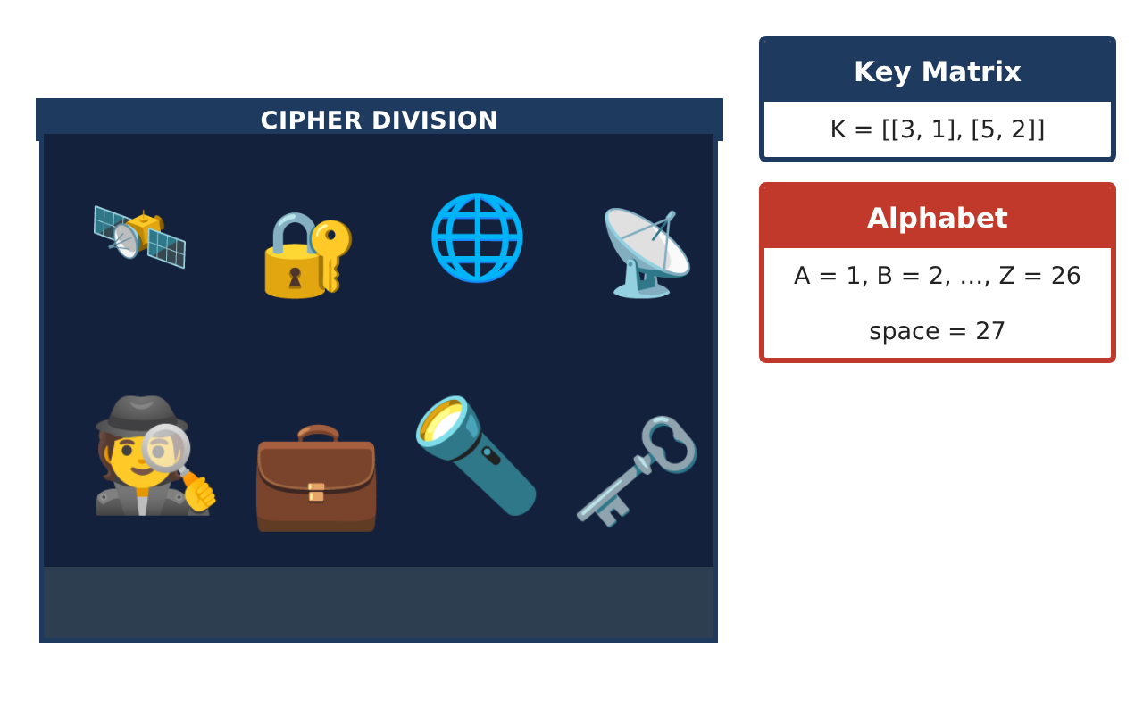
Learning Goals
- I can add matrices and multiply by a scalar.
- I can multiply a matrix by a column matrix.
- I can encode a message with a key matrix.
Project Timeline
When | What you will do
Day 1 | Inventory
Day 2 | Costs
Day 3 | Secret Codes
Final | Agent Mission File + reflection
Part 1: Inventory
Day 1 · Write the inventory as a 3 × 3 matrix I (rows Boston, London, Tokyo; columns pens, watches, drones).
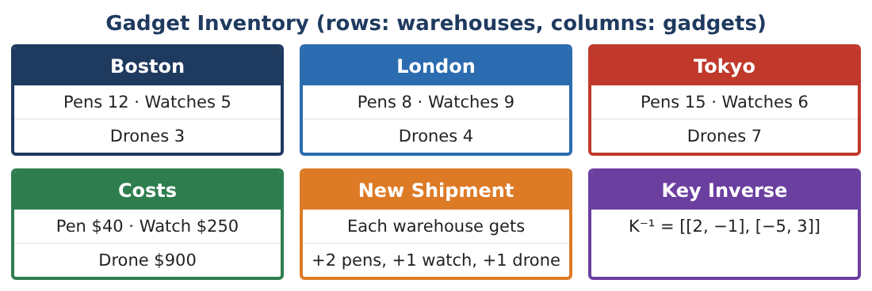
1. Write matrix I and give its dimensions.

2. Add the New Shipment matrix S = [[2, 1, 1], [2, 1, 1], [2, 1, 1]] to I.

3. The agency doubles the original inventory. Find 2I.

4. What does the entry in row 3, column 3 of I mean?

Part 2: Costs
Day 2 · Cost column matrix C = [40, 250, 900] (pens, watches, drones).
5. Find the value of the Boston gadgets: 12(40) + 5(250) + 3(900).
Starter: 12 × 40 + 5 × ___ + 3 × ___

6. Find I · C (the value of each warehouse).

7. Which warehouse has the most valuable inventory?

8. Why can we multiply a 3 × 3 matrix by a 3 × 1 matrix?

Part 3: Secret Codes
Day 3 · Key K = [[3, 1], [5, 2]]. Letters: A = 1, …, Z = 26.
9. Write the word HI as a column matrix.

10. Encode HI by computing K · [8, 9].

11. Decode [33, 58] using K⁻¹ = [[2, −1], [−5, 3]]. Do you get HI back?

Final Product: Agent Mission File
Your final product must include:
- Inventory matrices and operations
- Warehouse values
- Encoded and decoded message
- Explanation of dimensions
- Mission file
Reflection
R1. Why do the dimensions have to match to add matrices?

R2. Why does the inverse matrix decode the message?

Scoring Rubric
Criteria | 4 – Exceeds | 3 – Meets | 2 – Approaching | 1 – Beginning
Mathematical Accuracy | All calculations and solutions are correct; answers include units and are checked. | Nearly all work is correct; minor errors do not change conclusions. | Several errors; some conclusions are affected. | Many errors or missing work.
Reasoning & Justification | Clear, complete explanations connect every answer to the situation; uses precise vocabulary. | Explanations are mostly clear and connected to the situation. | Explanations are brief or partly unclear. | Little or no explanation.
Application & Design | Matrix operations, inverses, and determinants are correct and used for inventory, codes, and systems. Goes beyond the minimum with a creative, realistic choice. | Matrix operations, inverses, and determinants are correct and used for inventory, codes, and systems. | Design is incomplete or only partly uses the math from the unit. | Design is missing or unrelated to the unit math.
Communication & Presentation | Mission file includes matrices, coded messages, solved systems, and explanations. Polished, organized, and visually engaging. | Mission file includes matrices, coded messages, solved systems, and explanations. Organized and easy to follow. | Product is missing required parts or is hard to follow. | Product is mostly missing.

