PRECALCULUS · UNIT 6: MATRICES  Spy Agency Codes  Use matrices to manage inventory, encode secret messages, and solve systems. | Honors  2–3 class periods

Name: ________________________________ Date: ______________ Period: ______
The Scenario
Welcome to the Cipher Division. Agents carry gadgets from three warehouses, field reports must be encoded so enemies cannot read them, and supply problems arrive as systems of equations.
You will use matrices to track gadgets, encode and decode messages, and solve supply problems.
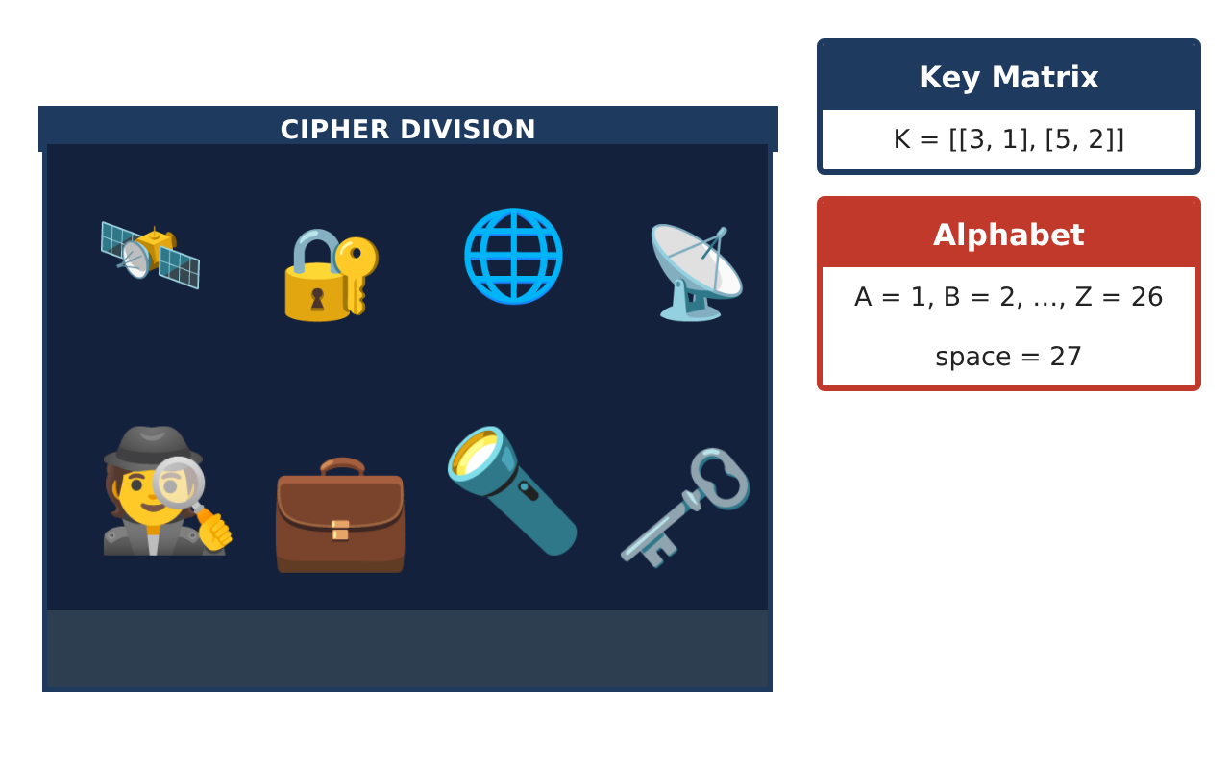
Learning Goals
- I can model with matrix operations and interpret products.
- I can design and break codes with invertible matrices.
- I can solve 3 × 3 systems with inverses and determinants.
Project Timeline
When | What you will do
Day 1 | Inventory Analysis
Day 2 | Code Design
Day 3 | 3 × 3 Supply System
Final | Agent Mission File + reflection
Part 1: Inventory Analysis
Day 1 · Use the Gadget Inventory.
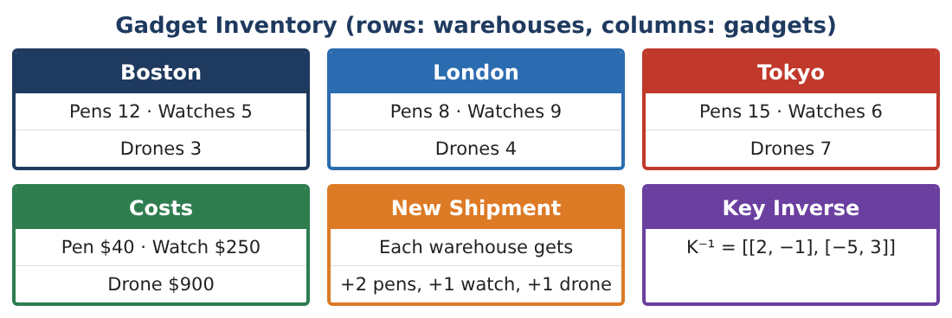
1. A transfer matrix T moves 20% of Boston’s gadgets to London each month. Write the new inventory after one month as a matrix product or sum.

2. Find the total value matrix after the transfer. Did the total value change?

3. Explain why matrix multiplication is not commutative using this context.

4. Find det I using cofactor expansion. Is I invertible?

Part 2: Code Design
Day 2 · A = 1, …, Z = 26, space = 27. Work mod 28 is NOT required; use ordinary integers.
5. Design a 2 × 2 key matrix with determinant 1 (so the inverse has integer entries). Give K and K⁻¹.

6. Encode MEET with your key and decode it to check.

7. An intercepted message was encoded with K = [[3, 1], [5, 2]]: [39, 70], [44, 75]. Decode it.

8. Explain why a key with determinant 2 would cause trouble with whole-number codes.

Part 3: 3 × 3 Supply System
Day 3 · An order of pens, watches, and drones has 27 items, costs $4,920, and has twice as many pens as watches and drones combined.
9. Write the system and the matrix equation.

10. Solve using an inverse matrix (technology allowed) and check.

11. Write the mission file with inventory analysis, your code system, and the supply solution.

Final Product: Agent Mission File
Your final product must include:
- Transfer and value analysis
- Determinant by cofactors
- Your code system with an example
- Decoded intercepted message
- 3 × 3 system solution
Reflection
R1. Why does an invertible key matter for a code?

R2. How did you check a matrix solution?

Scoring Rubric
Criteria | 4 – Exceeds | 3 – Meets | 2 – Approaching | 1 – Beginning
Mathematical Accuracy | All calculations and solutions are correct; answers include units and are checked. | Nearly all work is correct; minor errors do not change conclusions. | Several errors; some conclusions are affected. | Many errors or missing work.
Reasoning & Justification | Clear, complete explanations connect every answer to the situation; uses precise vocabulary. | Explanations are mostly clear and connected to the situation. | Explanations are brief or partly unclear. | Little or no explanation.
Application & Design | Matrix operations, inverses, and determinants are correct and used for inventory, codes, and systems. Goes beyond the minimum with a creative, realistic choice. | Matrix operations, inverses, and determinants are correct and used for inventory, codes, and systems. | Design is incomplete or only partly uses the math from the unit. | Design is missing or unrelated to the unit math.
Communication & Presentation | Mission file includes matrices, coded messages, solved systems, and explanations. Polished, organized, and visually engaging. | Mission file includes matrices, coded messages, solved systems, and explanations. Organized and easy to follow. | Product is missing required parts or is hard to follow. | Product is mostly missing.

