PRECALCULUS · UNIT 2: FUNCTIONS  Streaming Service Analyst  Use function families, transformations, compositions, and inverses to analyze a streaming business. | CP1  2–3 class periods

Name: ________________________________ Date: ______________ Period: ______
The Scenario
You are a data analyst at Wavelength, a new music streaming service. Leadership wants to know how pricing plans work, how fast subscribers are growing, and when the company will reach its goals.
You will use functions to model the business and present your findings.
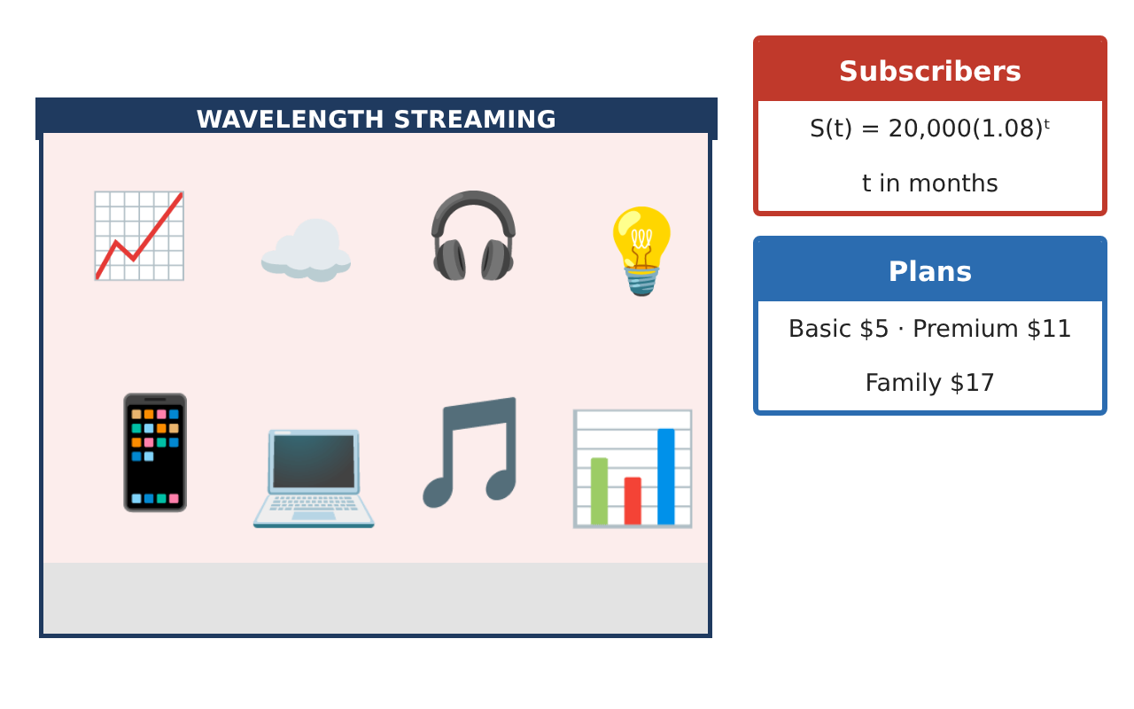
Learning Goals
- I can model with piecewise functions and transformations.
- I can compose functions and find inverses.
- I can use exponential and logarithmic functions to solve for time.
Project Timeline
When | What you will do
Day 1 | Pricing Functions
Day 2 | Transform the Data
Day 3 | Logs & Goals
Final | Analyst Briefing + reflection
Part 1: Pricing Functions
Day 1 · Use the Business Data Cards.
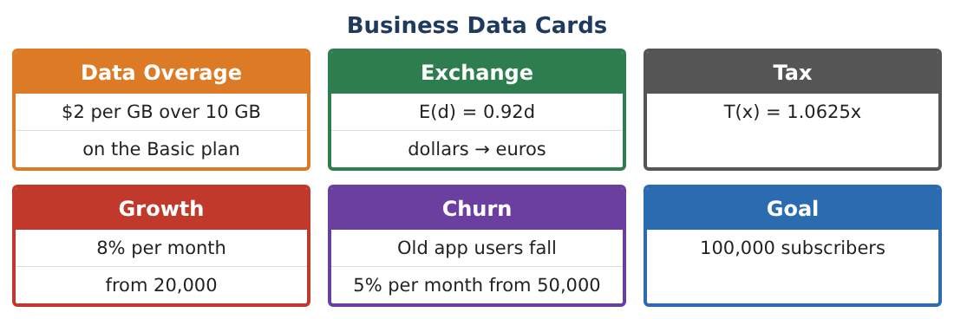
1. Write the Basic plan cost as a piecewise function and graph it.

2. Write the cost with tax, T(C(g)), for g = 14.

3. Write E(T(x)) as a single function and find the euro price of the $11 Premium plan.

4. Find the inverse of E(T(x)). What does it convert?

Part 2: Transform the Data
Day 2 · S(t) = 20,000(1.08)ᵗ.
5. A marketing campaign adds 5,000 subscribers at launch. Write the new function and describe the transformation.

6. The campaign starts 3 months late. Write S(t − 3) and describe the shift.

7. Is S(t) even, odd, or neither? Is it one-to-one?

8. Find the domain and range of S(t) for t ≥ 0.

Part 3: Logs & Goals
Day 3 · Use logarithms to solve for time.
9. Solve 20,000(1.08)ᵗ = 100,000 using logarithms.

10. Old app users: U(t) = 50,000(0.95)ᵗ. When do they fall below 25,000?

11. When will new subscribers be twice the old app users?

Final Product: Analyst Briefing
Your final product must include:
- Piecewise pricing and graph
- Compositions and inverse with meanings
- Transformed subscriber models
- Logarithmic time calculations
- Analyst briefing
Reflection
R1. What does the composition E(T(x)) mean in words?

R2. Why do we use logarithms to solve for time in an exponential model?

Scoring Rubric
Criteria | 4 – Exceeds | 3 – Meets | 2 – Approaching | 1 – Beginning
Mathematical Accuracy | All calculations and solutions are correct; answers include units and are checked. | Nearly all work is correct; minor errors do not change conclusions. | Several errors; some conclusions are affected. | Many errors or missing work.
Reasoning & Justification | Clear, complete explanations connect every answer to the situation; uses precise vocabulary. | Explanations are mostly clear and connected to the situation. | Explanations are brief or partly unclear. | Little or no explanation.
Application & Design | Functions, transformations, compositions, inverses, and exponential models are built and interpreted correctly. Goes beyond the minimum with a creative, realistic choice. | Functions, transformations, compositions, inverses, and exponential models are built and interpreted correctly. | Design is incomplete or only partly uses the math from the unit. | Design is missing or unrelated to the unit math.
Communication & Presentation | Briefing includes models, graphs, calculations, and a recommendation. Polished, organized, and visually engaging. | Briefing includes models, graphs, calculations, and a recommendation. Organized and easy to follow. | Product is missing required parts or is hard to follow. | Product is mostly missing.

