PRECALCULUS · UNIT 2: FUNCTIONS  Streaming Service Analyst  Use function families, transformations, compositions, and inverses to analyze a streaming business. | CP2  2–3 class periods

Name: ________________________________ Date: ______________ Period: ______
The Scenario
You are a data analyst at Wavelength, a new music streaming service. Leadership wants to know how pricing plans work, how fast subscribers are growing, and when the company will reach its goals.
You will use functions to model the business and present your findings.
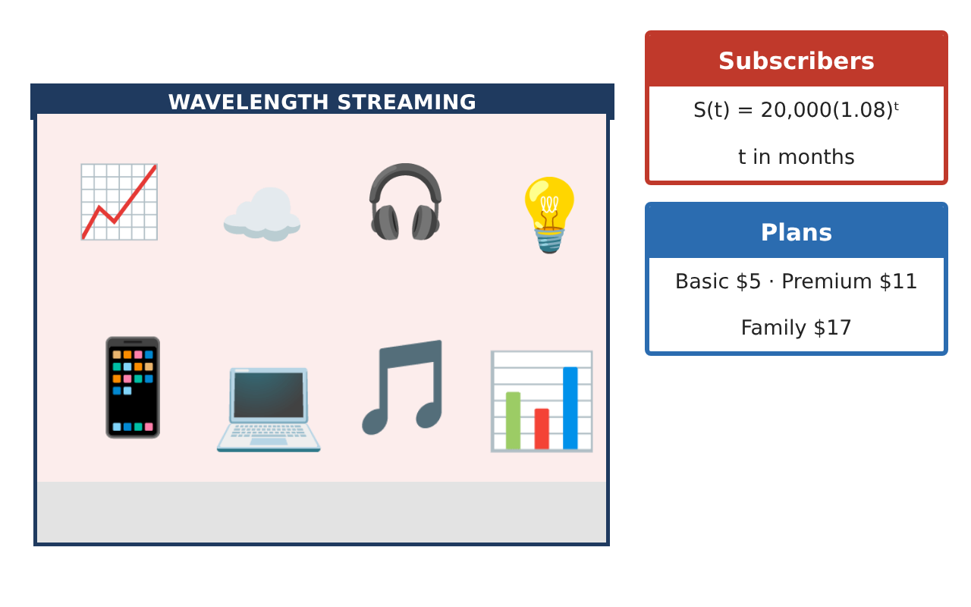
Learning Goals
- I can identify domain and range and evaluate functions.
- I can describe transformations of a graph.
- I can use exponential models to make predictions.
Project Timeline
When | What you will do
Day 1 | Plans as Functions
Day 2 | Transformations
Day 3 | Growth
Final | Analyst Briefing + reflection
Part 1: Plans as Functions
Day 1 · Basic costs $5 per month plus $2 for each GB over 10 GB.
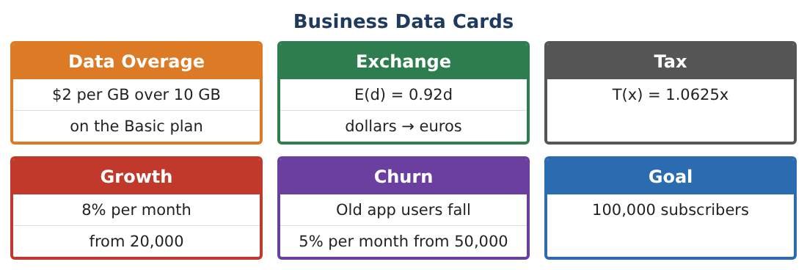
1. Write the cost C(g) for g GB if g ≤ 10 and if g > 10.

2. Find C(6), C(10), and C(14).

3. What is a sensible domain and range for C?

4. Is C a function? Explain.

Part 2: Transformations
Day 2 · The parent graph is y = x².
5. Describe how y = (x − 3)² + 2 is related to y = x².

6. Describe y = −2x².

7. Write the equation of y = |x| shifted left 4 and down 1.

8. Basic’s price rises $1 per month. How does the graph of C change?

Part 3: Growth
Day 3 · S(t) = 20,000(1.08)ᵗ.
9. Find S(6) and S(12). Round to the nearest subscriber.

10. Use a table to find the first month the subscribers reach 100,000.

11. Is this growth linear or exponential? How do you know?

Final Product: Analyst Briefing
Your final product must include:
- Piecewise plan cost with a graph
- Transformation descriptions
- Subscriber predictions
- Month the goal is reached
- One-page briefing
Reflection
R1. How does a piecewise function model a real price plan?

R2. Why does exponential growth start slow and then speed up?

Scoring Rubric
Criteria | 4 – Exceeds | 3 – Meets | 2 – Approaching | 1 – Beginning
Mathematical Accuracy | All calculations and solutions are correct; answers include units and are checked. | Nearly all work is correct; minor errors do not change conclusions. | Several errors; some conclusions are affected. | Many errors or missing work.
Reasoning & Justification | Clear, complete explanations connect every answer to the situation; uses precise vocabulary. | Explanations are mostly clear and connected to the situation. | Explanations are brief or partly unclear. | Little or no explanation.
Application & Design | Functions, transformations, compositions, inverses, and exponential models are built and interpreted correctly. Goes beyond the minimum with a creative, realistic choice. | Functions, transformations, compositions, inverses, and exponential models are built and interpreted correctly. | Design is incomplete or only partly uses the math from the unit. | Design is missing or unrelated to the unit math.
Communication & Presentation | Briefing includes models, graphs, calculations, and a recommendation. Polished, organized, and visually engaging. | Briefing includes models, graphs, calculations, and a recommendation. Organized and easy to follow. | Product is missing required parts or is hard to follow. | Product is mostly missing.

