ALGEBRA 2 · UNIT 6: EXPONENTIAL & LOGARITHMIC FUNCTIONS  Earthquake & Sound Lab  Use logarithms and exponential models to compare earthquakes, sounds, and ancient bones. | CP1  2–3 class periods

Name: ________________________________ Date: ______________ Period: ______
The Scenario
Scientists measure huge ranges of values: tiny tremors and enormous earthquakes, whispers and jet engines. Logarithmic scales squeeze these ranges into small numbers.
You will compare quakes and sounds, date ancient bones with carbon-14, model cooling, and present what you learn on a safety poster.
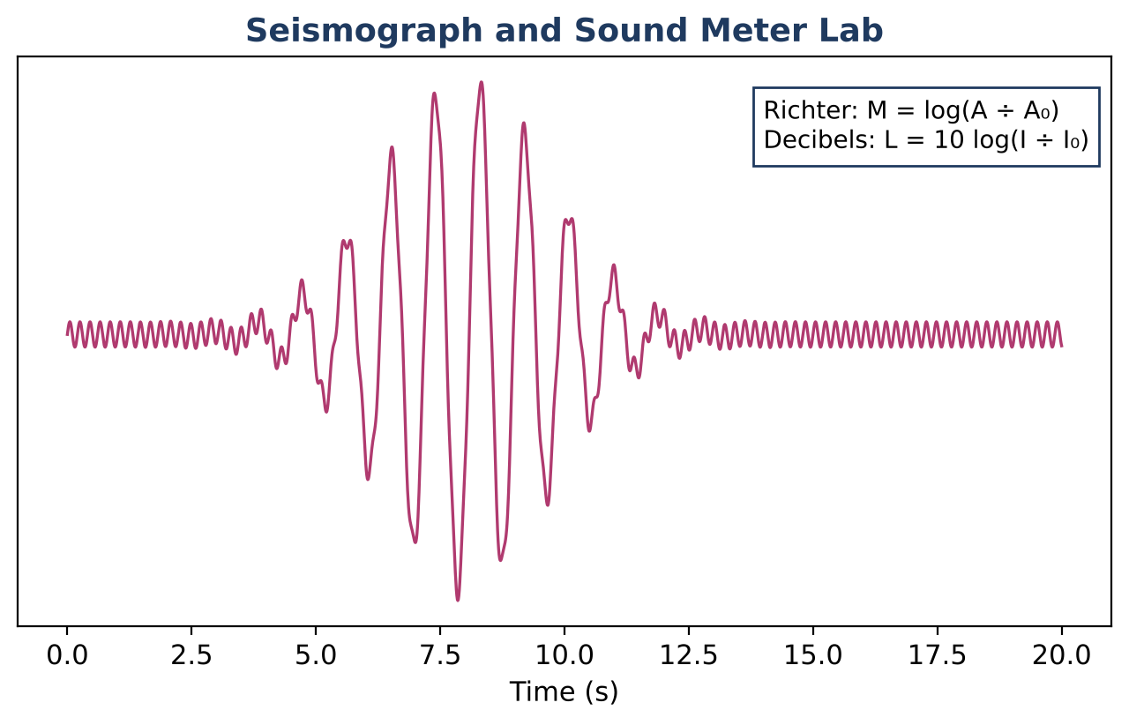
Learning Goals
- I can solve exponential equations using logarithms.
- I can use log properties to rewrite expressions.
- I can model with exponential decay and Newton's law of cooling.
Project Timeline
When | What you will do
Day 1 | Log Scales
Day 2 | Solve with Logs
Day 3 | Safety Poster
Final | Science Safety Poster + reflection

Part 1: Log Scales
Day 1 · Use the formulas on the hero image.
1. Compare the amplitudes of magnitude 6.8 and 5.3 quakes.

2. Each increase of 1 in magnitude multiplies the energy by about 10¹·⁵ ≈ 31.6. About how many times more energy does a magnitude 7 release than a magnitude 5?

3. Condense log 2 + log 50 and expand log(100x³).

Part 2: Solve with Logs
Day 2 · Carbon-14: A = A₀(0.5)ⁿ, where n = t ÷ 5730 is the number of half-lives.
4. A fossil has 30% of its carbon-14 left. Solve for its age with logarithms.

5. Coffee cools by T = 70 + 130e⁻⁰·⁰⁸ᵗ (°F, minutes). When will it reach 100°F?

6. Solve 2ˣ⁺³ = 50.

Part 3: Safety Poster
Day 3 · Create a poster with log comparisons and one model.
7. Compare three events with log scales.

8. Include one exponential model solved with logs.

9. Write a safety message for the public.

Final Product: Science Safety Poster
Your final product must include:
- Log-scale comparisons
- Solved exponential equations
- Poster
Reflection
R1. How do logarithms undo exponents?

R2. Why does the coffee never cool below 70°F in the model?

Scoring Rubric
Criteria | 4 – Exceeds | 3 – Meets | 2 – Approaching | 1 – Beginning
Mathematical Accuracy | All calculations and solutions are correct; answers include units and are checked. | Nearly all work is correct; minor errors do not change conclusions. | Several errors; some conclusions are affected. | Many errors or missing work.
Reasoning & Justification | Clear, complete explanations connect every answer to the situation; uses precise vocabulary. | Explanations are mostly clear and connected to the situation. | Explanations are brief or partly unclear. | Little or no explanation.
Application & Design | Comparisons and models are correct and explained in plain language for the public. Goes beyond the minimum with a creative, realistic choice. | Comparisons and models are correct and explained in plain language for the public. | Design is incomplete or only partly uses the math from the unit. | Design is missing or unrelated to the unit math.
Communication & Presentation | Poster shows the log scales, at least three comparisons with work, and an exponential model solved with logarithms. Polished, organized, and visually engaging. | Poster shows the log scales, at least three comparisons with work, and an exponential model solved with logarithms. Organized and easy to follow. | Product is missing required parts or is hard to follow. | Product is mostly missing.

