ALGEBRA 2 · UNIT 6: EXPONENTIAL & LOGARITHMIC FUNCTIONS  Earthquake & Sound Lab  Use logarithms and exponential models to compare earthquakes, sounds, and ancient bones. | CP2  2–3 class periods

Name: ________________________________ Date: ______________ Period: ______
The Scenario
Scientists measure huge ranges of values: tiny tremors and enormous earthquakes, whispers and jet engines. Logarithmic scales squeeze these ranges into small numbers.
You will compare quakes and sounds, date ancient bones with carbon-14, model cooling, and present what you learn on a safety poster.
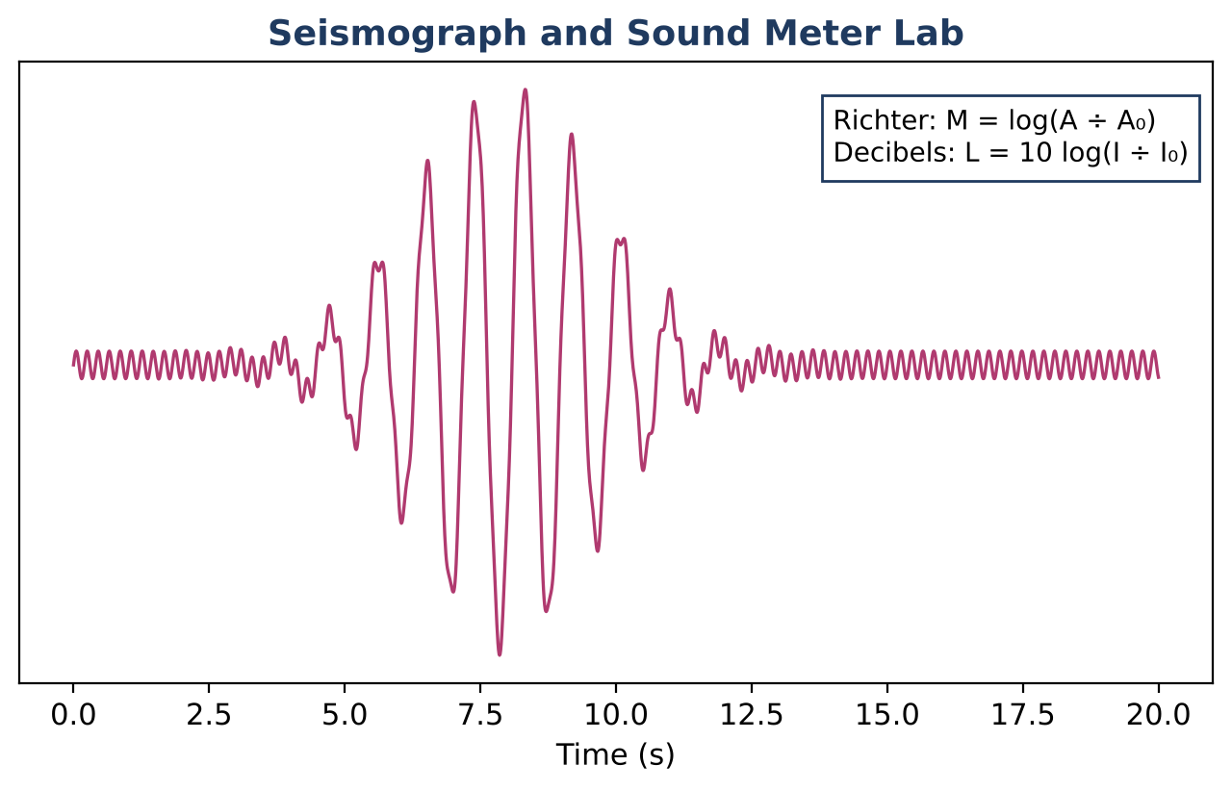
Learning Goals
- I can evaluate logarithms and use logarithmic scales.
- I can model decay with half-lives.
- I can use continuous growth formulas.
Project Timeline
When | What you will do
Day 1 | Log Scales
Day 2 | Decay & Growth
Day 3 | Safety Poster
Final | Science Safety Poster + reflection

Part 1: Log Scales
Day 1 · M = log(A ÷ A₀) and L = 10 log(I ÷ I₀).
1. A quake's amplitude is 100,000 times A₀. Find its magnitude.

2. How many times larger is the amplitude of a magnitude 7 quake than a magnitude 5 quake?

3. A whisper is 30 dB and a concert is 110 dB. How many times more intense is the concert?

4. Evaluate log 1000, log 0.01, and log 1.

Part 2: Decay & Growth
Day 2 · Carbon-14 has a half-life of 5,730 years.
5. A bone has 25% of its original carbon-14. How many half-lives have passed? How old is it?

6. A bone has 12.5% left. How old is it?

7. $1,000 grows continuously at 5% for 10 years: A = 1000e⁰·⁵. Find A. Compare with monthly compounding: 1000(1 + 0.05 ÷ 12)¹²⁰.

Part 3: Safety Poster
Day 3 · Make a poster about noise or earthquakes.
8. Choose three sounds or quakes and compare them with log scales.

9. Explain why each step of 10 dB means 10 times the intensity.

10. Add one safety tip backed by your math.

Final Product: Science Safety Poster
Your final product must include:
- Comparison table
- Carbon dating calculations
- Growth comparison
- Poster
Reflection
R1. Why do scientists use log scales?

R2. Why is a 10-dB increase a big deal?

Scoring Rubric
Criteria | 4 – Exceeds | 3 – Meets | 2 – Approaching | 1 – Beginning
Mathematical Accuracy | All calculations and solutions are correct; answers include units and are checked. | Nearly all work is correct; minor errors do not change conclusions. | Several errors; some conclusions are affected. | Many errors or missing work.
Reasoning & Justification | Clear, complete explanations connect every answer to the situation; uses precise vocabulary. | Explanations are mostly clear and connected to the situation. | Explanations are brief or partly unclear. | Little or no explanation.
Application & Design | Comparisons and models are correct and explained in plain language for the public. Goes beyond the minimum with a creative, realistic choice. | Comparisons and models are correct and explained in plain language for the public. | Design is incomplete or only partly uses the math from the unit. | Design is missing or unrelated to the unit math.
Communication & Presentation | Poster shows the log scales, at least three comparisons with work, and an exponential model solved with logarithms. Polished, organized, and visually engaging. | Poster shows the log scales, at least three comparisons with work, and an exponential model solved with logarithms. Organized and easy to follow. | Product is missing required parts or is hard to follow. | Product is mostly missing.

