ALGEBRA 2 · UNIT 6: EXPONENTIAL & LOGARITHMIC FUNCTIONS  Earthquake & Sound Lab  Use logarithms and exponential models to compare earthquakes, sounds, and ancient bones. | Honors  2–3 class periods

Name: ________________________________ Date: ______________ Period: ______
The Scenario
Scientists measure huge ranges of values: tiny tremors and enormous earthquakes, whispers and jet engines. Logarithmic scales squeeze these ranges into small numbers.
You will compare quakes and sounds, date ancient bones with carbon-14, model cooling, and present what you learn on a safety poster.
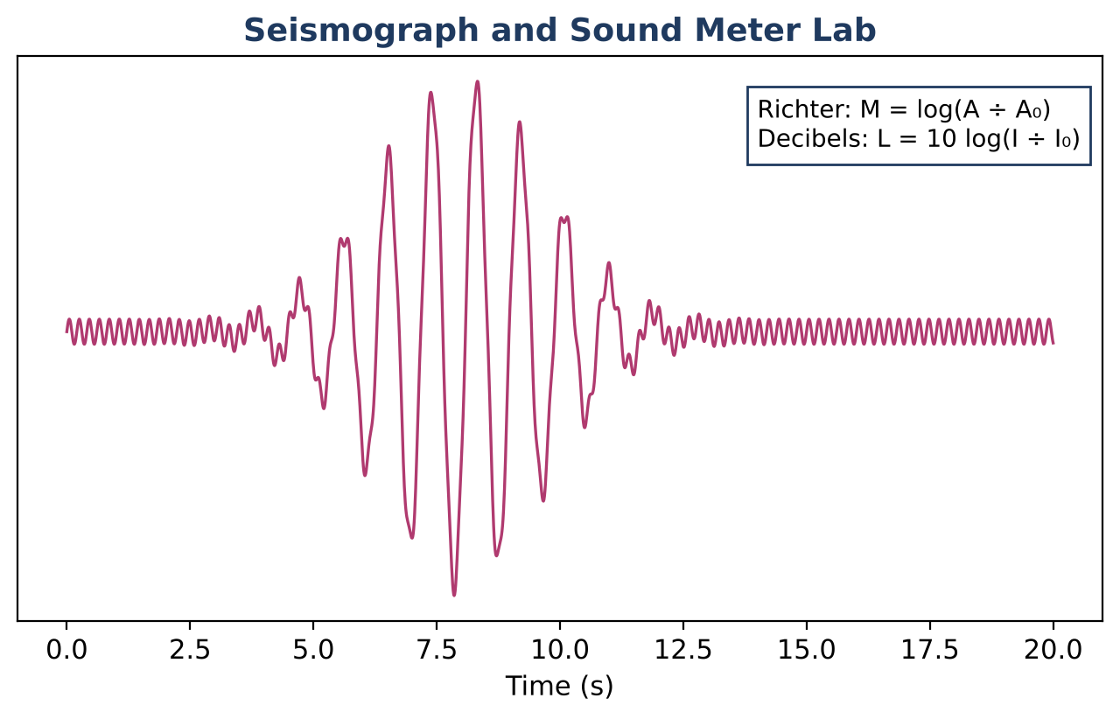
Learning Goals
- I can build exponential models from data and convert between forms.
- I can solve equations with different bases.
- I can reason with logarithmic scales.
Project Timeline
When | What you will do
Day 1 | Scales & Sums
Day 2 | Models
Day 3 | Poster
Final | Science Safety Poster + reflection

Part 1: Scales & Sums
Day 1 · Use L = 10 log(I ÷ I₀).
1. Two speakers each produce 80 dB. Find the combined level. Explain why it is not 160 dB.

2. How many 80-dB speakers would it take to reach 100 dB?

3. Prove log(a ÷ b) = log a − log b from the exponent rules.

Part 2: Models
Day 2 · Exact and approximate answers.
4. A bacteria culture has 500 cells at t = 2 h and 4,500 at t = 6 h. Find a and b in N = a · bᵗ, then write it as N = aeᵏᵗ.

5. Solve 3ˣ⁺¹ = 5ˣ.

6. A fossil has 30% of its carbon-14. Find its age, then find the age if the measurement could be off by ±2 percentage points.

Part 3: Poster
Day 3 · Create a poster explaining log scales with real data.
7. Include a model built from two data points.

8. Include an error range for one calculation.

9. Write a public message.

Final Product: Science Safety Poster
Your final product must include:
- Sound-level analysis
- Model from two points in both forms
- Error-range calculation
- Poster
Reflection
R1. Why do equal ratios correspond to equal differences on a log scale?

R2. How does uncertainty in a measurement affect an age estimate?

Scoring Rubric
Criteria | 4 – Exceeds | 3 – Meets | 2 – Approaching | 1 – Beginning
Mathematical Accuracy | All calculations and solutions are correct; answers include units and are checked. | Nearly all work is correct; minor errors do not change conclusions. | Several errors; some conclusions are affected. | Many errors or missing work.
Reasoning & Justification | Clear, complete explanations connect every answer to the situation; uses precise vocabulary. | Explanations are mostly clear and connected to the situation. | Explanations are brief or partly unclear. | Little or no explanation.
Application & Design | Comparisons and models are correct and explained in plain language for the public. Goes beyond the minimum with a creative, realistic choice. | Comparisons and models are correct and explained in plain language for the public. | Design is incomplete or only partly uses the math from the unit. | Design is missing or unrelated to the unit math.
Communication & Presentation | Poster shows the log scales, at least three comparisons with work, and an exponential model solved with logarithms. Polished, organized, and visually engaging. | Poster shows the log scales, at least three comparisons with work, and an exponential model solved with logarithms. Organized and easy to follow. | Product is missing required parts or is hard to follow. | Product is mostly missing.

