ALGEBRA 2 · UNIT 2: LINEAR FUNCTIONS & SYSTEMS  Farm Planner  Use linear programming and systems in three variables to run a farm. | CP1  2–3 class periods

Name: ________________________________ Date: ______________ Period: ______
The Scenario
Sunrise Farm grows corn and soybeans. Land and labor are limited, and each crop brings a different profit. The farmer wants the plan that earns the most money.
This is linear programming: graph the constraints, find the corners of the feasible region, and test them. Then you will mix feed for the farm's animals with a three-variable system.
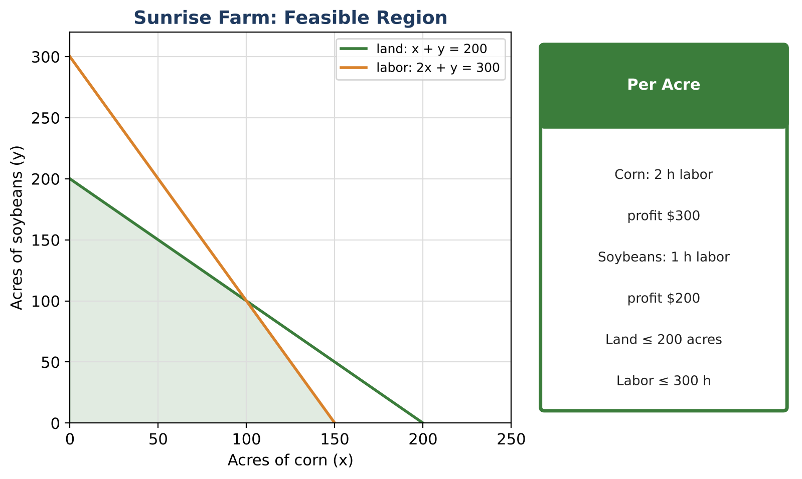
Learning Goals
- I can model constraints with a system of inequalities.
- I can optimize with linear programming.
- I can solve systems of three equations.
Project Timeline
When | What you will do
Day 1 | Constraints
Day 2 | Optimize
Day 3 | Mix the Feed
Final | Farm Business Plan + reflection

Part 1: Constraints
Day 1 · Use the Per Acre card.
1. Write all constraints and graph the feasible region.

2. Find all vertices algebraically.

3. Explain why the labor constraint makes some land-only plans impossible.

Part 2: Optimize
Day 2 · Profit P = 300x + 200y.
4. Find the maximum profit and the plan that gives it.

5. If corn profit drops to $150 per acre, what is the new best plan?

6. The farmer adds a rule: at least 40 acres of corn. Add it to the graph. Does the best plan change?

Part 3: Mix the Feed
Day 3 · Feed uses corn (a), soy meal (b), and oats (c), in pounds.
7. A 100-lb batch must have 16.6 lb of protein and cost $15. Protein: corn 9%, soy 44%, oats 12%. Cost per lb: $0.10, $0.30, $0.15. Write the system.

8. Solve the system by elimination and check.

9. Write a business plan with the crop plan and the feed recipe.

Final Product: Farm Business Plan
Your final product must include:
- Graph with all constraints and vertices
- Optimization with a what-if analysis
- Three-variable feed solution with check
- Business plan
Reflection
R1. Why do changes in profit per acre change the best corner?

R2. How is solving a 3 × 3 system like a 2 × 2 system?

Scoring Rubric
Criteria | 4 – Exceeds | 3 – Meets | 2 – Approaching | 1 – Beginning
Mathematical Accuracy | All calculations and solutions are correct; answers include units and are checked. | Nearly all work is correct; minor errors do not change conclusions. | Several errors; some conclusions are affected. | Many errors or missing work.
Reasoning & Justification | Clear, complete explanations connect every answer to the situation; uses precise vocabulary. | Explanations are mostly clear and connected to the situation. | Explanations are brief or partly unclear. | Little or no explanation.
Application & Design | Recommendation is the true optimum (or a tie is explained), and the feed system is solved and checked. Goes beyond the minimum with a creative, realistic choice. | Recommendation is the true optimum (or a tie is explained), and the feed system is solved and checked. | Design is incomplete or only partly uses the math from the unit. | Design is missing or unrelated to the unit math.
Communication & Presentation | Business plan includes the constraints, graph, vertices, optimal plan, and the feed mix solution. Polished, organized, and visually engaging. | Business plan includes the constraints, graph, vertices, optimal plan, and the feed mix solution. Organized and easy to follow. | Product is missing required parts or is hard to follow. | Product is mostly missing.

