ALGEBRA 2 · UNIT 2: LINEAR FUNCTIONS & SYSTEMS  Farm Planner  Use linear programming and systems in three variables to run a farm. | CP2  2–3 class periods

Name: ________________________________ Date: ______________ Period: ______
The Scenario
Sunrise Farm grows corn and soybeans. Land and labor are limited, and each crop brings a different profit. The farmer wants the plan that earns the most money.
This is linear programming: graph the constraints, find the corners of the feasible region, and test them. Then you will mix feed for the farm's animals with a three-variable system.
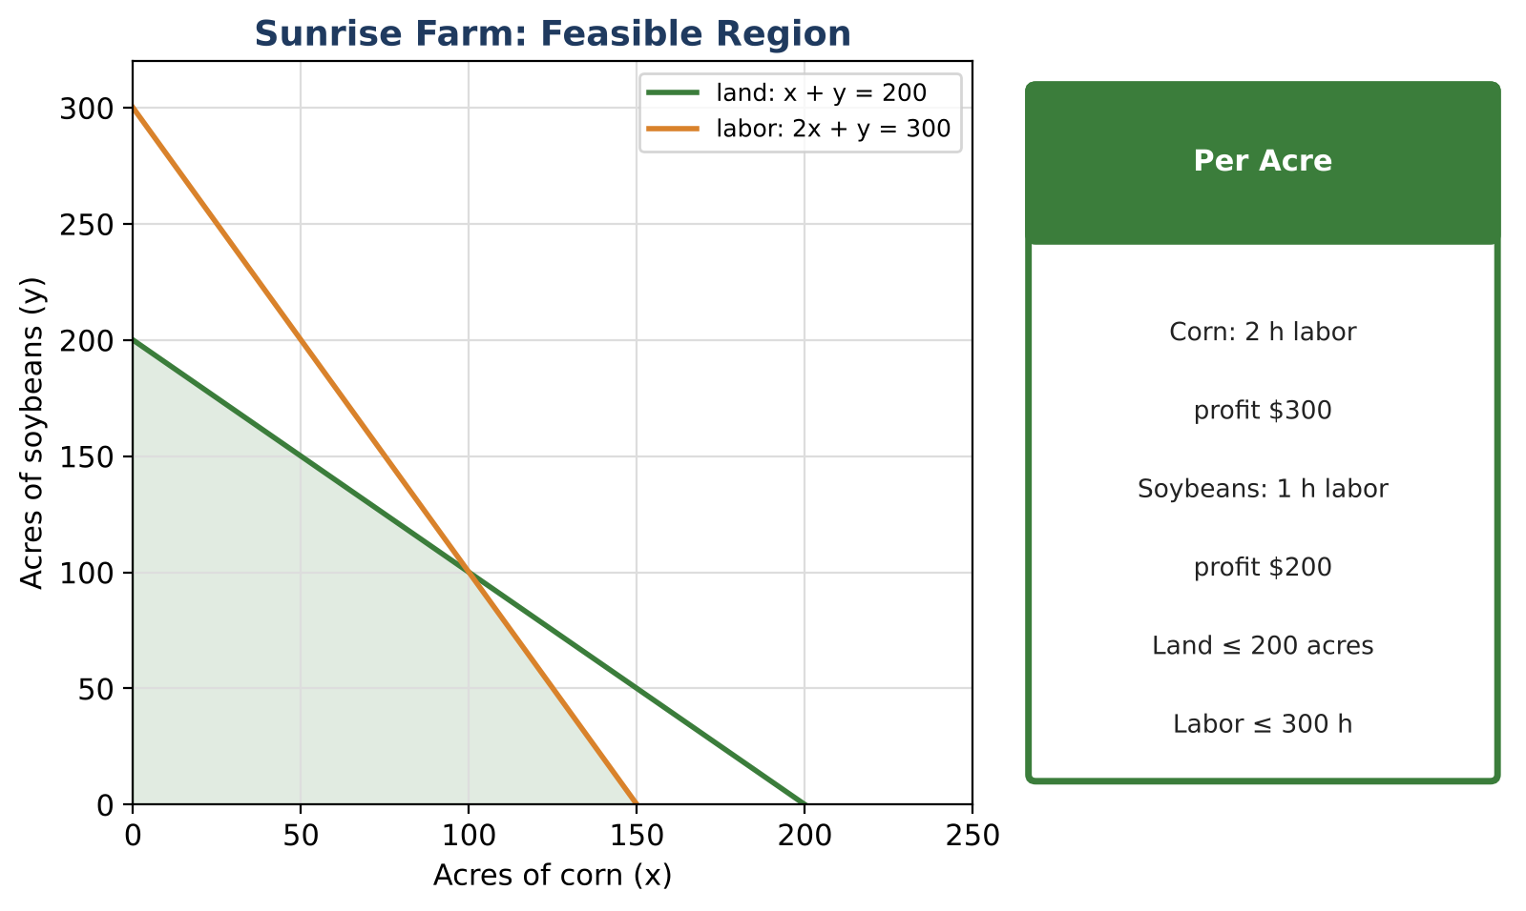
Learning Goals
- I can write and graph constraints as inequalities.
- I can find the vertices of a feasible region.
- I can use vertices to find the maximum profit.
Project Timeline
When | What you will do
Day 1 | Constraints
Day 2 | Find the Best Plan
Day 3 | Feed & Plan
Final | Farm Business Plan + reflection

Part 1: Constraints
Day 1 · Let x = acres of corn and y = acres of soybeans.
1. The farm has at most 200 acres. Write an inequality.

2. Corn needs 2 hours of labor per acre and soybeans need 1 hour. There are at most 300 hours. Write an inequality.

3. Why must x ≥ 0 and y ≥ 0?

4. Is the plan (90, 100) possible? Is (120, 90)? Check both constraints.

Part 2: Find the Best Plan
Day 2 · Profit P = 300x + 200y.
5. Find the vertex where the land and labor lines meet by solving the system x + y = 200 and 2x + y = 300.

6. List all four vertices of the feasible region.

7. Find the profit at each vertex. Which plan earns the most?
Vertex | Profit 300x + 200y
(0, 0)
(0, 200)
(150, 0)

Part 3: Feed & Plan
Day 3 · Feed mix: corn costs $0.10 per lb and soy meal costs $0.30 per lb.
8. The farmer needs 100 lb of feed that costs $16 total. Write and solve a system for the pounds of corn and soy meal.

9. Write a short business plan stating how many acres of each crop to plant and why.

10. What would change if soybean profit rose to $350 per acre?

Final Product: Farm Business Plan
Your final product must include:
- Graph of constraints with the feasible region shaded
- Vertex table with profits
- Feed mix solution
- Business plan
Reflection
R1. Why is the best plan always at a corner?

R2. What does a point outside the region mean for the farm?

Scoring Rubric
Criteria | 4 – Exceeds | 3 – Meets | 2 – Approaching | 1 – Beginning
Mathematical Accuracy | All calculations and solutions are correct; answers include units and are checked. | Nearly all work is correct; minor errors do not change conclusions. | Several errors; some conclusions are affected. | Many errors or missing work.
Reasoning & Justification | Clear, complete explanations connect every answer to the situation; uses precise vocabulary. | Explanations are mostly clear and connected to the situation. | Explanations are brief or partly unclear. | Little or no explanation.
Application & Design | Recommendation is the true optimum (or a tie is explained), and the feed system is solved and checked. Goes beyond the minimum with a creative, realistic choice. | Recommendation is the true optimum (or a tie is explained), and the feed system is solved and checked. | Design is incomplete or only partly uses the math from the unit. | Design is missing or unrelated to the unit math.
Communication & Presentation | Business plan includes the constraints, graph, vertices, optimal plan, and the feed mix solution. Polished, organized, and visually engaging. | Business plan includes the constraints, graph, vertices, optimal plan, and the feed mix solution. Organized and easy to follow. | Product is missing required parts or is hard to follow. | Product is mostly missing.

