ALGEBRA 2 · UNIT 2: LINEAR FUNCTIONS & SYSTEMS  Farm Planner  Use linear programming and systems in three variables to run a farm. | Honors  2–3 class periods

Name: ________________________________ Date: ______________ Period: ______
The Scenario
Sunrise Farm grows corn and soybeans. Land and labor are limited, and each crop brings a different profit. The farmer wants the plan that earns the most money.
This is linear programming: graph the constraints, find the corners of the feasible region, and test them. Then you will mix feed for the farm's animals with a three-variable system.
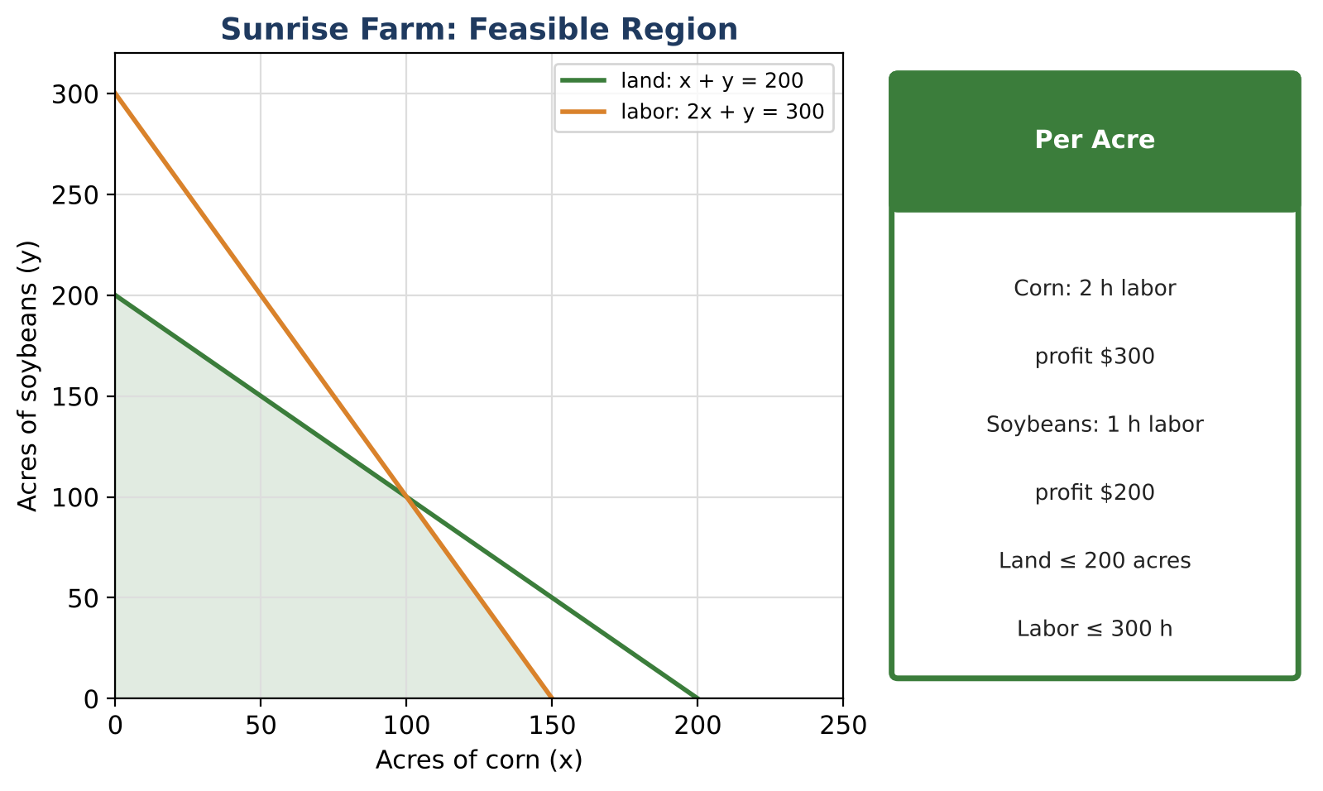
Learning Goals
- I can solve linear programming problems with several constraints.
- I can explain multiple optimal solutions.
- I can solve and interpret three-variable systems.
Project Timeline
When | What you will do
Day 1 | Constraints & Vertices
Day 2 | Optimize & Analyze
Day 3 | Mix the Feed
Final | Farm Business Plan + reflection

Part 1: Constraints & Vertices
Day 1 · Add a budget: corn costs $150 per acre and soybeans $100 per acre; budget $24,000.
1. Write all constraints and graph them.

2. Find every vertex of the new feasible region.

3. Which constraints are binding at each vertex?

Part 2: Optimize & Analyze
Day 2 · Profit P = 300x + 200y.
4. Evaluate P at each vertex. What do you notice?

5. Explain the tie using slopes. List three different optimal plans.

6. For what corn profit k (with soybeans still $200) would (120, 60) be the only best plan?

Part 3: Mix the Feed
Day 3 · Feed uses corn (a), soy meal (b), and oats (c).
7. Solve: a + b + c = 100; 0.09a + 0.44b + 0.12c = 16.6; 0.10a + 0.30b + 0.15c = 15.

8. If the protein target changes to p lb (cost and total stay the same), write a and b in terms of p (with c also in terms of p).

9. Find the range of p that keeps every amount nonnegative.

Final Product: Farm Business Plan
Your final product must include:
- Graph with all vertices and binding constraints
- Tie explanation and sensitivity analysis
- Feed solution and parametric analysis
- Business plan
Reflection
R1. What does it mean for a farmer that many plans tie?

R2. Why might a real feed problem have a range of good answers?

Scoring Rubric
Criteria | 4 – Exceeds | 3 – Meets | 2 – Approaching | 1 – Beginning
Mathematical Accuracy | All calculations and solutions are correct; answers include units and are checked. | Nearly all work is correct; minor errors do not change conclusions. | Several errors; some conclusions are affected. | Many errors or missing work.
Reasoning & Justification | Clear, complete explanations connect every answer to the situation; uses precise vocabulary. | Explanations are mostly clear and connected to the situation. | Explanations are brief or partly unclear. | Little or no explanation.
Application & Design | Recommendation is the true optimum (or a tie is explained), and the feed system is solved and checked. Goes beyond the minimum with a creative, realistic choice. | Recommendation is the true optimum (or a tie is explained), and the feed system is solved and checked. | Design is incomplete or only partly uses the math from the unit. | Design is missing or unrelated to the unit math.
Communication & Presentation | Business plan includes the constraints, graph, vertices, optimal plan, and the feed mix solution. Polished, organized, and visually engaging. | Business plan includes the constraints, graph, vertices, optimal plan, and the feed mix solution. Organized and easy to follow. | Product is missing required parts or is hard to follow. | Product is mostly missing.

