ALGEBRA 2 · UNIT 10: TRIGONOMETRIC FUNCTIONS  Ferris Wheel & Tides  Model a Ferris wheel ride and ocean tides with sine and cosine functions. | CP1  2–3 class periods

Name: ________________________________ Date: ______________ Period: ______
The Scenario
The Bayside Fair has a Ferris wheel 120 ft across with its center 70 ft above the ground. It turns once every 4 minutes, and riders board at the bottom, 10 ft up.
Next to the fair, the harbor's depth rises and falls with the tide. Both repeat in cycles, so both can be modeled with sine and cosine.
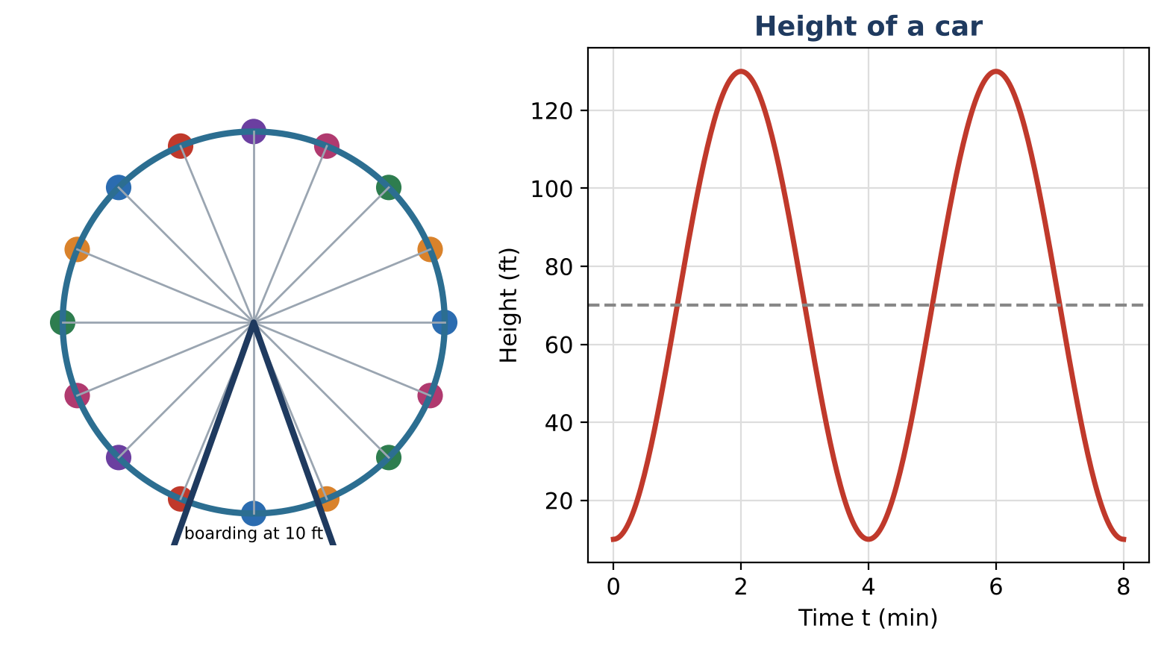
Learning Goals
- I can write sinusoidal models from descriptions.
- I can solve trig equations in context.
- I can interpret parameters.
Project Timeline
When | What you will do
Day 1 | The Wheel
Day 2 | Tides
Day 3 | Design a Ride
Final | Ride & Harbor Report + reflection

Part 1: The Wheel
Day 1 · Diameter 120 ft, center 70 ft, one turn every 4 minutes, boarding at the bottom.
1. Write h(t) and explain each number. Why is B = ½π?

2. Find h(0.5) and h(1.5) exactly.

3. For how long during each turn is a rider above 100 ft? Solve 70 − 60 cos(½πt) = 100.

Part 2: Tides
Day 2 · d(t) = 4 sin(⅙πt) + 10 (feet, hours after midnight).
4. A boat needs at least 8 ft of water. Solve d(t) = 8 for 0 ≤ t ≤ 12.

5. When can the boat use the harbor during the first 12 hours?

6. Rewrite the model if high tide were at 5 a.m. instead (same amplitude, midline, and period).

Part 3: Design a Ride
Day 3 · Design a wheel with at least 20 s above 80% of its maximum height each turn.
7. Write your model.

8. Solve for the time above 80% of the maximum height.

9. Present the design.

Final Product: Ride & Harbor Report
Your final product must include:
- Equation with explanation
- Solved timing questions
- Tide window
- Design
Reflection
R1. How do you get B from the period?

R2. Why do trig equations have many solutions?

Scoring Rubric
Criteria | 4 – Exceeds | 3 – Meets | 2 – Approaching | 1 – Beginning
Mathematical Accuracy | All calculations and solutions are correct; answers include units and are checked. | Nearly all work is correct; minor errors do not change conclusions. | Several errors; some conclusions are affected. | Many errors or missing work.
Reasoning & Justification | Clear, complete explanations connect every answer to the situation; uses precise vocabulary. | Explanations are mostly clear and connected to the situation. | Explanations are brief or partly unclear. | Little or no explanation.
Application & Design | Designed ride's function matches its description, and timing answers are found by solving trig equations. Goes beyond the minimum with a creative, realistic choice. | Designed ride's function matches its description, and timing answers are found by solving trig equations. | Design is incomplete or only partly uses the math from the unit. | Design is missing or unrelated to the unit math.
Communication & Presentation | Report includes both models with amplitude, midline, and period explained, a graph, and solved timing questions. Polished, organized, and visually engaging. | Report includes both models with amplitude, midline, and period explained, a graph, and solved timing questions. Organized and easy to follow. | Product is missing required parts or is hard to follow. | Product is mostly missing.

