ALGEBRA 2 · UNIT 10: TRIGONOMETRIC FUNCTIONS  Ferris Wheel & Tides  Model a Ferris wheel ride and ocean tides with sine and cosine functions. | CP2  2–3 class periods

Name: ________________________________ Date: ______________ Period: ______
The Scenario
The Bayside Fair has a Ferris wheel 120 ft across with its center 70 ft above the ground. It turns once every 4 minutes, and riders board at the bottom, 10 ft up.
Next to the fair, the harbor's depth rises and falls with the tide. Both repeat in cycles, so both can be modeled with sine and cosine.
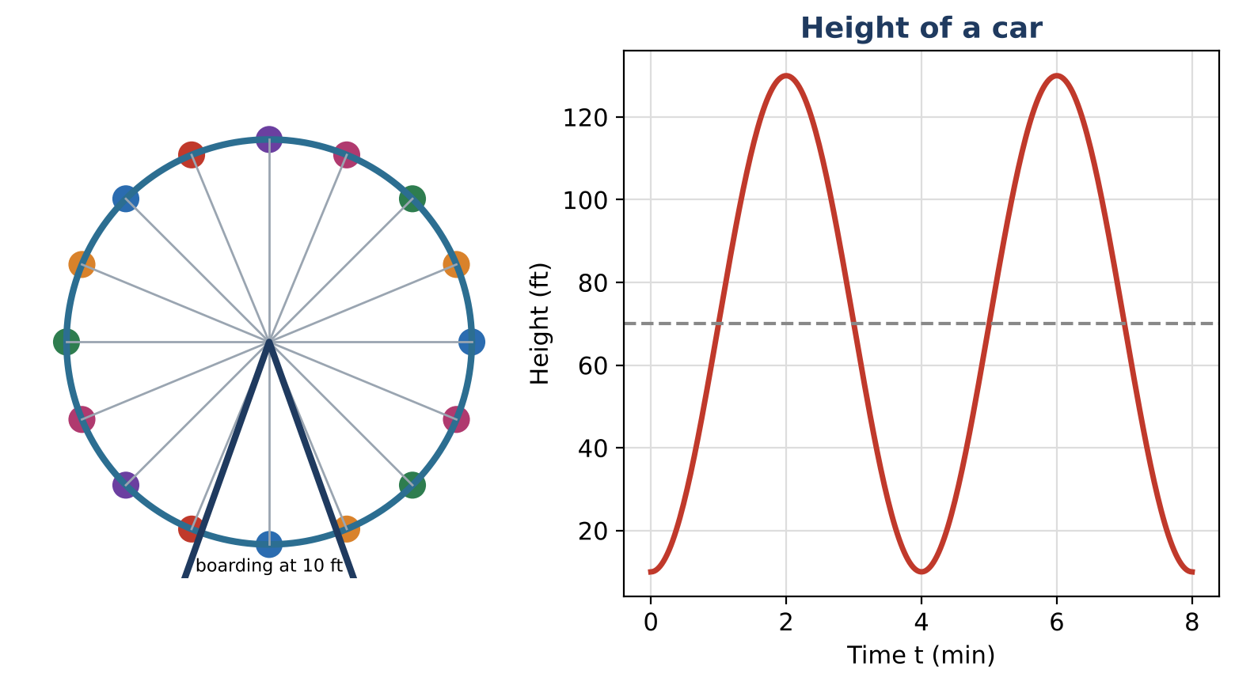
Learning Goals
- I can convert between degrees and radians and use the unit circle.
- I can identify amplitude, midline, and period.
- I can use a sinusoidal model to answer questions.
Project Timeline
When | What you will do
Day 1 | The Wheel
Day 2 | Tides
Day 3 | Design a Ride
Final | Ride & Harbor Report + reflection

Part 1: The Wheel
Day 1 · The wheel has 16 cars evenly spaced.
1. How many degrees apart are the cars? How many radians?

2. Convert 135° and 270° to radians.

3. Find the amplitude (radius), midline (center height), and period of the ride.

4. The model is h(t) = 70 − 60 cos(½πt). Complete the table.
t (min) | 0 | 1 | 2 | 3 | 4
h(t) (ft)

Part 2: Tides
Day 2 · The harbor depth is d(t) = 4 sin(⅙πt) + 10, in feet, t hours after midnight.
5. Find the maximum depth, minimum depth, and period.

6. At what times is the tide highest and lowest during the first 12 hours?

7. Sketch one cycle of the tide.

Part 3: Design a Ride
Day 3 · Design your own wheel.
8. Choose a diameter, center height, and time for one turn.

9. Write h(t) = (center) − (radius) cos(2πt ÷ period).

10. Make a table for one turn and sketch the graph.

Final Product: Ride & Harbor Report
Your final product must include:
- Wheel and tide graphs
- Parameter table
- Your ride design
- Report
Reflection
R1. Why does the model use −cos instead of sin?

R2. What does the period mean for a rider?

Scoring Rubric
Criteria | 4 – Exceeds | 3 – Meets | 2 – Approaching | 1 – Beginning
Mathematical Accuracy | All calculations and solutions are correct; answers include units and are checked. | Nearly all work is correct; minor errors do not change conclusions. | Several errors; some conclusions are affected. | Many errors or missing work.
Reasoning & Justification | Clear, complete explanations connect every answer to the situation; uses precise vocabulary. | Explanations are mostly clear and connected to the situation. | Explanations are brief or partly unclear. | Little or no explanation.
Application & Design | Designed ride's function matches its description, and timing answers are found by solving trig equations. Goes beyond the minimum with a creative, realistic choice. | Designed ride's function matches its description, and timing answers are found by solving trig equations. | Design is incomplete or only partly uses the math from the unit. | Design is missing or unrelated to the unit math.
Communication & Presentation | Report includes both models with amplitude, midline, and period explained, a graph, and solved timing questions. Polished, organized, and visually engaging. | Report includes both models with amplitude, midline, and period explained, a graph, and solved timing questions. Organized and easy to follow. | Product is missing required parts or is hard to follow. | Product is mostly missing.

