ALGEBRA 2 · UNIT 10: TRIGONOMETRIC FUNCTIONS  Ferris Wheel & Tides  Model a Ferris wheel ride and ocean tides with sine and cosine functions. | Honors  2–3 class periods

Name: ________________________________ Date: ______________ Period: ______
The Scenario
The Bayside Fair has a Ferris wheel 120 ft across with its center 70 ft above the ground. It turns once every 4 minutes, and riders board at the bottom, 10 ft up.
Next to the fair, the harbor's depth rises and falls with the tide. Both repeat in cycles, so both can be modeled with sine and cosine.
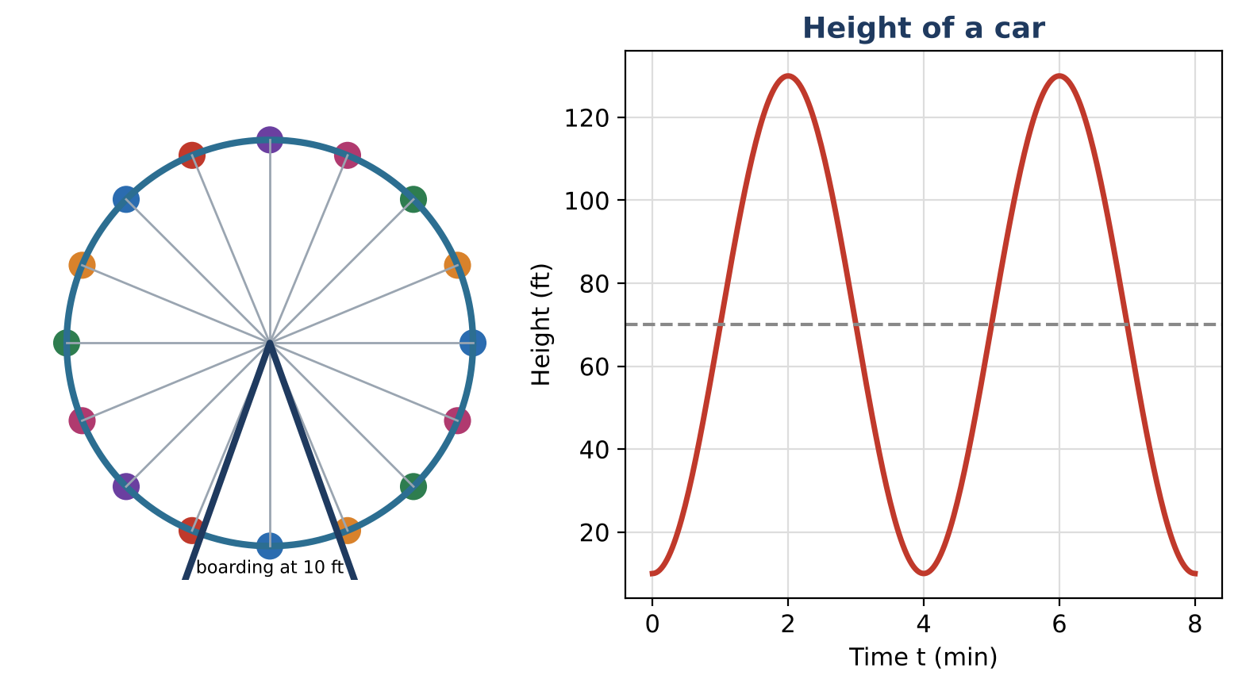
Learning Goals
- I can use phase shifts and equivalent sinusoidal forms.
- I can solve trig equations with inverse functions and general solutions.
- I can design a periodic model meeting constraints.
Project Timeline
When | What you will do
Day 1 | Equivalent Models
Day 2 | Harbor Planning
Day 3 | Design Within Constraints
Final | Ride & Harbor Report + reflection

Part 1: Equivalent Models
Day 1 · Use the wheel description.
1. Show that 70 − 60 cos(½πt) = 70 + 60 sin(½π(t − 1)).

2. A rider boards from a platform at the 3 o'clock position (70 ft) moving up. Write the model.

3. Find all times in the first 8 minutes when the bottom-boarding rider is at 40 ft.

Part 2: Harbor Planning
Day 2 · Real tides have a period of about 12.4 hours. Low tide is 3 ft at 2 a.m. and high tide is 13 ft.
4. Write a model for the depth.

5. A ship needs 10 ft. Find the first window after 2 a.m. when it can enter (to the nearest minute).

6. Explain why the docking windows shift later each day.

Part 3: Design Within Constraints
Day 3 · Design a wheel: top at most 200 ft, boarding at 10 ft, each rider above 150 ft for at least 1 minute, one turn at most 8 minutes.
7. Choose parameters and write the model.

8. Prove that your design meets every constraint.

9. Present it.

Final Product: Ride & Harbor Report
Your final product must include:
- Equivalent forms with proof
- Harbor model and window
- Constrained design with proof
Reflection
R1. Why can the same motion be written with sine or cosine?

R2. How do general solutions help with repeated events?

Scoring Rubric
Criteria | 4 – Exceeds | 3 – Meets | 2 – Approaching | 1 – Beginning
Mathematical Accuracy | All calculations and solutions are correct; answers include units and are checked. | Nearly all work is correct; minor errors do not change conclusions. | Several errors; some conclusions are affected. | Many errors or missing work.
Reasoning & Justification | Clear, complete explanations connect every answer to the situation; uses precise vocabulary. | Explanations are mostly clear and connected to the situation. | Explanations are brief or partly unclear. | Little or no explanation.
Application & Design | Designed ride's function matches its description, and timing answers are found by solving trig equations. Goes beyond the minimum with a creative, realistic choice. | Designed ride's function matches its description, and timing answers are found by solving trig equations. | Design is incomplete or only partly uses the math from the unit. | Design is missing or unrelated to the unit math.
Communication & Presentation | Report includes both models with amplitude, midline, and period explained, a graph, and solved timing questions. Polished, organized, and visually engaging. | Report includes both models with amplitude, midline, and period explained, a graph, and solved timing questions. Organized and easy to follow. | Product is missing required parts or is hard to follow. | Product is mostly missing.

