ALGEBRA 2 · UNIT 8: SEQUENCES & SERIES  First Car Savings Plan  Plan savings and payments for a first car with sequences and series. | CP1  2–3 class periods

Name: ________________________________ Date: ______________ Period: ______
The Scenario
You want to buy a used car in two years. You can save a little more each month, your bank pays interest, and the car you want loses value every year.
Arithmetic sequences describe steady increases, geometric sequences describe percent changes, and series add them up. You will build a complete plan.
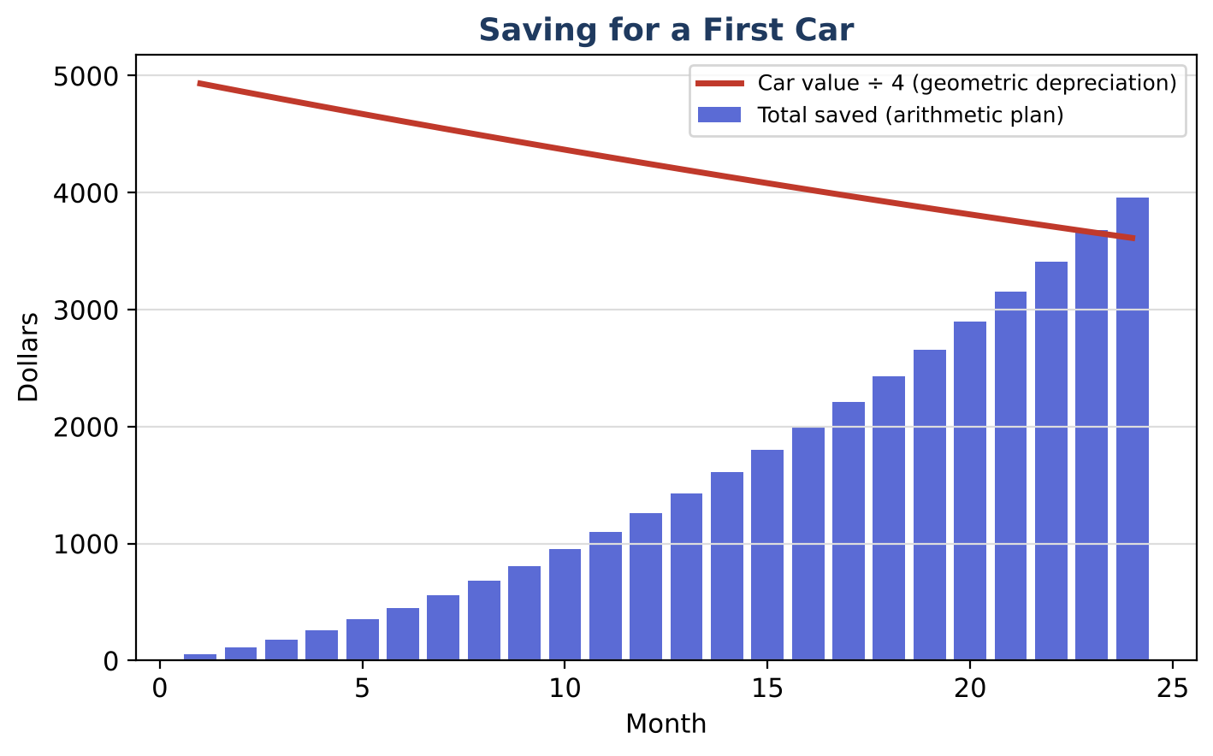
Learning Goals
- I can use arithmetic and geometric series formulas and sigma notation.
- I can solve for the number of terms.
- I can compare financial plans.
Project Timeline
When | What you will do
Day 1 | Saving Up
Day 2 | Cars & Bounces
Day 3 | Your Plan
Final | Car Buying Plan + reflection

Part 1: Saving Up
Day 1 · Plan A: $50 the first month, increasing by $10 each month.
1. Write the total for 24 months in sigma notation and evaluate it.

2. After how many months will the total first reach $5,000?

3. Plan B: deposit $200 each month into an account that pays 0.5% per month. After 24 months, the value is 200(1.005²⁴ − 1) ÷ 0.005. Evaluate it and explain why it is a geometric series.

Part 2: Cars & Bounces
Day 2 · Geometric models.
4. The car loses 15% per year from $20,000. In which year is it first worth less than $10,000?

5. Write the depreciation as a recursive rule.

6. Find the total distance traveled by a ball dropped from 6 ft that rebounds to 60% each bounce.

Part 3: Your Plan
Day 3 · Compare Plan A and Plan B and choose a car.
7. Compare the two plans after 24 months.

8. Choose a car and year and decide which plan (or combination) works.

9. Write the plan with sigma notation for one total.

Final Product: Car Buying Plan
Your final product must include:
- Sigma notation and totals
- Months-to-goal solution
- Plan comparison
- Car plan
Reflection
R1. Why does Plan B's total come from a geometric series?

R2. When does an infinite geometric series have a sum?

Scoring Rubric
Criteria | 4 – Exceeds | 3 – Meets | 2 – Approaching | 1 – Beginning
Mathematical Accuracy | All calculations and solutions are correct; answers include units and are checked. | Nearly all work is correct; minor errors do not change conclusions. | Several errors; some conclusions are affected. | Many errors or missing work.
Reasoning & Justification | Clear, complete explanations connect every answer to the situation; uses precise vocabulary. | Explanations are mostly clear and connected to the situation. | Explanations are brief or partly unclear. | Little or no explanation.
Application & Design | Models are correct sequences or series, and the decision uses the totals correctly. Goes beyond the minimum with a creative, realistic choice. | Models are correct sequences or series, and the decision uses the totals correctly. | Design is incomplete or only partly uses the math from the unit. | Design is missing or unrelated to the unit math.
Communication & Presentation | Plan includes savings and depreciation models, totals using series, and a final decision with a timeline. Polished, organized, and visually engaging. | Plan includes savings and depreciation models, totals using series, and a final decision with a timeline. Organized and easy to follow. | Product is missing required parts or is hard to follow. | Product is mostly missing.

