ALGEBRA 2 · UNIT 8: SEQUENCES & SERIES  First Car Savings Plan  Plan savings and payments for a first car with sequences and series. | CP2  2–3 class periods

Name: ________________________________ Date: ______________ Period: ______
The Scenario
You want to buy a used car in two years. You can save a little more each month, your bank pays interest, and the car you want loses value every year.
Arithmetic sequences describe steady increases, geometric sequences describe percent changes, and series add them up. You will build a complete plan.
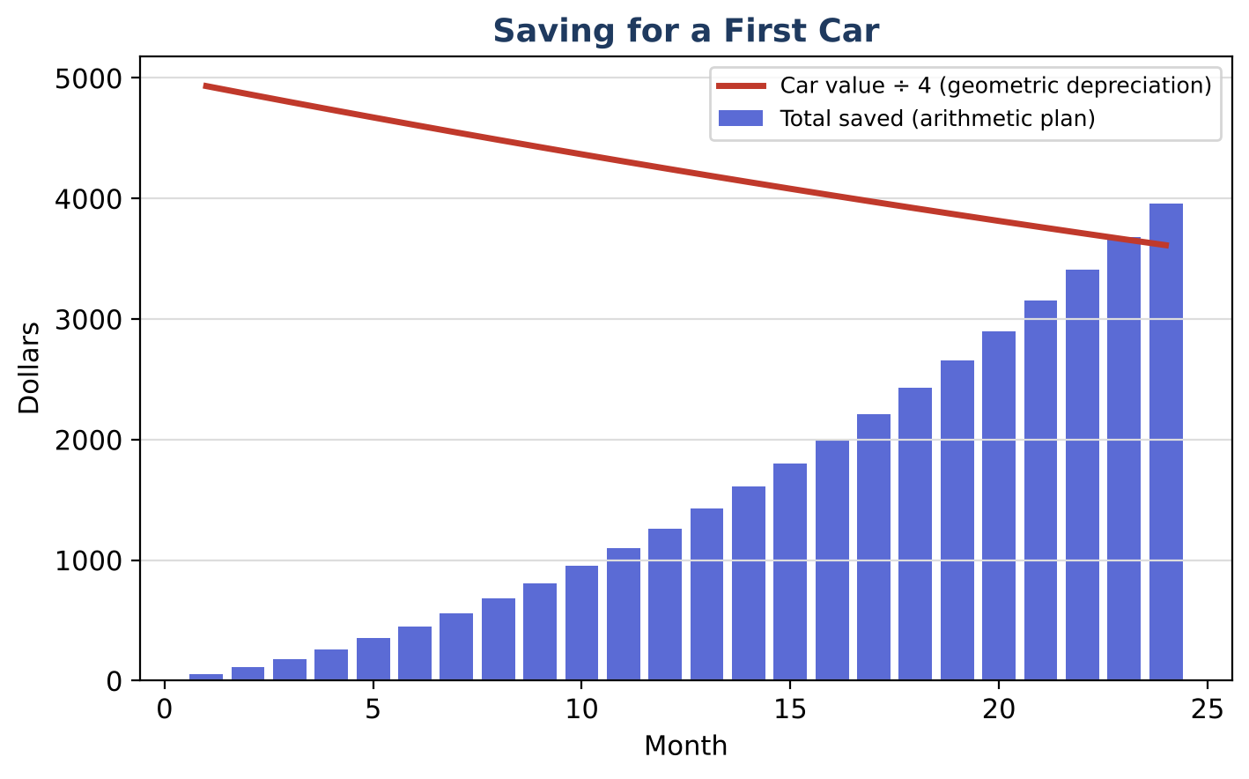
Learning Goals
- I can write arithmetic and geometric sequences.
- I can find sums with series formulas.
- I can use sequences to make a financial decision.
Project Timeline
When | What you will do
Day 1 | Saving Up
Day 2 | Cars Lose Value
Day 3 | Your Plan
Final | Car Buying Plan + reflection

Part 1: Saving Up
Day 1 · You save $50 the first month and $10 more each month after that.
1. Write the first five terms and an explicit rule aₙ.

2. How much do you save in month 12?

3. Use Sₙ = n(a₁ + aₙ) ÷ 2 to find the total saved in 24 months.

Part 2: Cars Lose Value
Day 2 · The car you want costs $20,000 new and loses 15% of its value each year.
4. Write a rule for the car's value after n years.

5. Find its value after 5 years.

6. A ball dropped from 6 ft bounces back to 60% of its height each time. List the first four heights.

7. The total distance the ball travels is 6 + 2(3.6 + 2.16 + …). Use S = a₁ ÷ (1 − r) for the sum in the parentheses and find the total distance.

Part 3: Your Plan
Day 3 · Make a car plan.
8. Find a used car's value (or use a 5-year-old $20,000 car). Can your 24-month savings buy it?

9. Change your plan (start amount or monthly increase) so you can afford the car in 24 months.

10. Write your plan.

Final Product: Car Buying Plan
Your final product must include:
- Savings sequence and total
- Depreciation model
- Infinite series example
- Car plan
Reflection
R1. How is an arithmetic sequence different from a geometric one?

R2. How can an infinite list of bounces have a finite total distance?

Scoring Rubric
Criteria | 4 – Exceeds | 3 – Meets | 2 – Approaching | 1 – Beginning
Mathematical Accuracy | All calculations and solutions are correct; answers include units and are checked. | Nearly all work is correct; minor errors do not change conclusions. | Several errors; some conclusions are affected. | Many errors or missing work.
Reasoning & Justification | Clear, complete explanations connect every answer to the situation; uses precise vocabulary. | Explanations are mostly clear and connected to the situation. | Explanations are brief or partly unclear. | Little or no explanation.
Application & Design | Models are correct sequences or series, and the decision uses the totals correctly. Goes beyond the minimum with a creative, realistic choice. | Models are correct sequences or series, and the decision uses the totals correctly. | Design is incomplete or only partly uses the math from the unit. | Design is missing or unrelated to the unit math.
Communication & Presentation | Plan includes savings and depreciation models, totals using series, and a final decision with a timeline. Polished, organized, and visually engaging. | Plan includes savings and depreciation models, totals using series, and a final decision with a timeline. Organized and easy to follow. | Product is missing required parts or is hard to follow. | Product is mostly missing.

