ALGEBRA 2 · UNIT 8: SEQUENCES & SERIES  First Car Savings Plan  Plan savings and payments for a first car with sequences and series. | Honors  2–3 class periods

Name: ________________________________ Date: ______________ Period: ______
The Scenario
You want to buy a used car in two years. You can save a little more each month, your bank pays interest, and the car you want loses value every year.
Arithmetic sequences describe steady increases, geometric sequences describe percent changes, and series add them up. You will build a complete plan.
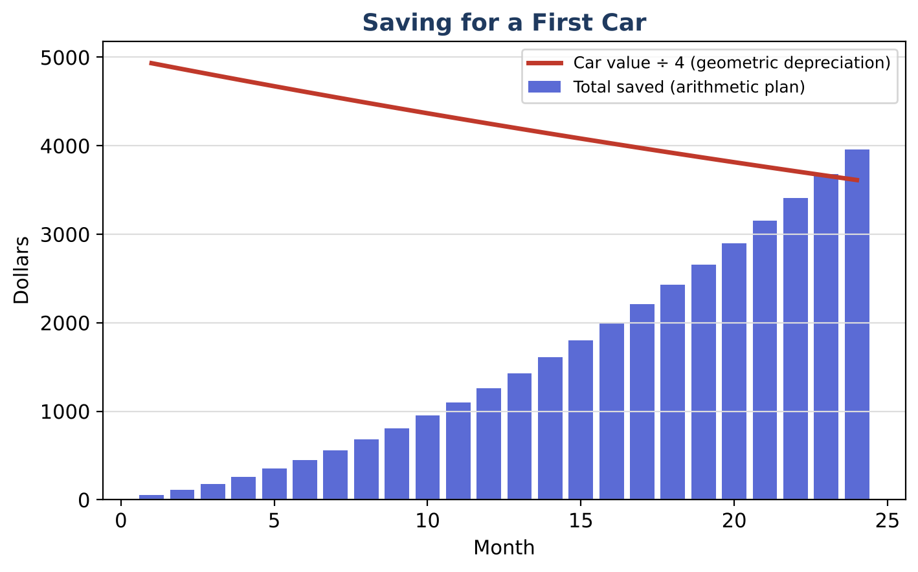
Learning Goals
- I can derive series formulas.
- I can derive and use the loan payment formula.
- I can make a justified financial decision.
Project Timeline
When | What you will do
Day 1 | Derivations
Day 2 | Borrowing
Day 3 | Decision
Final | Car Buying Plan + reflection

Part 1: Derivations
Day 1 · Let S = a + ar + ar² + … + arⁿ⁻¹.
1. Derive Sₙ = a(1 − rⁿ) ÷ (1 − r) by computing S − rS.

2. Use it to show that 24 monthly deposits of $200 at 0.5% per month grow to 200(1.005²⁴ − 1) ÷ 0.005. Evaluate.

3. Explain why the sum of an infinite geometric series exists only when |r| < 1.

Part 2: Borrowing
Day 2 · A loan of L dollars at monthly rate r is paid with n equal payments M.
4. The present values of the payments form a geometric series: L = M(1 + r)⁻¹ + M(1 + r)⁻² + … + M(1 + r)⁻ⁿ. Show that M = rL ÷ (1 − (1 + r)⁻ⁿ).

5. Find the monthly payment for $15,000 at 0.5% per month for 48 months, and the total interest paid.

6. Compare: save $352.28 per month for 48 months at 0.5% per month first, then buy. How much would you have?

Part 3: Decision
Day 3 · Save or borrow?
7. Compare saving first with borrowing now, using your numbers.

8. Consider depreciation: the car loses 15% per year. Include it in your decision.

9. Write the final plan.

Final Product: Car Buying Plan
Your final product must include:
- Two derivations
- Loan payment and interest
- Save-vs-borrow comparison
- Final plan
Reflection
R1. Why does borrowing cost more than saving?

R2. How did the geometric series formula appear in both saving and borrowing?

Scoring Rubric
Criteria | 4 – Exceeds | 3 – Meets | 2 – Approaching | 1 – Beginning
Mathematical Accuracy | All calculations and solutions are correct; answers include units and are checked. | Nearly all work is correct; minor errors do not change conclusions. | Several errors; some conclusions are affected. | Many errors or missing work.
Reasoning & Justification | Clear, complete explanations connect every answer to the situation; uses precise vocabulary. | Explanations are mostly clear and connected to the situation. | Explanations are brief or partly unclear. | Little or no explanation.
Application & Design | Models are correct sequences or series, and the decision uses the totals correctly. Goes beyond the minimum with a creative, realistic choice. | Models are correct sequences or series, and the decision uses the totals correctly. | Design is incomplete or only partly uses the math from the unit. | Design is missing or unrelated to the unit math.
Communication & Presentation | Plan includes savings and depreciation models, totals using series, and a final decision with a timeline. Polished, organized, and visually engaging. | Plan includes savings and depreciation models, totals using series, and a final decision with a timeline. Organized and easy to follow. | Product is missing required parts or is hard to follow. | Product is mostly missing.

