ALGEBRA 2 · UNIT 3: QUADRATIC FUNCTIONS & COMPLEX NUMBERS  Fountain Designer  Design plaza fountains with quadratic functions, inequalities, and complex numbers. | CP1  2–3 class periods

Name: ________________________________ Date: ______________ Period: ______
The Scenario
The town is building a plaza fountain, and the design firm has asked students to plan the water jets. Each jet of water follows a parabola.
Designers need to know how high the water goes, where it lands, whether it clears a sign, and when it can never reach a certain height. Some answers will turn out to be complex numbers, and you will learn what that means.
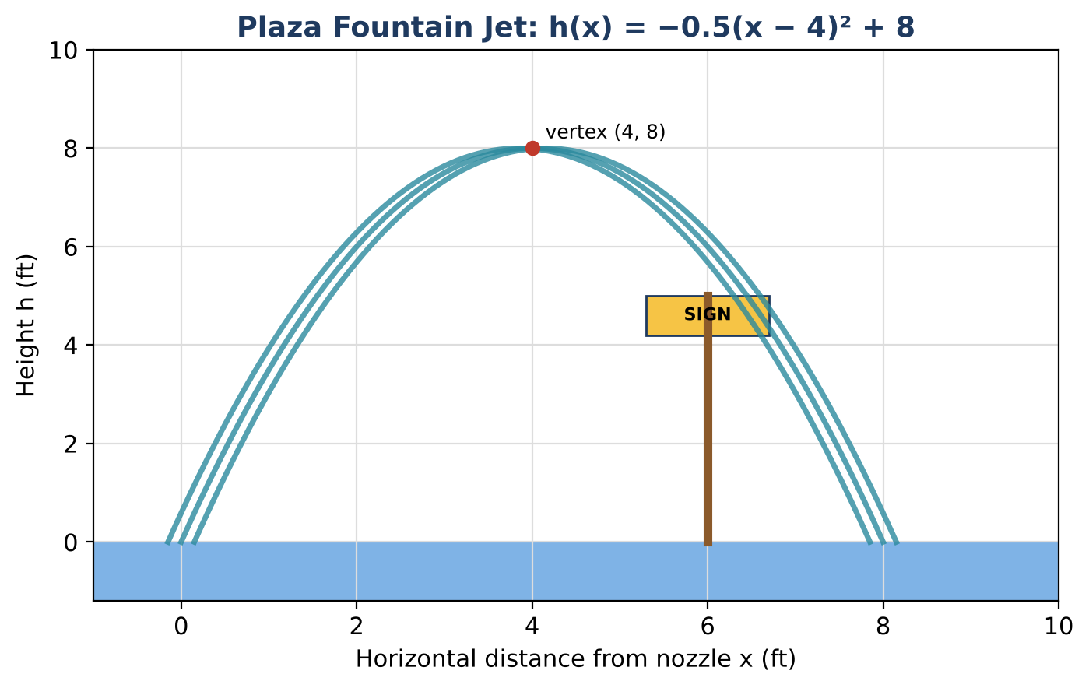
Learning Goals
- I can convert between standard and vertex form by completing the square.
- I can use the quadratic formula and discriminant.
- I can solve linear-quadratic systems.
Project Timeline
When | What you will do
Day 1 | Two Jets
Day 2 | Claims & Systems
Day 3 | Design a Jet
Final | Fountain Design Proposal + reflection

Part 1: Two Jets
Day 1 · Main jet h(x) = −0.5(x − 4)² + 8. Side jet s(x) = −0.5x² + 3x + 1.5.
1. Complete the square to write s(x) in vertex form. Give its maximum height.

2. Find where the side jet lands (exact and decimal).

3. Which jet goes higher? Which lands farther away?

Part 2: Claims & Systems
Day 2 · Use the discriminant and systems.
4. Use the discriminant to decide if the side jet ever reaches 7 ft. If not, give the complex solutions.

5. A light beam follows y = 0.5x + 1. Where does it meet the main jet? Give exact and decimal answers.

6. Where is the main jet above 6 ft? Solve the inequality.

7. Simplify (4 + i√2)(4 − i√2) and explain why the answer is real.

Part 3: Design a Jet
Day 3 · Design a jet in standard form that starts at the nozzle (height 1 ft at x = 0), peaks between 6 and 9 ft, and lands within 10 ft.
8. Write the equation and complete the square to verify the peak.

9. Use the quadratic formula to find the landing point.

10. Pick a height your jet never reaches and show the solutions are complex.

Final Product: Fountain Design Proposal
Your final product must include:
- Both jets in two forms
- Light beam intersection
- Discriminant claims
- Your jet design
Reflection
R1. How does the discriminant tell you about heights without solving?

R2. Why do complex solutions come in conjugate pairs?

Scoring Rubric
Criteria | 4 – Exceeds | 3 – Meets | 2 – Approaching | 1 – Beginning
Mathematical Accuracy | All calculations and solutions are correct; answers include units and are checked. | Nearly all work is correct; minor errors do not change conclusions. | Several errors; some conclusions are affected. | Many errors or missing work.
Reasoning & Justification | Clear, complete explanations connect every answer to the situation; uses precise vocabulary. | Explanations are mostly clear and connected to the situation. | Explanations are brief or partly unclear. | Little or no explanation.
Application & Design | Fountain design meets every requirement, with complex or real solutions interpreted correctly. Goes beyond the minimum with a creative, realistic choice. | Fountain design meets every requirement, with complex or real solutions interpreted correctly. | Design is incomplete or only partly uses the math from the unit. | Design is missing or unrelated to the unit math.
Communication & Presentation | Proposal includes each jet's equation in two forms, the key features, and solutions to the design questions. Polished, organized, and visually engaging. | Proposal includes each jet's equation in two forms, the key features, and solutions to the design questions. Organized and easy to follow. | Product is missing required parts or is hard to follow. | Product is mostly missing.

