ALGEBRA 2 · UNIT 3: QUADRATIC FUNCTIONS & COMPLEX NUMBERS  Fountain Designer  Design plaza fountains with quadratic functions, inequalities, and complex numbers. | CP2  2–3 class periods

Name: ________________________________ Date: ______________ Period: ______
The Scenario
The town is building a plaza fountain, and the design firm has asked students to plan the water jets. Each jet of water follows a parabola.
Designers need to know how high the water goes, where it lands, whether it clears a sign, and when it can never reach a certain height. Some answers will turn out to be complex numbers, and you will learn what that means.
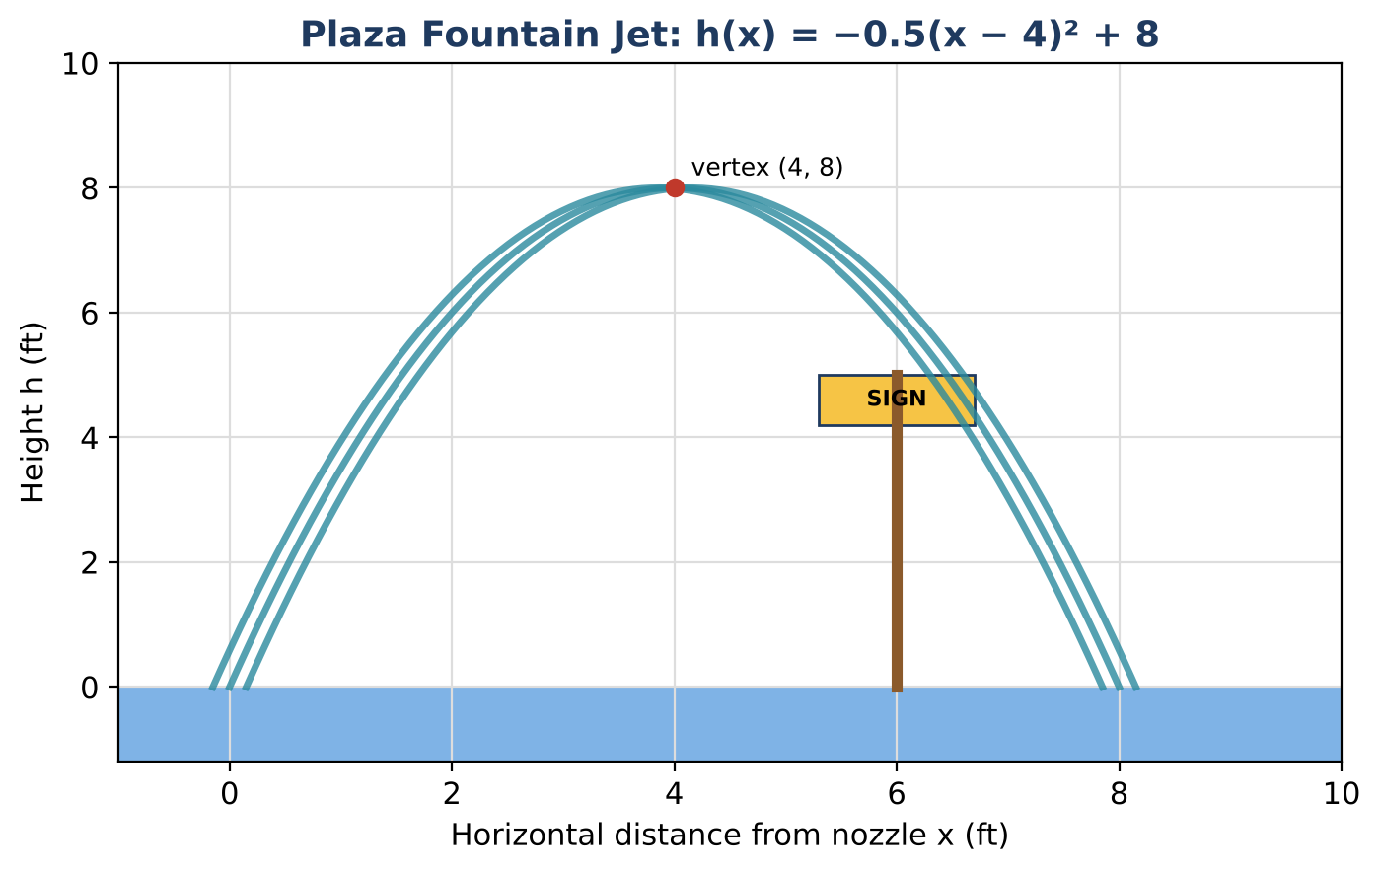
Learning Goals
- I can identify key features of a quadratic in vertex form.
- I can solve quadratics by square roots and recognize complex solutions.
- I can add, subtract, and multiply complex numbers.
Project Timeline
When | What you will do
Day 1 | The Main Jet
Day 2 | Heights & Complex Numbers
Day 3 | Design a Jet
Final | Fountain Design Proposal + reflection

Part 1: The Main Jet
Day 1 · The main jet follows h(x) = −0.5(x − 4)² + 8.
1. Give the vertex, the axis of symmetry, and the maximum height.

2. Find where the water lands by solving −0.5(x − 4)² + 8 = 0 with square roots.

3. Rewrite h(x) in standard form.

4. A 5-ft-tall sign stands at x = 6. Does the water clear it? By how much?

Part 2: Heights & Complex Numbers
Day 2 · Answer each question with algebra.
5. Where is the water higher than 6 ft? Write and solve a quadratic inequality.

6. A designer claims the jet reaches 9 ft. Solve h(x) = 9. What do the solutions tell you?

7. Simplify (3 + 2i) + (1 − 5i) and (2 + i)(3 − i).

8. Explain why i² = −1 means √(−2) = i√2.

Part 3: Design a Jet
Day 3 · The pool is 10 ft wide. Your jet starts at x = 0 and must land inside the pool and stay below 9 ft.
9. Write your jet in vertex form h(x) = a(x − h)² + k.

10. Find where it lands and its maximum height.

11. Show that it can never reach 9 ft by solving h(x) = 9.

Final Product: Fountain Design Proposal
Your final product must include:
- Equations of the main jet and your jet
- Graph with key features
- Sign and height checks
- Proposal to the town
Reflection
R1. What does it mean when a quadratic equation has complex solutions in this context?

R2. Why does vertex form make the maximum height easy to see?

Scoring Rubric
Criteria | 4 – Exceeds | 3 – Meets | 2 – Approaching | 1 – Beginning
Mathematical Accuracy | All calculations and solutions are correct; answers include units and are checked. | Nearly all work is correct; minor errors do not change conclusions. | Several errors; some conclusions are affected. | Many errors or missing work.
Reasoning & Justification | Clear, complete explanations connect every answer to the situation; uses precise vocabulary. | Explanations are mostly clear and connected to the situation. | Explanations are brief or partly unclear. | Little or no explanation.
Application & Design | Fountain design meets every requirement, with complex or real solutions interpreted correctly. Goes beyond the minimum with a creative, realistic choice. | Fountain design meets every requirement, with complex or real solutions interpreted correctly. | Design is incomplete or only partly uses the math from the unit. | Design is missing or unrelated to the unit math.
Communication & Presentation | Proposal includes each jet's equation in two forms, the key features, and solutions to the design questions. Polished, organized, and visually engaging. | Proposal includes each jet's equation in two forms, the key features, and solutions to the design questions. Organized and easy to follow. | Product is missing required parts or is hard to follow. | Product is mostly missing.

