ALGEBRA 2 · UNIT 3: QUADRATIC FUNCTIONS & COMPLEX NUMBERS  Fountain Designer  Design plaza fountains with quadratic functions, inequalities, and complex numbers. | Honors  2–3 class periods

Name: ________________________________ Date: ______________ Period: ______
The Scenario
The town is building a plaza fountain, and the design firm has asked students to plan the water jets. Each jet of water follows a parabola.
Designers need to know how high the water goes, where it lands, whether it clears a sign, and when it can never reach a certain height. Some answers will turn out to be complex numbers, and you will learn what that means.
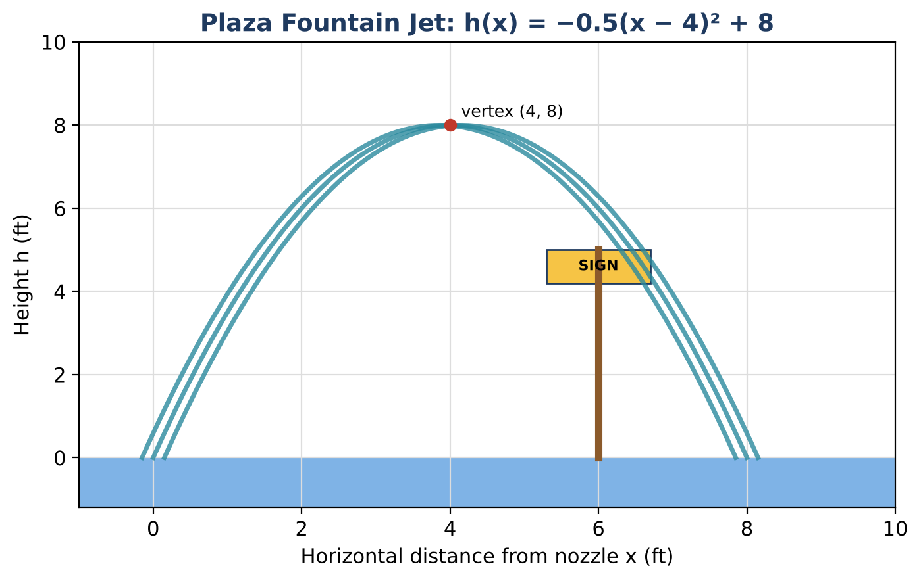
Learning Goals
- I can solve quadratic systems and compound quadratic inequalities.
- I can describe complex solutions as functions of a parameter.
- I can design under several constraints and justify it.
Project Timeline
When | What you will do
Day 1 | Two Crossing Jets
Day 2 | Complex Heights
Day 3 | Design a Two-Jet Fountain
Final | Fountain Design Proposal + reflection

Part 1: Two Crossing Jets
Day 1 · h(x) = −0.5(x − 4)² + 8 and g(x) = −0.5(x − 6)² + 8.
1. Find where the two jets cross and the height there.

2. Find where both jets are above 7 ft at the same time.

3. Write g(x) as a transformation of h(x).

Part 2: Complex Heights
Day 2 · Let k be a target height.
4. Solve h(x) = k for x in terms of k.

5. For which k are the solutions real and different, equal, or complex? Interpret each case.

6. For k = 10, find the solutions and verify that their sum and product match the coefficients of the equation.

7. Simplify (3 − 2i) ÷ (1 + i) by multiplying by the conjugate.

Part 3: Design a Two-Jet Fountain
Day 3 · Two jets start 12 ft apart, cross at a height of at least 6 ft, and never exceed 10 ft.
8. Write both jets and find where they cross.

9. Prove the max-height rule with a discriminant.

10. Present the design with a graph.

Final Product: Fountain Design Proposal
Your final product must include:
- Crossing point and the overlap interval
- Complex solutions in terms of k
- Two-jet design with proofs
- Proposal
Reflection
R1. How does the vertex form show that complex solutions start exactly at the maximum height?

R2. Why do the jets cross exactly halfway between their peaks?

Scoring Rubric
Criteria | 4 – Exceeds | 3 – Meets | 2 – Approaching | 1 – Beginning
Mathematical Accuracy | All calculations and solutions are correct; answers include units and are checked. | Nearly all work is correct; minor errors do not change conclusions. | Several errors; some conclusions are affected. | Many errors or missing work.
Reasoning & Justification | Clear, complete explanations connect every answer to the situation; uses precise vocabulary. | Explanations are mostly clear and connected to the situation. | Explanations are brief or partly unclear. | Little or no explanation.
Application & Design | Fountain design meets every requirement, with complex or real solutions interpreted correctly. Goes beyond the minimum with a creative, realistic choice. | Fountain design meets every requirement, with complex or real solutions interpreted correctly. | Design is incomplete or only partly uses the math from the unit. | Design is missing or unrelated to the unit math.
Communication & Presentation | Proposal includes each jet's equation in two forms, the key features, and solutions to the design questions. Polished, organized, and visually engaging. | Proposal includes each jet's equation in two forms, the key features, and solutions to the design questions. Organized and easy to follow. | Product is missing required parts or is hard to follow. | Product is mostly missing.

