ALGEBRA 2 · UNIT 7: RATIONAL FUNCTIONS  Mural Business  Run a mural-painting business with rational functions, work rates, and rational equations. | CP1  2–3 class periods

Name: ________________________________ Date: ______________ Period: ______
The Scenario
You and your friends are starting a mural business. Equipment costs $1,200 once, and materials cost $150 per mural. The more murals you paint, the lower your average cost per mural.
You will also schedule painters who work at different speeds and plan your travel. Every question leads to a rational function or equation.
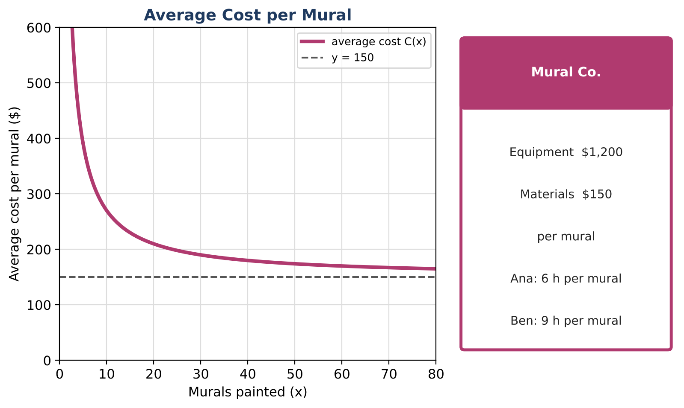
Learning Goals
- I can simplify rational expressions and identify restrictions.
- I can solve rational equations and check for extraneous solutions.
- I can interpret asymptotes in context.
Project Timeline
When | What you will do
Day 1 | Average Cost
Day 2 | Rational Equations
Day 3 | Business Plan
Final | Business Plan + reflection

Part 1: Average Cost
Day 1 · C(x) = (1200 + 150x) ÷ x.
1. Rewrite C(x) as 150 + 1200 ÷ x. Identify the vertical and horizontal asymptotes and explain them in context.

2. How many murals give an average cost of $175?

3. A larger studio has C₂(x) = (3000 + 120x) ÷ x. For how many murals is the larger studio cheaper per mural?

Part 2: Rational Equations
Day 2 · Check every solution.
4. Ana takes 6 h, Ben 9 h. Together with Cara they take 2.4 h. Find Cara's time with a rational equation.

5. You drive 60 miles to a job and back. You drive 10 mph faster coming home, and the round trip takes 2.7 hours of driving. Find your speed going.

6. Simplify (x² − 9) ÷ (x² + 5x + 6). State the restrictions and where the graph has a hole.

Part 3: Business Plan
Day 3 · Plan the season.
7. Set a price and find the break-even number of murals with a rational equation.

8. Schedule a three-person team and find their combined time.

9. Write the plan with a graph.

Final Product: Business Plan
Your final product must include:
- Average cost analysis with asymptotes
- Studio comparison
- Solved rational equations
- Business plan
Reflection
R1. What does the horizontal asymptote mean for the business?

R2. How do you know when a solution is extraneous?

Scoring Rubric
Criteria | 4 – Exceeds | 3 – Meets | 2 – Approaching | 1 – Beginning
Mathematical Accuracy | All calculations and solutions are correct; answers include units and are checked. | Nearly all work is correct; minor errors do not change conclusions. | Several errors; some conclusions are affected. | Many errors or missing work.
Reasoning & Justification | Clear, complete explanations connect every answer to the situation; uses precise vocabulary. | Explanations are mostly clear and connected to the situation. | Explanations are brief or partly unclear. | Little or no explanation.
Application & Design | Prices and schedules are based on correctly solved rational equations, with extraneous solutions rejected. Goes beyond the minimum with a creative, realistic choice. | Prices and schedules are based on correctly solved rational equations, with extraneous solutions rejected. | Design is incomplete or only partly uses the math from the unit. | Design is missing or unrelated to the unit math.
Communication & Presentation | Plan includes the average cost function with asymptotes, work-rate schedules, and a pricing decision supported by equations. Polished, organized, and visually engaging. | Plan includes the average cost function with asymptotes, work-rate schedules, and a pricing decision supported by equations. Organized and easy to follow. | Product is missing required parts or is hard to follow. | Product is mostly missing.

