ALGEBRA 2 · UNIT 7: RATIONAL FUNCTIONS  Mural Business  Run a mural-painting business with rational functions, work rates, and rational equations. | CP2  2–3 class periods

Name: ________________________________ Date: ______________ Period: ______
The Scenario
You and your friends are starting a mural business. Equipment costs $1,200 once, and materials cost $150 per mural. The more murals you paint, the lower your average cost per mural.
You will also schedule painters who work at different speeds and plan your travel. Every question leads to a rational function or equation.
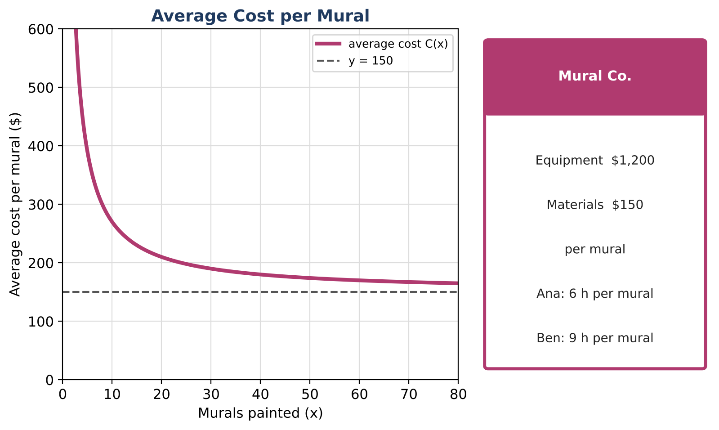
Learning Goals
- I can evaluate and graph a rational function and interpret its asymptote.
- I can solve work-rate problems.
- I can use inverse variation.
Project Timeline
When | What you will do
Day 1 | Average Cost
Day 2 | Painters & Rates
Day 3 | Business Plan
Final | Business Plan + reflection

Part 1: Average Cost
Day 1 · Average cost per mural: C(x) = (1200 + 150x) ÷ x.
1. Complete the table.
Murals x | 1 | 5 | 10 | 30 | 60
C(x) ($)

2. What value does C(x) get close to as x gets large? Why does that make sense?

3. How many murals must you paint for the average cost to be $190?

4. Why is x = 0 not in the domain?

Part 2: Painters & Rates
Day 2 · Ana paints a mural in 6 hours, so she paints ⅙ of a mural per hour. Ben takes 9 hours.
5. What fraction of a mural does Ben paint per hour?

6. Working together, how long do Ana and Ben take? Solve ⅙ + ⅑ = 1 ÷ t.

7. With Cara, all three finish in 2.4 hours. How long would Cara take alone?

8. A big wall takes 24 painter-days: days = 24 ÷ (painters). How many days with 4 painters? With 6?

Part 3: Business Plan
Day 3 · Plan your first season.
9. Choose a price per mural. How many murals do you need so that the price is at least $50 more than the average cost?

10. Choose a team and find how long one mural takes together.

11. Write a short business plan.

Final Product: Business Plan
Your final product must include:
- Average cost graph with the asymptote labeled
- Team schedule
- Price and goal
- Business plan
Reflection
R1. Why can the average cost never reach $150?

R2. Why do we add rates and not times?

Scoring Rubric
Criteria | 4 – Exceeds | 3 – Meets | 2 – Approaching | 1 – Beginning
Mathematical Accuracy | All calculations and solutions are correct; answers include units and are checked. | Nearly all work is correct; minor errors do not change conclusions. | Several errors; some conclusions are affected. | Many errors or missing work.
Reasoning & Justification | Clear, complete explanations connect every answer to the situation; uses precise vocabulary. | Explanations are mostly clear and connected to the situation. | Explanations are brief or partly unclear. | Little or no explanation.
Application & Design | Prices and schedules are based on correctly solved rational equations, with extraneous solutions rejected. Goes beyond the minimum with a creative, realistic choice. | Prices and schedules are based on correctly solved rational equations, with extraneous solutions rejected. | Design is incomplete or only partly uses the math from the unit. | Design is missing or unrelated to the unit math.
Communication & Presentation | Plan includes the average cost function with asymptotes, work-rate schedules, and a pricing decision supported by equations. Polished, organized, and visually engaging. | Plan includes the average cost function with asymptotes, work-rate schedules, and a pricing decision supported by equations. Organized and easy to follow. | Product is missing required parts or is hard to follow. | Product is mostly missing.

