ALGEBRA 2 · UNIT 7: RATIONAL FUNCTIONS  Mural Business  Run a mural-painting business with rational functions, work rates, and rational equations. | Honors  2–3 class periods

Name: ________________________________ Date: ______________ Period: ______
The Scenario
You and your friends are starting a mural business. Equipment costs $1,200 once, and materials cost $150 per mural. The more murals you paint, the lower your average cost per mural.
You will also schedule painters who work at different speeds and plan your travel. Every question leads to a rational function or equation.
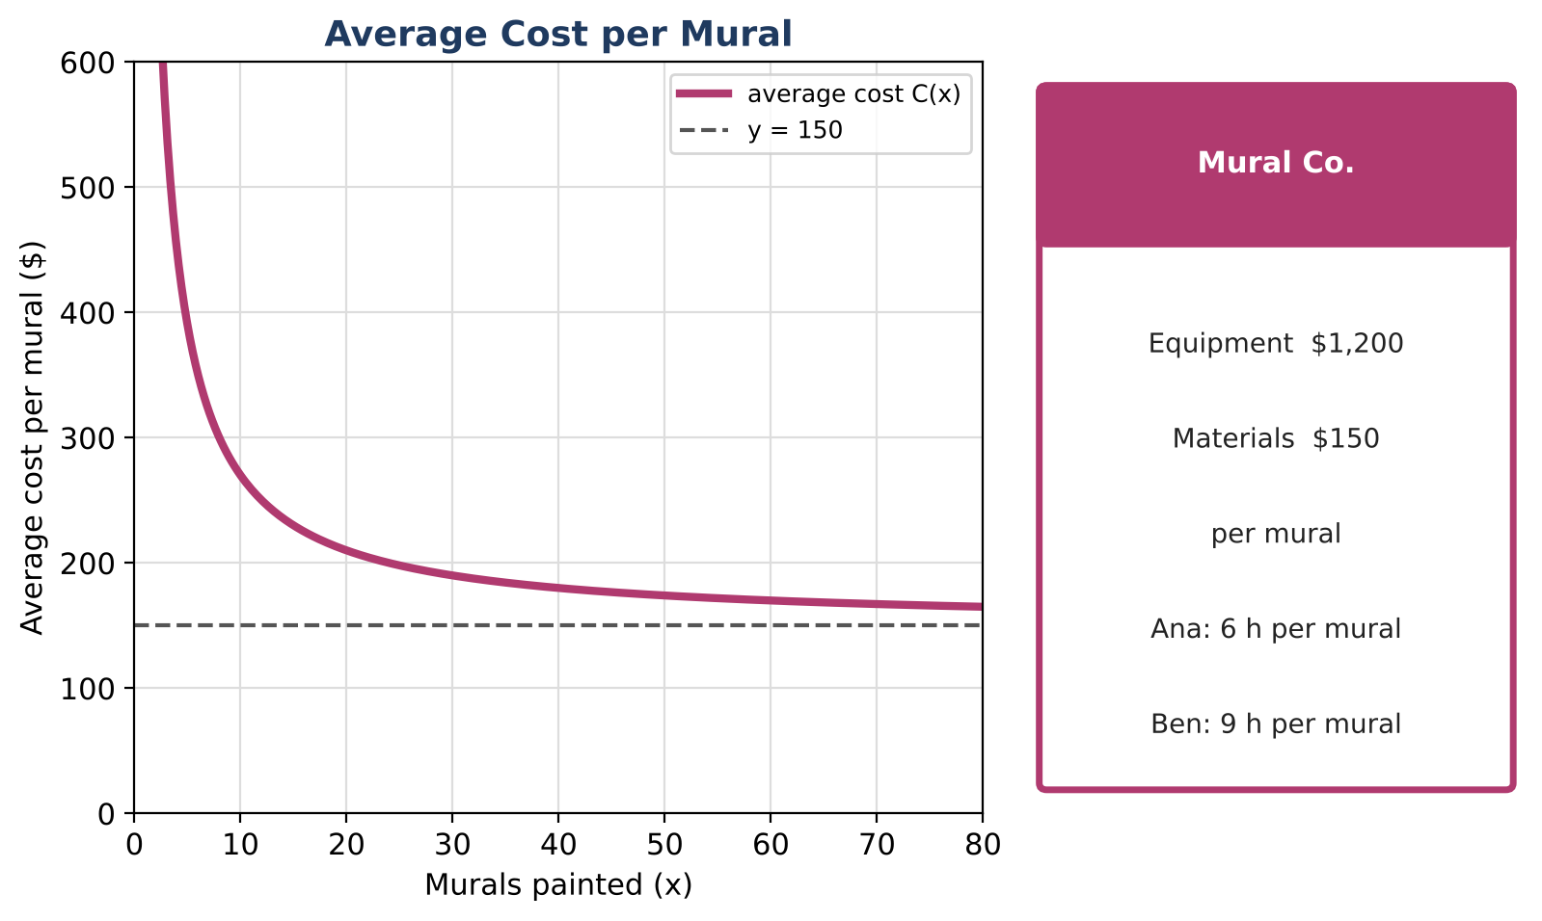
Learning Goals
- I can solve rational equations and inequalities in context.
- I can analyze rational functions completely.
- I can design a pricing model with a rational function.
Project Timeline
When | What you will do
Day 1 | Cost Analysis
Day 2 | Hard Equations
Day 3 | Design a Pricing Model
Final | Business Plan + reflection

Part 1: Cost Analysis
Day 1 · C(x) = (1200 + 150x) ÷ x and a larger studio C₂(x) = (3000 + 120x) ÷ x.
1. Solve C(x) < 175 and interpret the answer.

2. Find where C(x) = C₂(x) and explain which studio to choose for different seasons.

3. Graph both and describe all asymptotes, intercepts, and end behavior.

Part 2: Hard Equations
Day 2 · Check every solution.
4. One painter takes 5 hours longer than another. Together they finish in 6 hours. Find each painter's time.

5. Solve 60 ÷ r + 60 ÷ (r + 10) = 2.7 and interpret both roots.

6. Solve x ÷ (x − 3) − 3 ÷ (x + 3) = 18 ÷ (x² − 9).

Part 3: Design a Pricing Model
Day 3 · Offer a discount: price per mural P(x) = 400 − 600 ÷ (x + 2) for an order of x murals.
7. Find the profit per mural, P(x) − C(x), and simplify into one rational expression.

8. For what order sizes is the profit per mural at least $100? (Use a table or solve.)

9. Write your recommendation.

Final Product: Business Plan
Your final product must include:
- Inequality and comparison analysis
- Solved equations with extraneous solutions identified
- Profit-per-mural model
- Recommendation
Reflection
R1. Why might a rational equation produce an extraneous solution?

R2. How do asymptotes guide business decisions?

Scoring Rubric
Criteria | 4 – Exceeds | 3 – Meets | 2 – Approaching | 1 – Beginning
Mathematical Accuracy | All calculations and solutions are correct; answers include units and are checked. | Nearly all work is correct; minor errors do not change conclusions. | Several errors; some conclusions are affected. | Many errors or missing work.
Reasoning & Justification | Clear, complete explanations connect every answer to the situation; uses precise vocabulary. | Explanations are mostly clear and connected to the situation. | Explanations are brief or partly unclear. | Little or no explanation.
Application & Design | Prices and schedules are based on correctly solved rational equations, with extraneous solutions rejected. Goes beyond the minimum with a creative, realistic choice. | Prices and schedules are based on correctly solved rational equations, with extraneous solutions rejected. | Design is incomplete or only partly uses the math from the unit. | Design is missing or unrelated to the unit math.
Communication & Presentation | Plan includes the average cost function with asymptotes, work-rate schedules, and a pricing decision supported by equations. Polished, organized, and visually engaging. | Plan includes the average cost function with asymptotes, work-rate schedules, and a pricing decision supported by equations. Organized and easy to follow. | Product is missing required parts or is hard to follow. | Product is mostly missing.

