ALGEBRA 2 · UNIT 1: FUNCTIONS & TRANSFORMATIONS  Ride-Share Pricing Lab  Model ride fares with piecewise functions, transformations, composition, and inverses. | CP1  2–3 class periods

Name: ________________________________ Date: ______________ Period: ______
The Scenario
ZipRide is a new ride-share app in town. Its fare depends on miles traveled, but the rate changes after 10 miles, during busy times there is a surge multiplier, and the app is considering a booking fee.
Every one of these rules is a function idea: piecewise definitions, transformations, composition, and inverses. You will analyze ZipRide and then design a plan for a competitor.
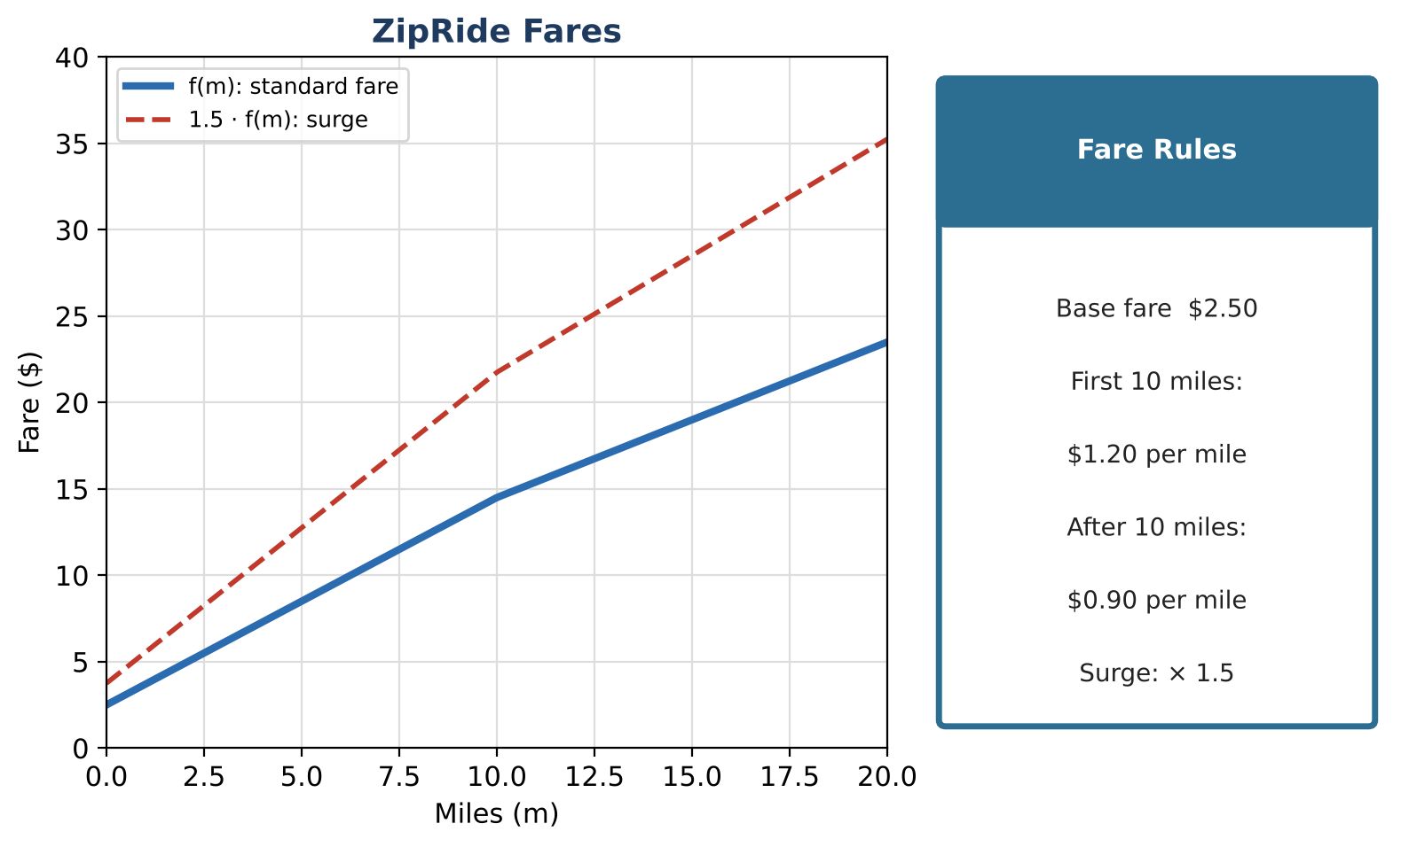
Learning Goals
- I can write and graph piecewise functions.
- I can apply transformations and compositions.
- I can find inverses of piecewise functions.
Project Timeline
When | What you will do
Day 1 | The Fare Function
Day 2 | Compose & Invert
Day 3 | Design a Competitor
Final | Pricing Plan Pitch + reflection

Part 1: The Fare Function
Day 1 · Use the Fare Rules card.
1. Write f(m) as a piecewise function and simplify the second piece to the form am + b.

2. Show that the two pieces meet at m = 10 (the function is continuous).

3. Find the average rate of change from m = 5 to m = 15.

4. Graph f and the surge function 1.5 · f on one set of axes. What changes and what stays the same?

Part 2: Compose & Invert
Day 2 · Write rules, not just values.
5. With m(t) = 0.4t, write f(m(t)) for the first 25 minutes. What does the slope mean?

6. Find f⁻¹(c) for each piece and state the domain of each piece of the inverse.

7. Use f⁻¹ to find how far a rider can go for $19.00 and for $11.50.

8. A competitor charges g(m) = 3.00 + 1.10m for any distance. For which trip lengths is the competitor cheaper?

Part 3: Design a Competitor
Day 3 · Design a two-piece plan that is cheaper than ZipRide for long trips only.
9. Write your piecewise function and show it is continuous.

10. Find exactly where your plan becomes cheaper than ZipRide.

11. Find the inverse of your function's second piece and use it for a customer question.

Final Product: Pricing Plan Pitch
Your final product must include:
- Continuous piecewise plan with graph
- Break-even distance
- Inverse and composition used for customer questions
- Pitch
Reflection
R1. Why does a surge stretch the graph instead of shifting it?

R2. How does an inverse switch the input and output?

Scoring Rubric
Criteria | 4 – Exceeds | 3 – Meets | 2 – Approaching | 1 – Beginning
Mathematical Accuracy | All calculations and solutions are correct; answers include units and are checked. | Nearly all work is correct; minor errors do not change conclusions. | Several errors; some conclusions are affected. | Many errors or missing work.
Reasoning & Justification | Clear, complete explanations connect every answer to the situation; uses precise vocabulary. | Explanations are mostly clear and connected to the situation. | Explanations are brief or partly unclear. | Little or no explanation.
Application & Design | Pricing plan is a correct piecewise function with a correct inverse or composition used to answer a customer question. Goes beyond the minimum with a creative, realistic choice. | Pricing plan is a correct piecewise function with a correct inverse or composition used to answer a customer question. | Design is incomplete or only partly uses the math from the unit. | Design is missing or unrelated to the unit math.
Communication & Presentation | Pitch shows the piecewise fare function, its graph, transformations for fees or surges, and a comparison with ZipRide. Polished, organized, and visually engaging. | Pitch shows the piecewise fare function, its graph, transformations for fees or surges, and a comparison with ZipRide. Organized and easy to follow. | Product is missing required parts or is hard to follow. | Product is mostly missing.

