ALGEBRA 2 · UNIT 1: FUNCTIONS & TRANSFORMATIONS  Ride-Share Pricing Lab  Model ride fares with piecewise functions, transformations, composition, and inverses. | CP2  2–3 class periods

Name: ________________________________ Date: ______________ Period: ______
The Scenario
ZipRide is a new ride-share app in town. Its fare depends on miles traveled, but the rate changes after 10 miles, during busy times there is a surge multiplier, and the app is considering a booking fee.
Every one of these rules is a function idea: piecewise definitions, transformations, composition, and inverses. You will analyze ZipRide and then design a plan for a competitor.
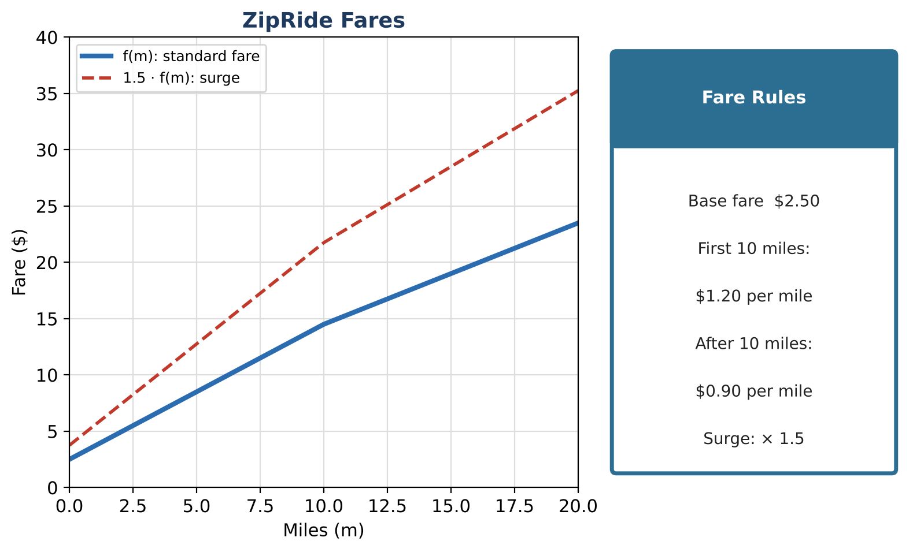
Learning Goals
- I can evaluate and graph a piecewise function.
- I can describe vertical stretches and shifts in context.
- I can use composition and inverses to answer questions.
Project Timeline
When | What you will do
Day 1 | The Fare Function
Day 2 | Surges, Fees & Questions
Day 3 | Design a Competitor
Final | Pricing Plan Pitch + reflection

Part 1: The Fare Function
Day 1 · f(m) = 2.50 + 1.20m for 0 ≤ m ≤ 10, and f(m) = 14.50 + 0.90(m − 10) for m > 10.
1. Find f(4), f(10), and f(15). Explain which rule you used each time.

2. Why does the second rule start with 14.50?

3. Make a table for m = 0, 5, 10, 15, 20 and sketch the graph.

4. What are a reasonable domain and range?

Part 2: Surges, Fees & Questions
Day 2 · Use function language.
5. During a surge, every fare is multiplied by 1.5: S(m) = 1.5 · f(m). Find S(4). Describe the transformation.

6. ZipRide adds a $2 booking fee: B(m) = f(m) + 2. Describe the transformation and find B(15).

7. In traffic, the car travels m(t) = 0.4t miles in t minutes. Find the fare for a 20-minute ride, f(m(20)).

8. A rider has $11.50. Use the inverse idea to find how many miles she can ride (no surge).

Part 3: Design a Competitor
Day 3 · Design fares for a rival app, CityHop.
9. Write a two-piece fare function with a different rate after some distance.

10. Make a table and graph your function with ZipRide's.

11. For what trip lengths is your app cheaper? Explain how you know.

Final Product: Pricing Plan Pitch
Your final product must include:
- Your piecewise fare function and graph
- Comparison with ZipRide
- One surge or fee transformation
- An ad for your app
Reflection
R1. Why do ride-share companies use piecewise pricing?

R2. What does the inverse of a fare function tell a rider?

Scoring Rubric
Criteria | 4 – Exceeds | 3 – Meets | 2 – Approaching | 1 – Beginning
Mathematical Accuracy | All calculations and solutions are correct; answers include units and are checked. | Nearly all work is correct; minor errors do not change conclusions. | Several errors; some conclusions are affected. | Many errors or missing work.
Reasoning & Justification | Clear, complete explanations connect every answer to the situation; uses precise vocabulary. | Explanations are mostly clear and connected to the situation. | Explanations are brief or partly unclear. | Little or no explanation.
Application & Design | Pricing plan is a correct piecewise function with a correct inverse or composition used to answer a customer question. Goes beyond the minimum with a creative, realistic choice. | Pricing plan is a correct piecewise function with a correct inverse or composition used to answer a customer question. | Design is incomplete or only partly uses the math from the unit. | Design is missing or unrelated to the unit math.
Communication & Presentation | Pitch shows the piecewise fare function, its graph, transformations for fees or surges, and a comparison with ZipRide. Polished, organized, and visually engaging. | Pitch shows the piecewise fare function, its graph, transformations for fees or surges, and a comparison with ZipRide. Organized and easy to follow. | Product is missing required parts or is hard to follow. | Product is mostly missing.

