ALGEBRA 2 · UNIT 1: FUNCTIONS & TRANSFORMATIONS  Ride-Share Pricing Lab  Model ride fares with piecewise functions, transformations, composition, and inverses. | Honors  2–3 class periods

Name: ________________________________ Date: ______________ Period: ______
The Scenario
ZipRide is a new ride-share app in town. Its fare depends on miles traveled, but the rate changes after 10 miles, during busy times there is a surge multiplier, and the app is considering a booking fee.
Every one of these rules is a function idea: piecewise definitions, transformations, composition, and inverses. You will analyze ZipRide and then design a plan for a competitor.
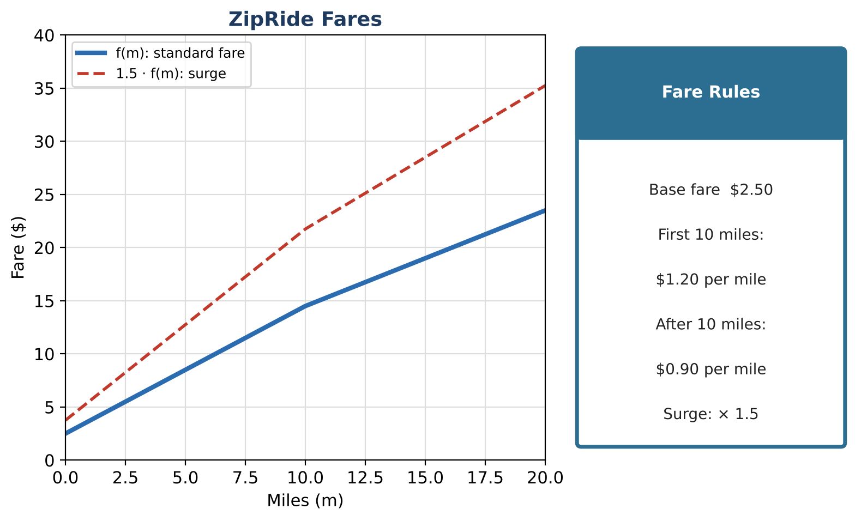
Learning Goals
- I can analyze transformations and their order.
- I can find inverses of composed and piecewise functions with domains.
- I can design a function that meets several conditions.
Project Timeline
When | What you will do
Day 1 | Fare Functions
Day 2 | Composition & Inverse
Day 3 | Engineer a Plan
Final | Pricing Plan Pitch + reflection

Part 1: Fare Functions
Day 1 · Use the Fare Rules card.
1. Write f(m) piecewise and find its domain and range. Is f one-to-one? Explain.

2. Compare F₁(m) = 1.5(f(m) + 2) and F₂(m) = 1.5 · f(m) + 2. Which is fair to riders, and how much do they differ?

3. Describe F₁ as a sequence of transformations of f, in order.

Part 2: Composition & Inverse
Day 2 · Exact rules with domains.
4. Traffic: m(t) = 0.4t for 0 ≤ t ≤ 15 and m(t) = 6 + 0.8(t − 15) for t > 15. Write f(m(t)) as a piecewise function of t.

5. Find the inverse of f(m(t)) and use it to find the ride time for a $19.00 fare.

6. Prove that (f⁻¹ ∘ f)(m) = m for m > 10.

Part 3: Engineer a Plan
Day 3 · Conditions: continuous; base fare between $2 and $4; the 8-mile fare is $11; the 20-mile fare is $20.
7. Design a two-piece plan that meets every condition. Show your algebra.

8. Find where your plan and ZipRide cost the same.

9. Write the inverse and explain one marketing use.

Final Product: Pricing Plan Pitch
Your final product must include:
- Piecewise analysis and transformation comparison
- Composed piecewise function and its inverse
- Engineered plan meeting all conditions
- Pitch
Reflection
R1. Why does the order of a fee and a surge matter?

R2. How do domains of the pieces become ranges of the inverse pieces?

Scoring Rubric
Criteria | 4 – Exceeds | 3 – Meets | 2 – Approaching | 1 – Beginning
Mathematical Accuracy | All calculations and solutions are correct; answers include units and are checked. | Nearly all work is correct; minor errors do not change conclusions. | Several errors; some conclusions are affected. | Many errors or missing work.
Reasoning & Justification | Clear, complete explanations connect every answer to the situation; uses precise vocabulary. | Explanations are mostly clear and connected to the situation. | Explanations are brief or partly unclear. | Little or no explanation.
Application & Design | Pricing plan is a correct piecewise function with a correct inverse or composition used to answer a customer question. Goes beyond the minimum with a creative, realistic choice. | Pricing plan is a correct piecewise function with a correct inverse or composition used to answer a customer question. | Design is incomplete or only partly uses the math from the unit. | Design is missing or unrelated to the unit math.
Communication & Presentation | Pitch shows the piecewise fare function, its graph, transformations for fees or surges, and a comparison with ZipRide. Polished, organized, and visually engaging. | Pitch shows the piecewise fare function, its graph, transformations for fees or surges, and a comparison with ZipRide. Organized and easy to follow. | Product is missing required parts or is hard to follow. | Product is mostly missing.

