ALGEBRA 1 · UNIT 5: LINEAR FUNCTIONS AND GRAPHING  Mountain Trail Designer  Rate ski trails by slope and design a new run for Pine Ridge Mountain. | CP1  2–3 class periods

Name: ________________________________ Date: ______________ Period: ______
The Scenario
Pine Ridge Mountain is opening for the season, and the resort needs every trail rated before skiers arrive. Ratings depend on how steep a trail is, and steepness is slope!
The profile map shows each trail as a line segment between two points. The x-coordinate is the horizontal distance from the summit and the y-coordinate is the elevation, both in hundreds of feet. Your job: rate the trails, write their equations, and design a new trail.
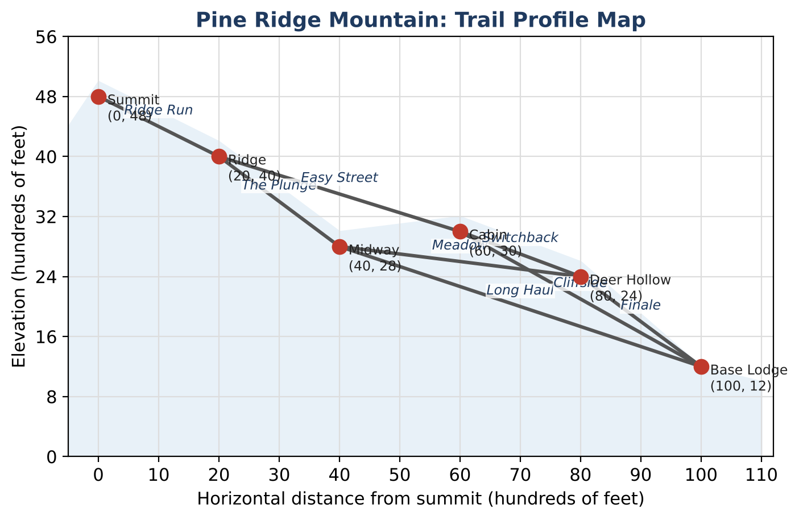
Learning Goals
- I can calculate and interpret slope from coordinates and tables.
- I can write linear equations in slope-intercept and point-slope form.
- I can use parallel and perpendicular slopes in a design.
Project Timeline
When | What you will do
Day 1 | Rate the Trails
Day 2 | Trail & Lift Equations
Day 3 | Design a Beginner Route
Final | New Trail Map + reflection

Part 1: Rate the Trails
Day 1 · Use the trail map and the rating card.
1. Find the slope, steepness, and rating of every trail.
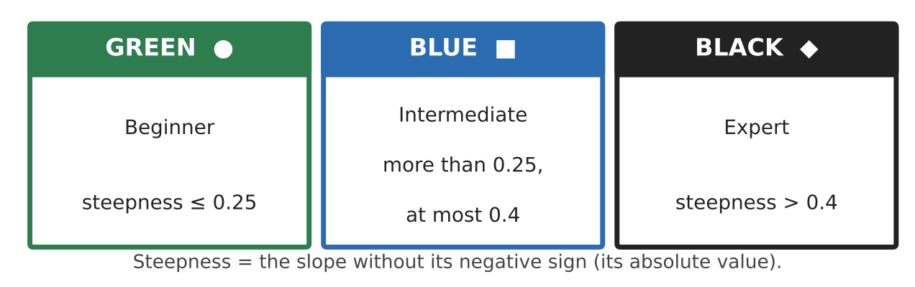
Trail | Slope | Steepness | Rating
Ridge Run
The Plunge
Long Haul
Easy Street
Cliffside
Meadow
Switchback
Finale

2. Explain why a slope of −0.6 is steeper than a slope of −0.25 even though −0.6 is less than −0.25.

3. Is there a route from the Summit to the Base Lodge with no black trails? Justify with your table.

4. Ridge Run drops 800 feet. How many feet does a skier travel horizontally on Ridge Run? Use the slope to explain.

Part 2: Trail & Lift Equations
Day 2 · Write each equation in slope-intercept form unless told otherwise.
5. Write the equation of Easy Street using point-slope form, then rewrite it in slope-intercept form.

6. Write the equation of the chairlift from (100, 12) to (0, 48). At what x-value is the lift at an elevation of 2,400 feet?

7. A new snow fence must run perpendicular to Ridge Run and pass through the Ridge (20, 40). Write its equation.

8. A snow groomer's elevation is shown in the table. Write an equation and find when it reaches 4,800 feet.
Time t (min) | 2 | 6 | 10 | 14
Elevation (ft) | 1,320 | 1,560 | 1,800 | 2,040

Part 3: Design a Beginner Route
Day 3 · Create a route from the Summit to a base where every trail is green or blue.
9. Add one or two new points. Draw your new trails on the map and give the coordinates.

10. Show the slope and rating of every trail on your route.

11. Write the equation of each new trail. One new trail must be parallel to an existing trail. Prove it with slopes.

Final Product: New Trail Map
Your final product must include:
- Trail map colored by rating with slopes labeled
- Equations for Easy Street, the chairlift, and the snow fence
- Groomer equation and solution
- Your beginner route with slopes, ratings, and equations
- Proof that one new trail is parallel to an existing one
Reflection
R1. How are the slopes of parallel lines and perpendicular lines related? Why?

R2. Explain what the slope of the groomer equation means in words.

Scoring Rubric
Criteria | 4 – Exceeds | 3 – Meets | 2 – Approaching | 1 – Beginning
Mathematical Accuracy | All calculations and solutions are correct; answers include units and are checked. | Nearly all work is correct; minor errors do not change conclusions. | Several errors; some conclusions are affected. | Many errors or missing work.
Reasoning & Justification | Clear, complete explanations connect every answer to the situation; uses precise vocabulary. | Explanations are mostly clear and connected to the situation. | Explanations are brief or partly unclear. | Little or no explanation.
Application & Design | New trail meets the rating requirements, with slopes and equations shown. Goes beyond the minimum with a creative, realistic choice. | New trail meets the rating requirements, with slopes and equations shown. | Design is incomplete or only partly uses the math from the unit. | Design is missing or unrelated to the unit math.
Communication & Presentation | Trail map is labeled with points, slopes, ratings, and equations. Polished, organized, and visually engaging. | Trail map is labeled with points, slopes, ratings, and equations. Organized and easy to follow. | Product is missing required parts or is hard to follow. | Product is mostly missing.

