ALGEBRA 1 · UNIT 5: LINEAR FUNCTIONS AND GRAPHING  Mountain Trail Designer  Rate ski trails by slope and design a new run for Pine Ridge Mountain. | CP2  2–3 class periods

Name: ________________________________ Date: ______________ Period: ______
The Scenario
Pine Ridge Mountain is opening for the season, and the resort needs every trail rated before skiers arrive. Ratings depend on how steep a trail is, and steepness is slope!
The profile map shows each trail as a line segment between two points. The x-coordinate is the horizontal distance from the summit and the y-coordinate is the elevation, both in hundreds of feet. Your job: rate the trails, write their equations, and design a new trail.
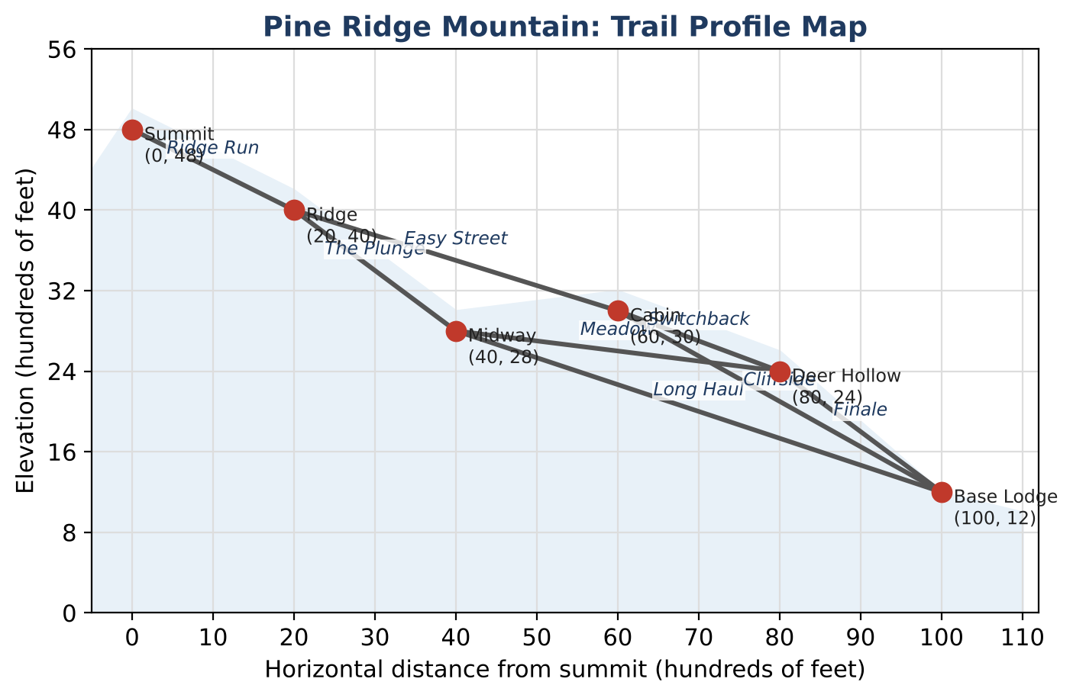
Learning Goals
- I can find the slope between two points and explain what it means.
- I can use slope to compare steepness.
- I can write the equation of a line in slope-intercept form.
Project Timeline
When | What you will do
Day 1 | Rate the Trails
Day 2 | Trail Equations
Day 3 | Design a New Trail
Final | New Trail Map + reflection

Part 1: Rate the Trails
Day 1 · Use the trail map and the rating card. Slope = rise ÷ run.
1. Use the rating card to answer: What rating does a trail with a slope of −0.3 get? Explain how you decided.
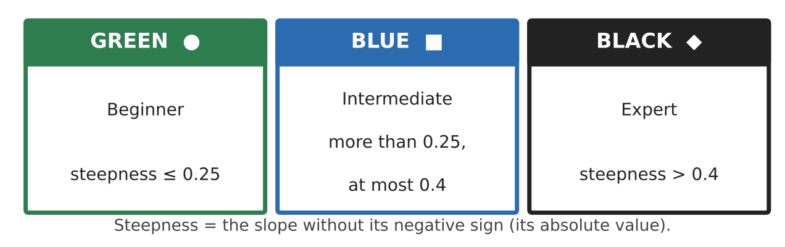

2. Complete the table. The first row is done for you.
Trail | Start | End | Rise | Run | Slope | Rating
Ridge Run | (0, 48) | (20, 40) | −8 | 20 | −0.4 | Blue
The Plunge | (20, 40) | (40, 28)
Easy Street | (20, 40) | (60, 30)
Meadow | (40, 28) | (80, 24)
Finale | (80, 24) | (100, 12)
Long Haul | (40, 28) | (100, 12)

3. Which trail is the steepest? Which is the least steep? Use the slopes to explain.

4. A beginner wants to ski from the Summit to the Base Lodge using only green and blue trails. Is it possible? Use the map to explain.

Part 2: Trail Equations
Day 2 · Each trail lies on a line. Write equations in the form y = mx + b.
5. Ridge Run starts at (0, 48). Write its equation. What does the 48 mean on the mountain?
Starter: y = (slope)x + (starting elevation)

6. The chairlift runs straight from the Base Lodge (100, 12) to the Summit (0, 48). Find its slope and write its equation.

7. Use your chairlift equation to find the elevation of the lift at x = 50.

8. A snow groomer climbs the mountain. Find its rate of change and write an equation for its elevation y (in feet) after t minutes. When will it reach the summit elevation of 4,800 feet?
Time t (min) | 0 | 5 | 10 | 15
Elevation (ft) | 1,200 | 1,500 | 1,800 | 2,100

Part 3: Design a New Trail
Day 3 · The resort wants beginners to reach the Base Lodge without any black trails.
9. Add one new point to the map (your choice). Draw a new trail from an existing point to your new point, and a trail from your new point to the Base Lodge (or a new base). Record the coordinates.

10. Find the slope and rating of each new trail. Both must be green or blue.

11. Give your trails names and write the full beginner route from the Summit to the base.

Final Product: New Trail Map
Your final product must include:
- The trail map with every trail colored by rating
- Your slope table
- The equation of Ridge Run and the chairlift
- Your new trails with slopes, ratings, and names
- A short safety message for beginners
Reflection
R1. Why do we use the absolute value of the slope to decide how steep a trail is?

R2. How did you choose your new point so that both of your trails were safe for beginners?

Scoring Rubric
Criteria | 4 – Exceeds | 3 – Meets | 2 – Approaching | 1 – Beginning
Mathematical Accuracy | All calculations and solutions are correct; answers include units and are checked. | Nearly all work is correct; minor errors do not change conclusions. | Several errors; some conclusions are affected. | Many errors or missing work.
Reasoning & Justification | Clear, complete explanations connect every answer to the situation; uses precise vocabulary. | Explanations are mostly clear and connected to the situation. | Explanations are brief or partly unclear. | Little or no explanation.
Application & Design | New trail meets the rating requirements, with slopes and equations shown. Goes beyond the minimum with a creative, realistic choice. | New trail meets the rating requirements, with slopes and equations shown. | Design is incomplete or only partly uses the math from the unit. | Design is missing or unrelated to the unit math.
Communication & Presentation | Trail map is labeled with points, slopes, ratings, and equations. Polished, organized, and visually engaging. | Trail map is labeled with points, slopes, ratings, and equations. Organized and easy to follow. | Product is missing required parts or is hard to follow. | Product is mostly missing.

