ALGEBRA 1 · UNIT 5: LINEAR FUNCTIONS AND GRAPHING  Mountain Trail Designer  Rate ski trails by slope and design a new run for Pine Ridge Mountain. | Honors  2–3 class periods

Name: ________________________________ Date: ______________ Period: ______
The Scenario
Pine Ridge Mountain is opening for the season, and the resort needs every trail rated before skiers arrive. Ratings depend on how steep a trail is, and steepness is slope!
The profile map shows each trail as a line segment between two points. The x-coordinate is the horizontal distance from the summit and the y-coordinate is the elevation, both in hundreds of feet. Your job: rate the trails, write their equations, and design a new trail.
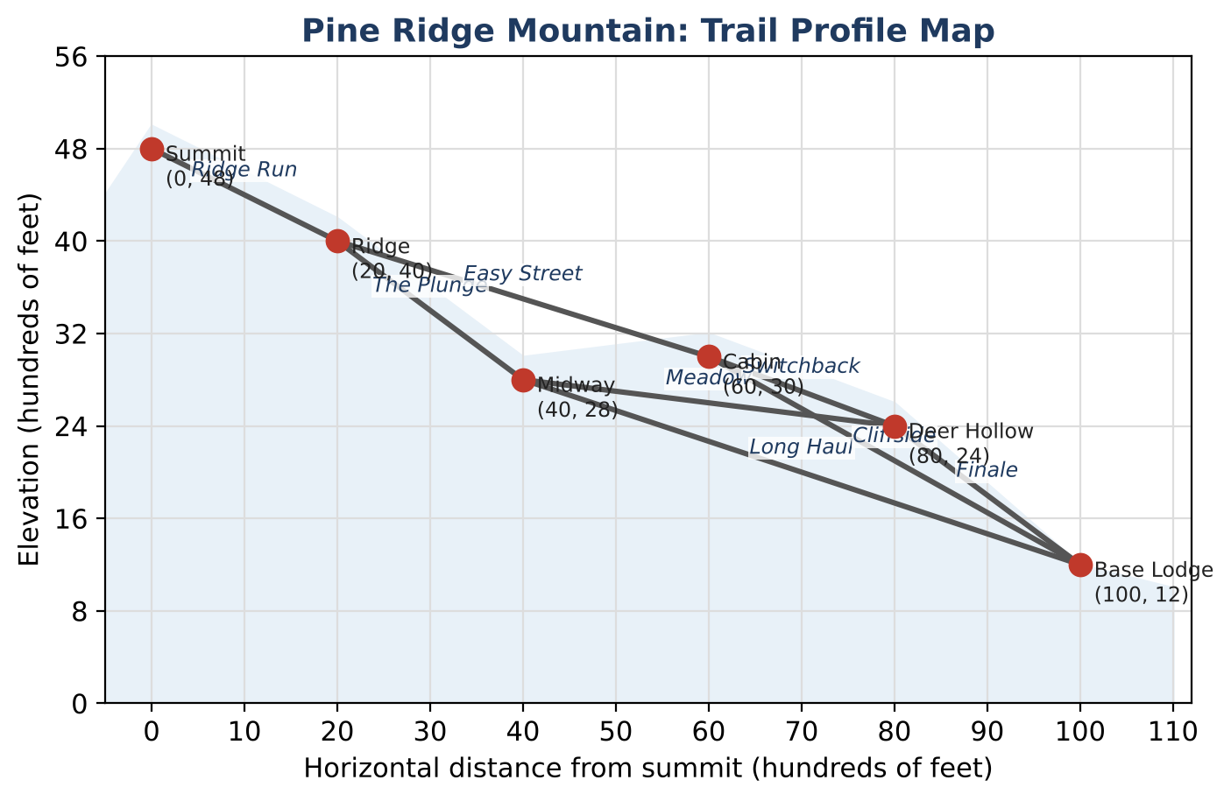
Learning Goals
- I can express slope ratings as absolute value inequalities and percent grades.
- I can write equations in slope-intercept, point-slope, and standard form.
- I can design a route by solving inequalities for an unknown coordinate.
Project Timeline
When | What you will do
Day 1 | Ratings as Inequalities
Day 2 | Equations & Relationships
Day 3 | Engineer an All-Blue Route
Final | New Trail Map + reflection

Part 1: Ratings as Inequalities
Day 1 · Use the map and rating card. Let m be the slope of a trail.
1. Write each rating as an inequality using |m|.
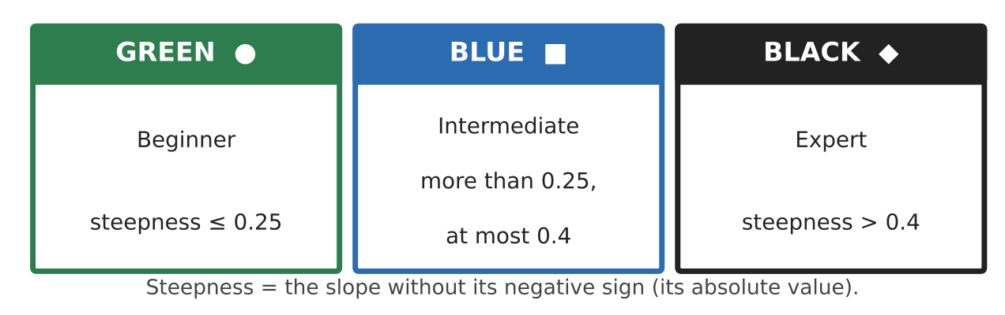

2. Find the slope and rating of every trail. Record them in the table.
Trail | Slope | Steepness | Rating
Ridge Run
The Plunge
Long Haul
Easy Street
Cliffside
Meadow
Switchback
Finale

3. Ski resorts often give the grade as a percent: grade = 100|m|%. Find the grade of the steepest and least steep trails.

4. Prove that no all-green-or-blue route exists from the Summit to the Base Lodge.

Part 2: Equations & Relationships
Day 2 · Use exact values.
5. Write the equation of the chairlift in slope-intercept form and in standard form Ax + By = C (A, B, and C integers).

6. Show that the Ridge Run line and the Midway-to-Deer Hollow line are not parallel, and find where the two lines (extended) intersect.

7. A snow fence through the Cabin (60, 30) must be perpendicular to Cliffside. Write its equation in standard form.

8. The groomer's elevation is a linear function of time with f(2) = 1,320 and f(14) = 2,040. Write f(t) and find the time when f(t) = 4,800.

Part 3: Engineer an All-Blue Route
Day 3 · The resort will add a new point E at x = 60 so that Ridge (20, 40) → E → Base Lodge (100, 12) is a route of blue trails.
9. Let E = (60, y). Write a compound inequality for the steepness of Ridge-to-E so that it is blue, and solve for y.

10. Do the same for E-to-Base Lodge.

11. Find all values of y that make both trails blue. Choose one value, write both trail equations, and add the route to your map with a recommendation.

Final Product: New Trail Map
Your final product must include:
- Rating inequalities and the complete slope table with percent grades
- Equations in multiple forms (chairlift, snow fence, groomer)
- The intersection of the two extended trail lines
- The compound inequality for E and your chosen design
- A labeled map with the new all-blue route
Reflection
R1. How did solving for y in Part 3 turn a design problem into an inequality problem?

R2. When is standard form more useful than slope-intercept form?

Scoring Rubric
Criteria | 4 – Exceeds | 3 – Meets | 2 – Approaching | 1 – Beginning
Mathematical Accuracy | All calculations and solutions are correct; answers include units and are checked. | Nearly all work is correct; minor errors do not change conclusions. | Several errors; some conclusions are affected. | Many errors or missing work.
Reasoning & Justification | Clear, complete explanations connect every answer to the situation; uses precise vocabulary. | Explanations are mostly clear and connected to the situation. | Explanations are brief or partly unclear. | Little or no explanation.
Application & Design | New trail meets the rating requirements, with slopes and equations shown. Goes beyond the minimum with a creative, realistic choice. | New trail meets the rating requirements, with slopes and equations shown. | Design is incomplete or only partly uses the math from the unit. | Design is missing or unrelated to the unit math.
Communication & Presentation | Trail map is labeled with points, slopes, ratings, and equations. Polished, organized, and visually engaging. | Trail map is labeled with points, slopes, ratings, and equations. Organized and easy to follow. | Product is missing required parts or is hard to follow. | Product is mostly missing.

