ALGEBRA 1 · UNIT 10: FACTORING AND ZERO PRODUCT PROPERTY  Packaging Engineer  Factor area and volume expressions to design boxes and labels. | CP1  2–3 class periods

Name: ________________________________ Date: ______________ Period: ______
The Scenario
Pack-It Packaging designs boxes, labels, and posters for local businesses. Customers usually tell the company the AREA or VOLUME they need, and the engineers must work backward to find the dimensions.
Working backward from area is factoring! When a customer gives an exact area, you will set up a quadratic equation and solve it with the Zero Product Property. Then you will design a box from a flat sheet of cardboard.
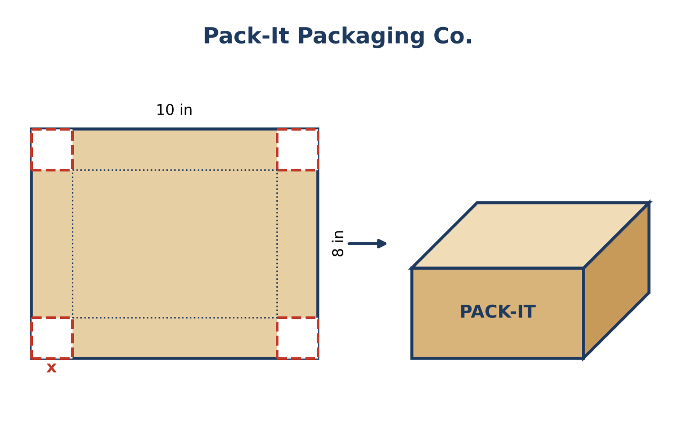
Learning Goals
- I can factor polynomials using GCF, trinomials, grouping, and special patterns.
- I can solve quadratic equations by factoring in context.
- I can explain which solutions are reasonable.
Project Timeline
When | What you will do
Day 1 | Area & Volume to Dimensions
Day 2 | Exact Size Orders
Day 3 | Design a Box
Final | Box Design Spec Sheet + reflection

Part 1: Area & Volume to Dimensions
Day 1 · Factor completely to find dimensions.
1. A box has volume 2x³ + 10x² + 12x. Factor completely to find three dimensions.

2. Labels have areas 2x² + 7x + 3 and 3x² − 10x − 8. Factor each.

3. A shipping crate has volume x³ + 3x² + 4x + 12. Factor by grouping.

4. Explain, using the cut-square picture, why x² − 16 = (x + 4)(x − 4).
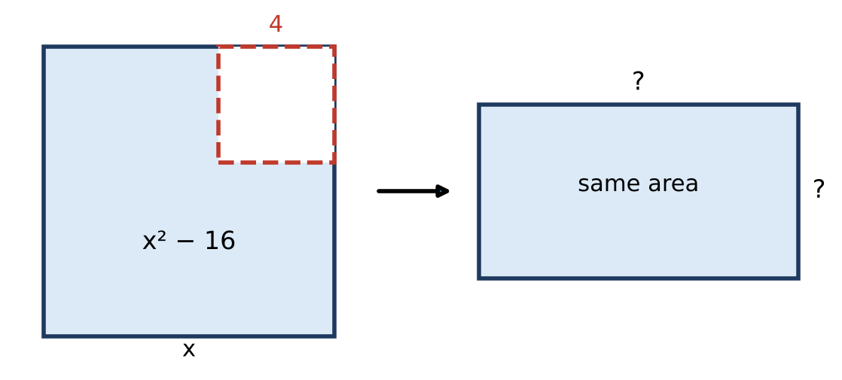

Part 2: Exact Size Orders
Day 2 · Write an equation, solve by factoring, and reject any solution that doesn't make sense.
5. A label's length is 3 inches more than twice its width. Its area is 44 square inches. Find its dimensions.

6. A 20 in by 30 in poster gets a frame of width x all the way around. The framed poster has an area of 704 square inches. Find x.

7. Cut squares of side x from a 10 in by 8 in sheet. The base must be 48 square inches. Find x and the volume.

8. Solve 3x² − 10x = 8 and decide which solution could be a length.

Part 3: Design a Box
Day 3 · Design an open box from a rectangular sheet of your choice (whole-number dimensions).
9. Choose your sheet size and a target base area that gives a whole-number cut size. Write and solve the equation.

10. Find the box's dimensions and volume. Explain why one solution must be rejected.

11. Write a spec sheet entry giving the base area in factored form and the volume as a factored polynomial in x.

Final Product: Box Design Spec Sheet
Your final product must include:
- Factored dimensions for every label and box
- Solutions to all exact-size orders with rejected solutions explained
- Your box design with equation, dimensions, and volume
- A spec sheet with factored expressions
Reflection
R1. How do you decide which factoring method to try first?

R2. Why does a frame problem always give one negative solution?

Scoring Rubric
Criteria | 4 – Exceeds | 3 – Meets | 2 – Approaching | 1 – Beginning
Mathematical Accuracy | All calculations and solutions are correct; answers include units and are checked. | Nearly all work is correct; minor errors do not change conclusions. | Several errors; some conclusions are affected. | Many errors or missing work.
Reasoning & Justification | Clear, complete explanations connect every answer to the situation; uses precise vocabulary. | Explanations are mostly clear and connected to the situation. | Explanations are brief or partly unclear. | Little or no explanation.
Application & Design | Box design meets the customer's area or volume exactly, and impossible solutions are rejected with a reason. Goes beyond the minimum with a creative, realistic choice. | Box design meets the customer's area or volume exactly, and impossible solutions are rejected with a reason. | Design is incomplete or only partly uses the math from the unit. | Design is missing or unrelated to the unit math.
Communication & Presentation | Spec sheet shows the factored dimensions, the equation solved with the Zero Product Property, and a labeled net or drawing. Polished, organized, and visually engaging. | Spec sheet shows the factored dimensions, the equation solved with the Zero Product Property, and a labeled net or drawing. Organized and easy to follow. | Product is missing required parts or is hard to follow. | Product is mostly missing.

