ALGEBRA 1 · UNIT 10: FACTORING AND ZERO PRODUCT PROPERTY  Packaging Engineer  Factor area and volume expressions to design boxes and labels. | CP2  2–3 class periods

Name: ________________________________ Date: ______________ Period: ______
The Scenario
Pack-It Packaging designs boxes, labels, and posters for local businesses. Customers usually tell the company the AREA or VOLUME they need, and the engineers must work backward to find the dimensions.
Working backward from area is factoring! When a customer gives an exact area, you will set up a quadratic equation and solve it with the Zero Product Property. Then you will design a box from a flat sheet of cardboard.
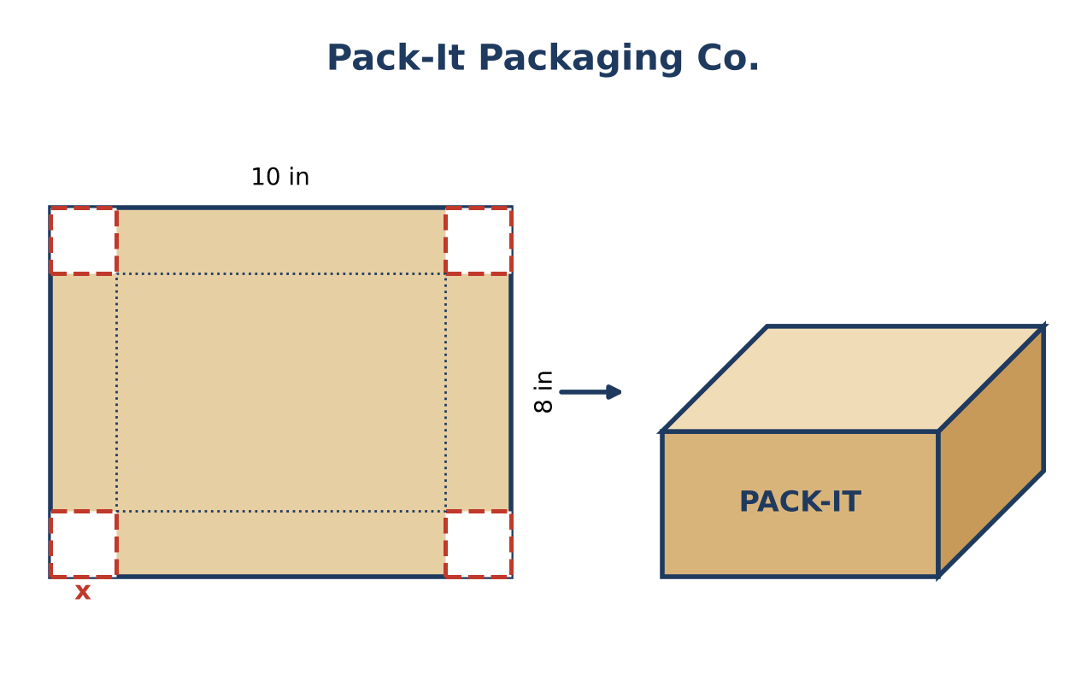
Learning Goals
- I can factor to find the dimensions of a rectangle from its area.
- I can use the Zero Product Property to solve quadratic equations.
- I can decide which solutions make sense for a length.
Project Timeline
When | What you will do
Day 1 | Area to Dimensions
Day 2 | Exact Size Orders
Day 3 | Build a Box
Final | Box Design Spec Sheet + reflection

Part 1: Area to Dimensions
Day 1 · Each area is length × width. Factor to find possible dimensions.
1. A label has area 6x² + 9x. Factor out the GCF to find its dimensions.
Starter: GCF = 3x

2. A box base has area x² + 7x + 12. Factor to find the dimensions.
Starter: Two numbers that multiply to 12 and add to 7

3. A square sticker has area x² + 10x + 25. What is the length of one side?

4. A square sheet x by x has a 4 by 4 square cut from its corner. The area left is x² − 16. Factor it to find the dimensions of a rectangle with the same area.
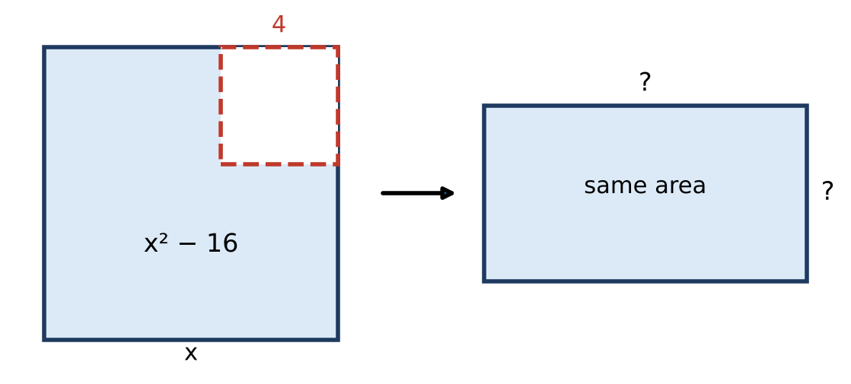

Part 2: Exact Size Orders
Day 2 · Set the area equal to the order, move everything to one side, factor, and use the Zero Product Property.
5. Solve (x + 3)(x − 2) = 0. Which solution could be a length? Explain.

6. A customer wants the base from #2, (x + 3)(x + 4), to have an area of exactly 30 square inches. Find x and the base's dimensions.
Starter: x² + 7x + 12 = 30 → x² + 7x − 18 = 0

7. A square label has side (x + 2) and area 49 square inches. Write and solve an equation for x.

8. A sticker has area x² − 3x and must be 10 square inches. Find x.

Part 3: Build a Box
Day 3 · Cut a square of side x from each corner of a 10 in by 8 in sheet and fold up the sides.
9. Write the length and width of the box's base in terms of x.

10. The base must have an area of 48 square inches. Solve (10 − 2x)(8 − 2x) = 48. Which answer works? Why?

11. Find the volume of your box. Then design a label for its front and write the label's area as a factored expression.

Final Product: Box Design Spec Sheet
Your final product must include:
- Factored dimensions for the labels and base
- Each exact-size order solved with the Zero Product Property
- Your box: cut size, dimensions, volume
- A drawing or net of your box with labels
- One sentence explaining a solution you rejected
Reflection
R1. Why do we need one side of the equation to equal 0 before using the Zero Product Property?

R2. Why did we reject some solutions in this project?

Scoring Rubric
Criteria | 4 – Exceeds | 3 – Meets | 2 – Approaching | 1 – Beginning
Mathematical Accuracy | All calculations and solutions are correct; answers include units and are checked. | Nearly all work is correct; minor errors do not change conclusions. | Several errors; some conclusions are affected. | Many errors or missing work.
Reasoning & Justification | Clear, complete explanations connect every answer to the situation; uses precise vocabulary. | Explanations are mostly clear and connected to the situation. | Explanations are brief or partly unclear. | Little or no explanation.
Application & Design | Box design meets the customer's area or volume exactly, and impossible solutions are rejected with a reason. Goes beyond the minimum with a creative, realistic choice. | Box design meets the customer's area or volume exactly, and impossible solutions are rejected with a reason. | Design is incomplete or only partly uses the math from the unit. | Design is missing or unrelated to the unit math.
Communication & Presentation | Spec sheet shows the factored dimensions, the equation solved with the Zero Product Property, and a labeled net or drawing. Polished, organized, and visually engaging. | Spec sheet shows the factored dimensions, the equation solved with the Zero Product Property, and a labeled net or drawing. Organized and easy to follow. | Product is missing required parts or is hard to follow. | Product is mostly missing.

