ALGEBRA 1 · UNIT 10: FACTORING AND ZERO PRODUCT PROPERTY  Packaging Engineer  Factor area and volume expressions to design boxes and labels. | Honors  2–3 class periods

Name: ________________________________ Date: ______________ Period: ______
The Scenario
Pack-It Packaging designs boxes, labels, and posters for local businesses. Customers usually tell the company the AREA or VOLUME they need, and the engineers must work backward to find the dimensions.
Working backward from area is factoring! When a customer gives an exact area, you will set up a quadratic equation and solve it with the Zero Product Property. Then you will design a box from a flat sheet of cardboard.
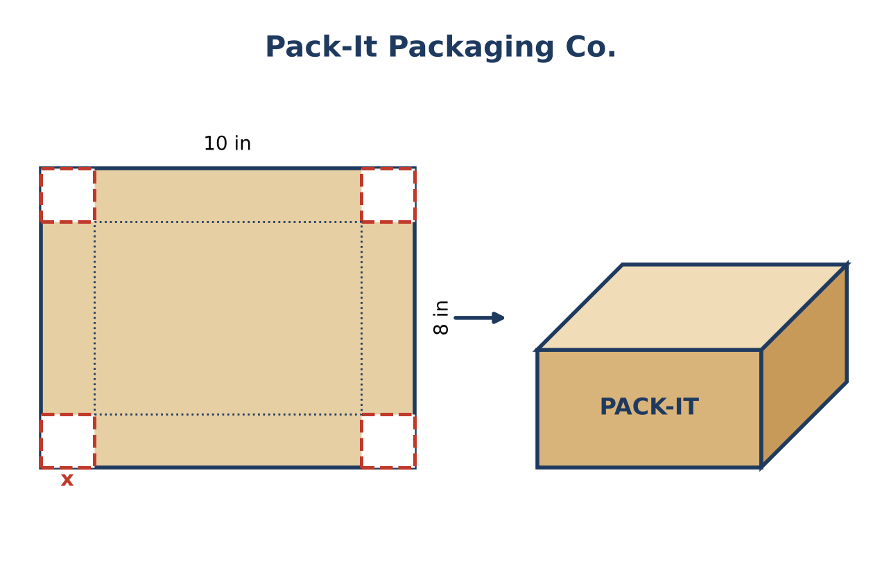
Learning Goals
- I can factor completely using every method, including higher-degree polynomials.
- I can solve polynomial equations by factoring and interpret restrictions on x.
- I can design a package that meets exact specifications.
Project Timeline
When | What you will do
Day 1 | Factor Completely
Day 2 | Exact Size Orders
Day 3 | Engineer a Package
Final | Box Design Spec Sheet + reflection

Part 1: Factor Completely
Day 1 · Factor completely. Name each method you use.
1. 4x³ − 36x and x⁴ − 16

2. A crate has volume V(x) = x³ + 3x² − 4x − 12. Factor it completely to find its dimensions.

3. For which values of x does the crate in #2 exist (all dimensions positive)? Find its volume when x = 5 two ways.

4. Show that x² − 16 = (x + 4)(x − 4) using the cut-square picture, and use the same idea to explain why x² + 16 cannot be factored over the integers.
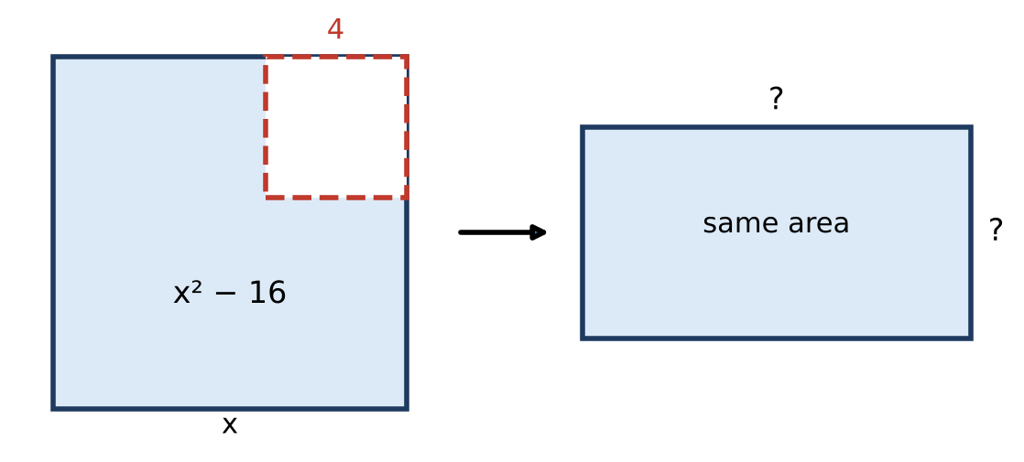

Part 2: Exact Size Orders
Day 2 · Write and solve each equation. Justify every rejected solution.
5. Squares of side x are cut from a 12 in by 12 in sheet. The base must be 64 square inches. Find x and the volume.

6. A 20 in by 30 in poster gets a frame of width x. The frame itself (not the poster) has an area of 104 square inches. Find x.

7. Solve 6x² + x = 15. Which solution could be a length?

8. Find every x with V(x) = 0 for V(x) = x³ + 3x² − 4x − 12. Explain what these values mean for the crate.

Part 3: Engineer a Package
Day 3 · A customer wants an open box from a 16 in by 10 in sheet with a base area of 72 square inches.
9. Write and solve the equation. Find the box's volume.

10. Explain the restriction on x (the values that give a real box) and use it to reject a solution.

11. Design your own order: choose a sheet and a base area so that the cut size is a whole number. Write a spec sheet with the factored base area and the volume polynomial.

Final Product: Box Design Spec Sheet
Your final product must include:
- Complete factorizations with methods named
- Crate analysis with the domain restriction
- Solutions to every exact-size order
- Engineered package for the customer
- Your own order with spec sheet
Reflection
R1. How does the factored form of a volume show when the box would have zero volume?

R2. Why does each real-world problem have a restricted domain for x?

Scoring Rubric
Criteria | 4 – Exceeds | 3 – Meets | 2 – Approaching | 1 – Beginning
Mathematical Accuracy | All calculations and solutions are correct; answers include units and are checked. | Nearly all work is correct; minor errors do not change conclusions. | Several errors; some conclusions are affected. | Many errors or missing work.
Reasoning & Justification | Clear, complete explanations connect every answer to the situation; uses precise vocabulary. | Explanations are mostly clear and connected to the situation. | Explanations are brief or partly unclear. | Little or no explanation.
Application & Design | Box design meets the customer's area or volume exactly, and impossible solutions are rejected with a reason. Goes beyond the minimum with a creative, realistic choice. | Box design meets the customer's area or volume exactly, and impossible solutions are rejected with a reason. | Design is incomplete or only partly uses the math from the unit. | Design is missing or unrelated to the unit math.
Communication & Presentation | Spec sheet shows the factored dimensions, the equation solved with the Zero Product Property, and a labeled net or drawing. Polished, organized, and visually engaging. | Spec sheet shows the factored dimensions, the equation solved with the Zero Product Property, and a labeled net or drawing. Organized and easy to follow. | Product is missing required parts or is hard to follow. | Product is mostly missing.

