ALGEBRA 1 · UNIT 4: RELATIONS AND FUNCTIONS  Roller Coaster Designer  Use functions to analyze a coaster ride and design your own. | CP1  2–3 class periods

Name: ________________________________ Date: ______________ Period: ______
The Scenario
Thunder Ridge Park is building a new roller coaster, and your team has been hired as ride designers. Before you build your own coaster, you need to study the park's current ride, Thunder Ridge.
Engineers describe a coaster with functions: the height of a car depends on time, the wait in line depends on your place, and every rider is assigned to exactly one car. You will analyze these functions and then design a coaster that meets the park's rules.
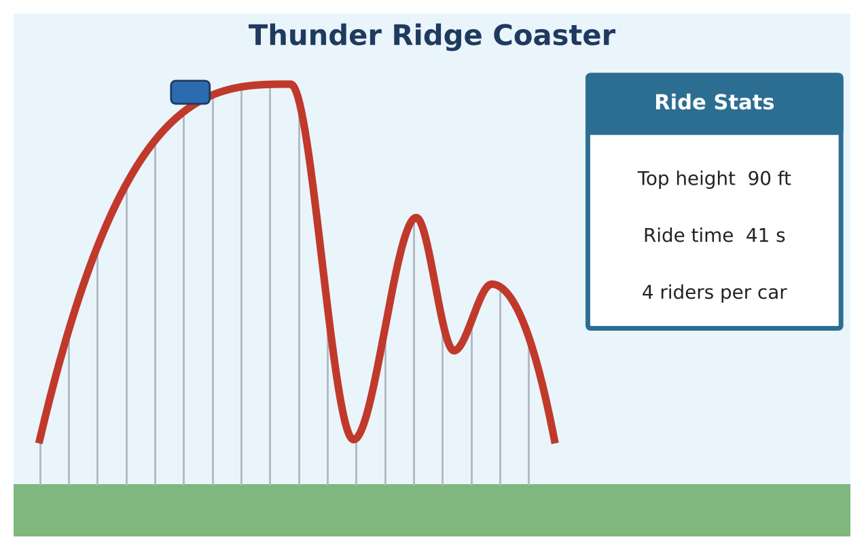
Learning Goals
- I can identify functions from mappings, ordered pairs, and graphs.
- I can interpret key features, average rates of change, and domain in context.
- I can write arithmetic sequences explicitly and recursively.
Project Timeline
When | What you will do
Day 1 | Is It a Function?
Day 2 | Read the Ride
Day 3 | The Line & Your Coaster
Final | Coaster Design Proposal + reflection

Part 1: Is It a Function?
Day 1 · Explain each answer using inputs and outputs.
1. Is "rider → car" a function? Is "car → rider"?
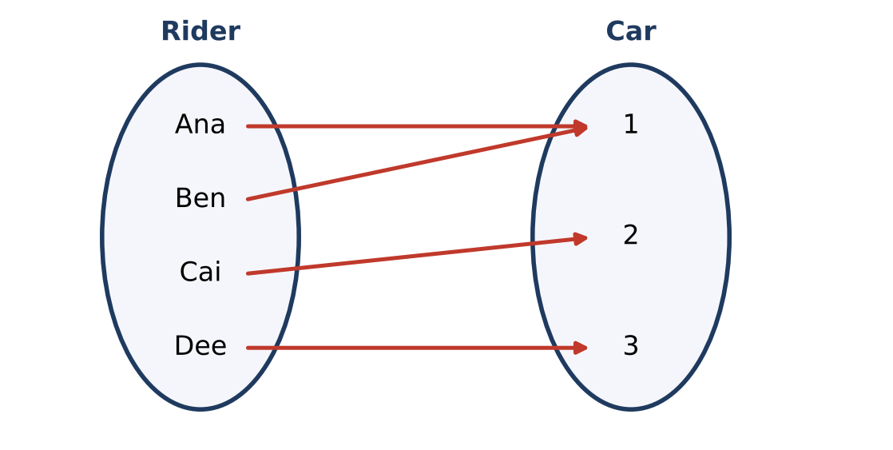

2. Which relation is a function? A = {(1, 4), (2, 6), (3, 8)}; B = {(5, 2), (5, 7), (6, 3)}; C = {(0, 3), (1, 3), (2, 3)}. Give the domain and range of each function.

3. Explain, using the vertical line test, why Track A is not a function of horizontal position but every ride's height IS a function of time.
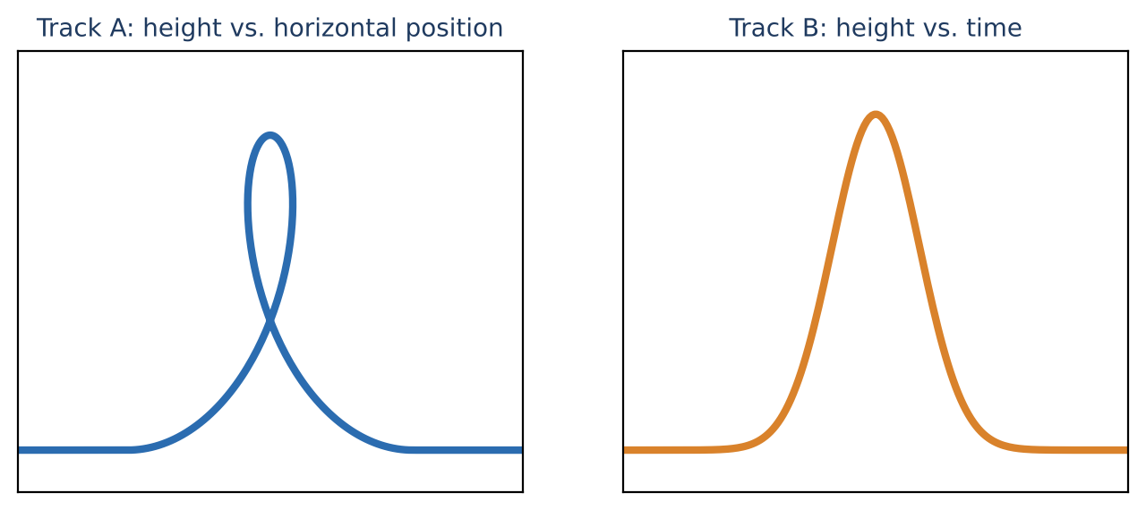

4. Ride tickets cost $3 each and a wristband limit is 8 rides. Is the cost a discrete or continuous function of rides? Give its domain and range.

Part 2: Read the Ride
Day 2 · Use the Thunder Ridge graph.
5. Give the domain and range. Identify the maximum and every local maximum.
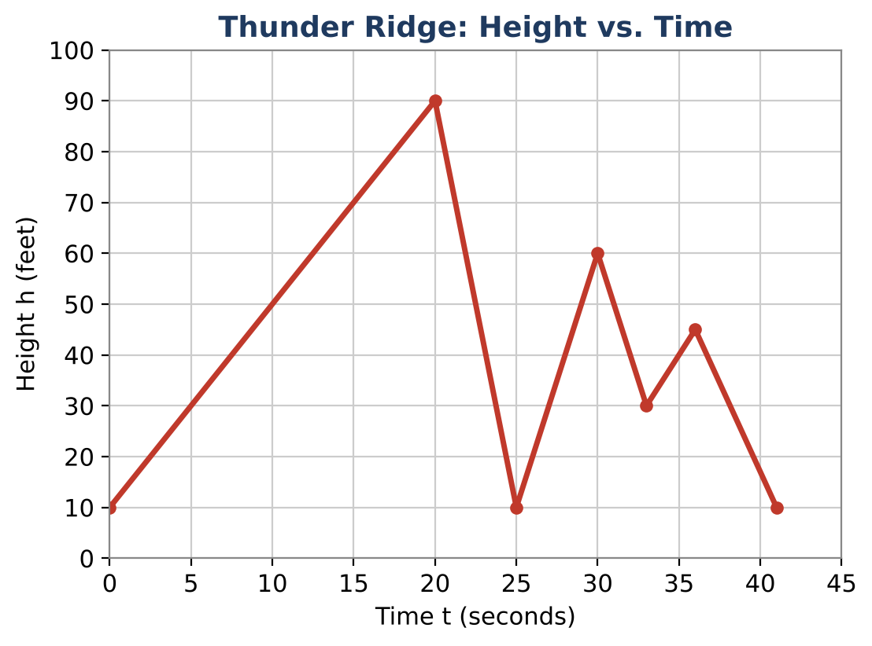

6. The lift hill is h(t) = 4t + 10 for 0 ≤ t ≤ 20. Find h(12) and solve h(t) = 60. Interpret both.

7. Find the average rate of change from t = 20 to t = 25 and from t = 0 to t = 25. Explain why the second one is 0 even though the car moved.

8. Write the increasing and decreasing intervals.

Part 3: The Line & Your Coaster
Day 3 · Group 1 waits 2 minutes and each later group waits 1.5 minutes more.
9. Write explicit and recursive rules for the wait w(n). Is the domain discrete or continuous?
Group (n) | 1 | 2 | 3 | 4 | 5
Wait (minutes) | 2 | 3.5

10. The park posts a sign when the wait is more than 45 minutes. Which group is the first to see the sign?

11. Design a coaster (30 to 60 s, at least two hills, top height 100 to 150 ft). Draw it, give the domain and range, all extrema, intervals, and the average rate of change for the first drop.

Final Product: Coaster Design Proposal
Your final product must include:
- Coaster graph with key features labeled
- Function notation statements and the lift-hill formula for your coaster
- Average rates of change for two intervals
- Queue rules (explicit and recursive)
- Proposal paragraph
Reflection
R1. How is an average rate of change different from what happens at each moment of the ride?

R2. Why is the queue model discrete but the height model continuous?

Scoring Rubric
Criteria | 4 – Exceeds | 3 – Meets | 2 – Approaching | 1 – Beginning
Mathematical Accuracy | All calculations and solutions are correct; answers include units and are checked. | Nearly all work is correct; minor errors do not change conclusions. | Several errors; some conclusions are affected. | Many errors or missing work.
Reasoning & Justification | Clear, complete explanations connect every answer to the situation; uses precise vocabulary. | Explanations are mostly clear and connected to the situation. | Explanations are brief or partly unclear. | Little or no explanation.
Application & Design | Coaster design meets every park rule and its key features are identified correctly. Goes beyond the minimum with a creative, realistic choice. | Coaster design meets every park rule and its key features are identified correctly. | Design is incomplete or only partly uses the math from the unit. | Design is missing or unrelated to the unit math.
Communication & Presentation | Proposal includes a labeled graph, domain and range, key features, function notation, and the queue model. Polished, organized, and visually engaging. | Proposal includes a labeled graph, domain and range, key features, function notation, and the queue model. Organized and easy to follow. | Product is missing required parts or is hard to follow. | Product is mostly missing.

