ALGEBRA 1 · UNIT 4: RELATIONS AND FUNCTIONS  Roller Coaster Designer  Use functions to analyze a coaster ride and design your own. | CP2  2–3 class periods

Name: ________________________________ Date: ______________ Period: ______
The Scenario
Thunder Ridge Park is building a new roller coaster, and your team has been hired as ride designers. Before you build your own coaster, you need to study the park's current ride, Thunder Ridge.
Engineers describe a coaster with functions: the height of a car depends on time, the wait in line depends on your place, and every rider is assigned to exactly one car. You will analyze these functions and then design a coaster that meets the park's rules.
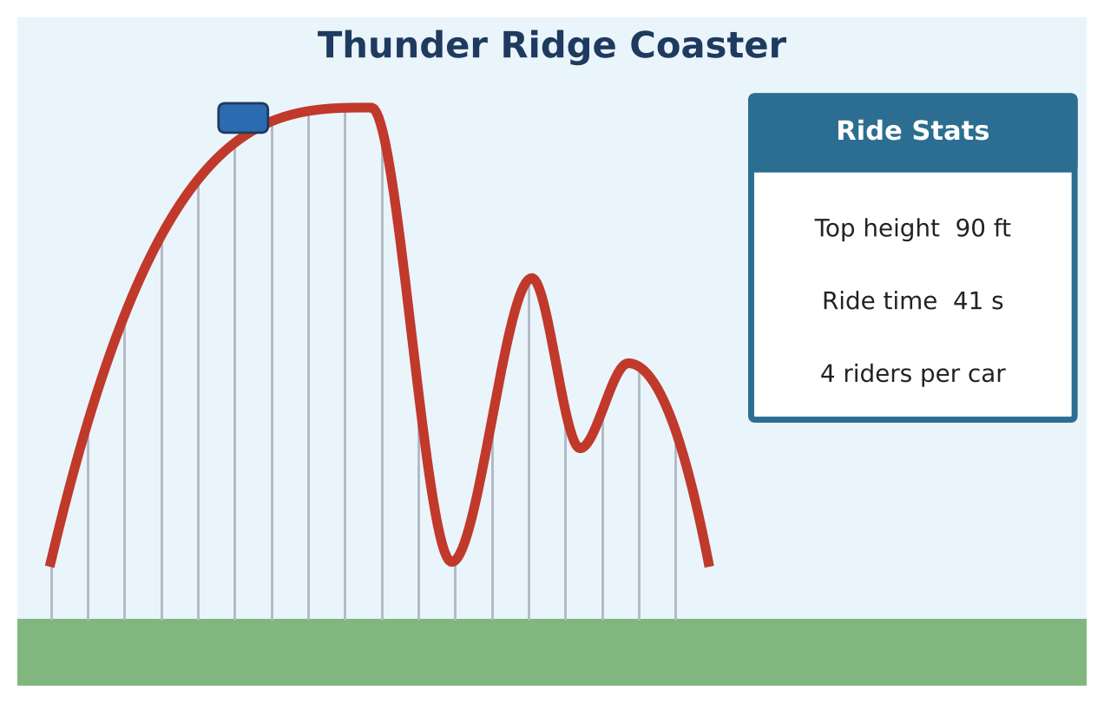
Learning Goals
- I can decide whether a relation is a function.
- I can find domain, range, and key features from a graph.
- I can use function notation and arithmetic sequences in context.
Project Timeline
When | What you will do
Day 1 | Is It a Function?
Day 2 | Read the Ride
Day 3 | The Line & Your Coaster
Final | Coaster Design Proposal + reflection

Part 1: Is It a Function?
Day 1 · A function gives each input exactly one output.
1. Each rider is assigned to a car. Is "rider → car" a function? Explain.
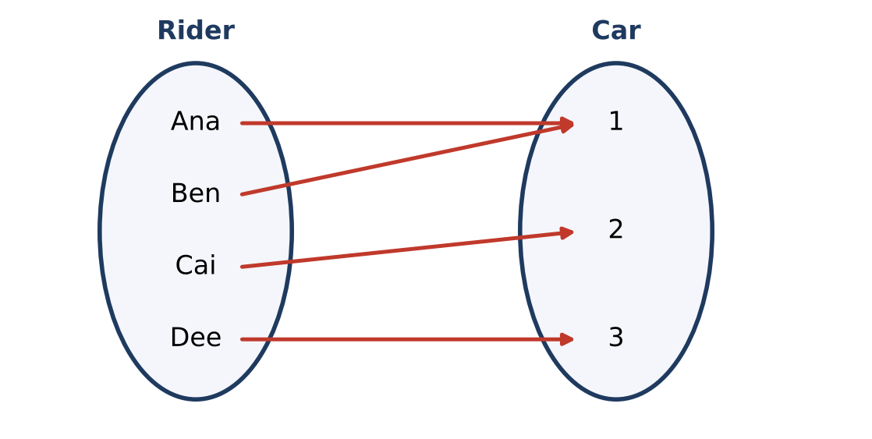

2. Now reverse it: "car → rider." Is this a function? Explain.

3. Which of these relations are functions? A = {(1, 4), (2, 6), (3, 8), (4, 10)}; B = {(5, 2), (5, 7), (6, 3)}; C = {(0, 3), (1, 3), (2, 3)}

4. Use the vertical line test. Which track graph is a function? Why can't the other one be a function?
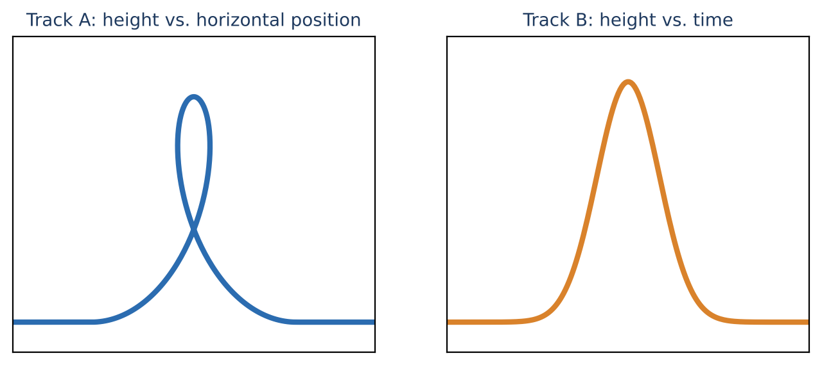

Part 2: Read the Ride
Day 2 · Use the Thunder Ridge graph of height h(t) in feet after t seconds.
5. What is the domain of the ride? What is the range?
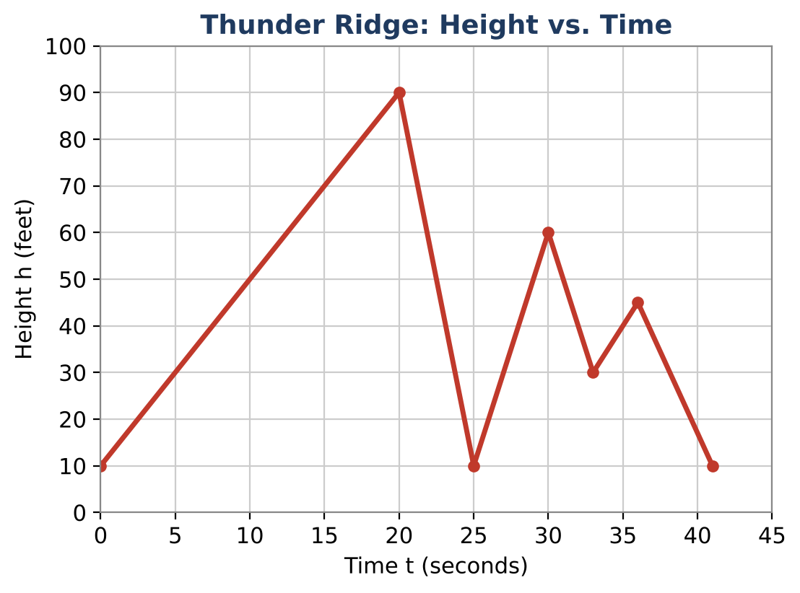
Starter: Domain: ___ ≤ t ≤ ___ Range: ___ ≤ h ≤ ___

6. Find h(0), h(20), and h(30). Explain what h(20) means.

7. When is the car at its highest point? At which times is the car at its lowest height?

8. List the time intervals when the car is going up.

9. Which drop is the steepest? How do you know from the graph?

Part 3: The Line & Your Coaster
Day 3 · The first group waits 2 minutes. Each group behind it waits 1.5 minutes more.
10. Complete the table.
Group (n) | 1 | 2 | 3 | 4 | 5
Wait (minutes) | 2 | 3.5

11. Write a rule for the wait time w(n) of group n. How long does group 20 wait?
Starter: w(n) = 2 + 1.5(n − 1)

12. Design your own coaster! Sketch a height vs. time graph that lasts 30 to 60 seconds, has at least two hills, and has a top height between 100 and 150 feet. Label the domain, range, highest point, and one interval where it increases.

Final Product: Coaster Design Proposal
Your final product must include:
- Your coaster's name and design graph
- Domain, range, and highest and lowest points
- Increasing and decreasing intervals
- Two statements in function notation, like h(10) = 50
- Your line-wait rule
Reflection
R1. Why is height vs. time always a function, even for a coaster with a loop?

R2. What does the domain tell a rider about the ride?

Scoring Rubric
Criteria | 4 – Exceeds | 3 – Meets | 2 – Approaching | 1 – Beginning
Mathematical Accuracy | All calculations and solutions are correct; answers include units and are checked. | Nearly all work is correct; minor errors do not change conclusions. | Several errors; some conclusions are affected. | Many errors or missing work.
Reasoning & Justification | Clear, complete explanations connect every answer to the situation; uses precise vocabulary. | Explanations are mostly clear and connected to the situation. | Explanations are brief or partly unclear. | Little or no explanation.
Application & Design | Coaster design meets every park rule and its key features are identified correctly. Goes beyond the minimum with a creative, realistic choice. | Coaster design meets every park rule and its key features are identified correctly. | Design is incomplete or only partly uses the math from the unit. | Design is missing or unrelated to the unit math.
Communication & Presentation | Proposal includes a labeled graph, domain and range, key features, function notation, and the queue model. Polished, organized, and visually engaging. | Proposal includes a labeled graph, domain and range, key features, function notation, and the queue model. Organized and easy to follow. | Product is missing required parts or is hard to follow. | Product is mostly missing.

