ALGEBRA 1 · UNIT 4: RELATIONS AND FUNCTIONS  Roller Coaster Designer  Use functions to analyze a coaster ride and design your own. | Honors  2–3 class periods

Name: ________________________________ Date: ______________ Period: ______
The Scenario
Thunder Ridge Park is building a new roller coaster, and your team has been hired as ride designers. Before you build your own coaster, you need to study the park's current ride, Thunder Ridge.
Engineers describe a coaster with functions: the height of a car depends on time, the wait in line depends on your place, and every rider is assigned to exactly one car. You will analyze these functions and then design a coaster that meets the park's rules.
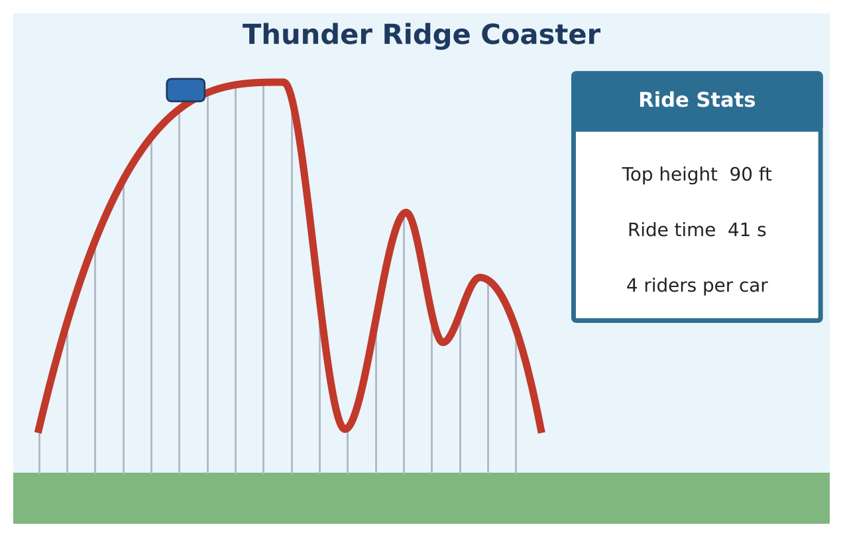
Learning Goals
- I can represent a graph as a piecewise function and solve equations on each piece.
- I can connect key features and rates of change to context.
- I can design a function that satisfies several constraints.
Project Timeline
When | What you will do
Day 1 | Functions & Relations
Day 2 | The Piecewise Ride
Day 3 | Design Within the Rules
Final | Coaster Design Proposal + reflection

Part 1: Functions & Relations
Day 1 · Justify each answer.
1. Explain why "rider → car" is a function but its inverse relation is not. What would have to be true for the inverse to be a function?
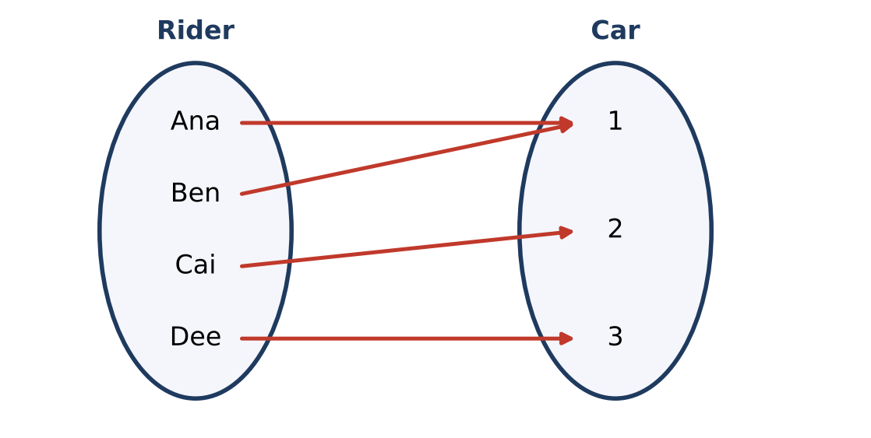

2. For which values of k is {(1, 4), (2, k), (k, 8)} a function?

3. Explain, with the vertical line test, why the loop track is not a function of horizontal position, and describe a different input that would make the loop a function.
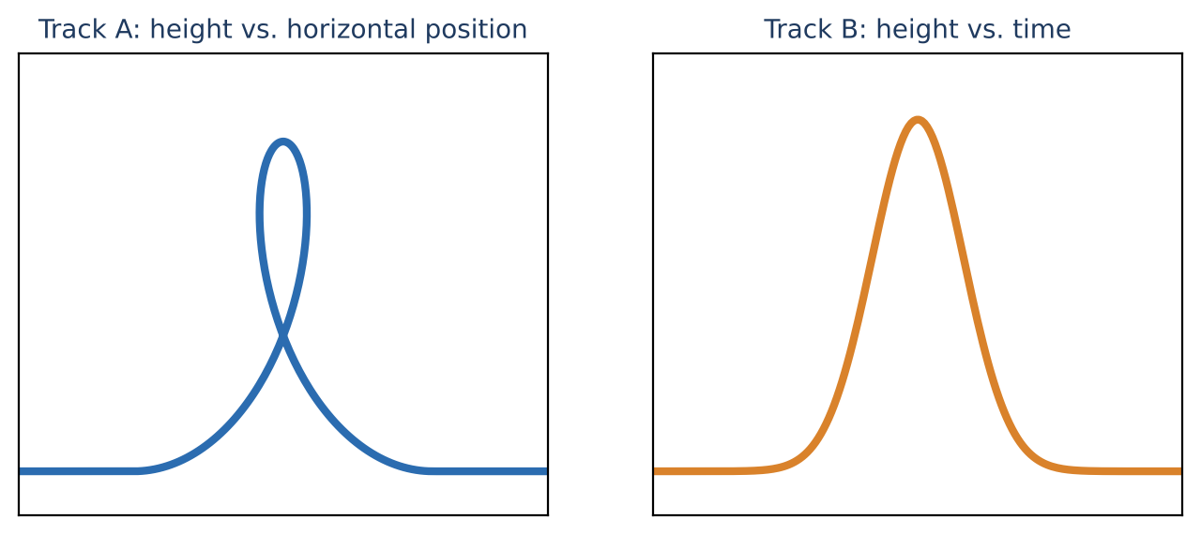

4. Wristband: 8 rides for $20, or $3 per ride without a band. Write a rule for the cheapest cost C(r) for r rides (0 ≤ r ≤ 8) and give its range.

Part 2: The Piecewise Ride
Day 2 · Use the Thunder Ridge graph.
5. Write h(t) as a piecewise function with six linear pieces (include each domain).
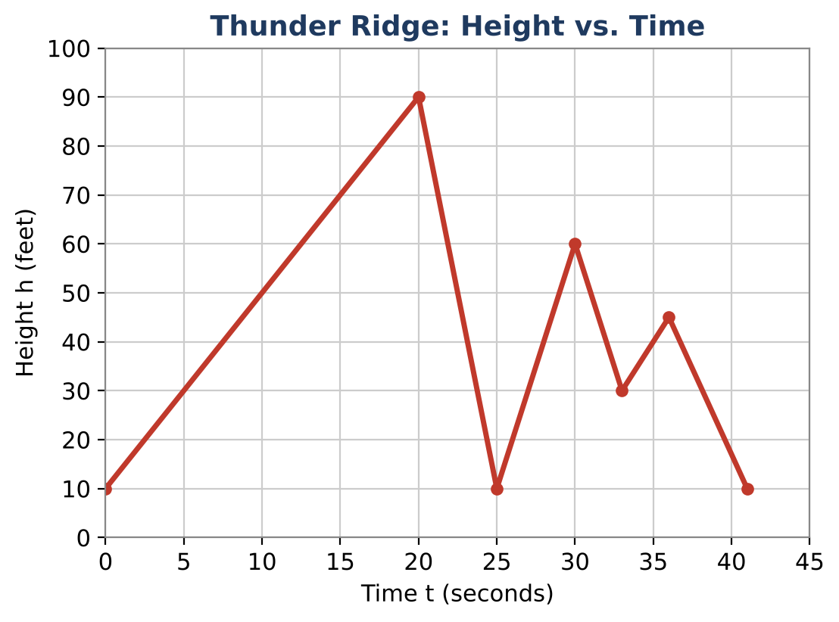

6. Find every time t when h(t) = 45. Show which pieces you used.

7. Find the average rate of change on each piece. Which piece is the fastest climb? The fastest drop?

8. Park rule: no drop may be faster than 15 ft per second on average. Does Thunder Ridge follow it? If not, propose a new point that fixes it without changing the top height.

Part 3: Design Within the Rules
Day 3 · Rules: 30 to 60 s; top height 100 to 150 ft; at least three hills; no climb faster than 6 ft per s; no drop faster than 15 ft per s; start and end at 10 ft.
9. Design your coaster as a piecewise linear function. List every point and every piece.

10. Show that every piece follows the rate rules. Give the domain, range, and all extrema.

11. The queue for your ride grows by 1.5 minutes per group starting at 2 minutes, and your ride loads a new group every 50 seconds. Write the wait as a function of group number and decide whether the 1.5-minute growth is realistic.

Final Product: Coaster Design Proposal
Your final product must include:
- Piecewise function for Thunder Ridge
- All solutions to h(t) = 45
- Safety analysis and fix
- Your piecewise coaster with checked rates
- Queue model and reflection
Reflection
R1. How does a piecewise function let you describe a complicated graph exactly?

R2. How did the rate rules limit your design choices?

Scoring Rubric
Criteria | 4 – Exceeds | 3 – Meets | 2 – Approaching | 1 – Beginning
Mathematical Accuracy | All calculations and solutions are correct; answers include units and are checked. | Nearly all work is correct; minor errors do not change conclusions. | Several errors; some conclusions are affected. | Many errors or missing work.
Reasoning & Justification | Clear, complete explanations connect every answer to the situation; uses precise vocabulary. | Explanations are mostly clear and connected to the situation. | Explanations are brief or partly unclear. | Little or no explanation.
Application & Design | Coaster design meets every park rule and its key features are identified correctly. Goes beyond the minimum with a creative, realistic choice. | Coaster design meets every park rule and its key features are identified correctly. | Design is incomplete or only partly uses the math from the unit. | Design is missing or unrelated to the unit math.
Communication & Presentation | Proposal includes a labeled graph, domain and range, key features, function notation, and the queue model. Polished, organized, and visually engaging. | Proposal includes a labeled graph, domain and range, key features, function notation, and the queue model. Organized and easy to follow. | Product is missing required parts or is hard to follow. | Product is mostly missing.

