ALGEBRA 1 · UNIT 7: EXPONENTS AND SCIENTIFIC NOTATION  Scale of the Universe  Use scientific notation and exponent rules from viruses to stars. | CP1  2–3 class periods

Name: ________________________________ Date: ______________ Period: ______
The Scenario
NASA has asked students to help explain space to younger kids. The problem: space is enormous, and the things inside our bodies are tiny. Numbers like 150,000,000 km and 0.00008 m are hard to picture.
You will use scientific notation and exponent rules to compare sizes, compute travel times, and then design a scale model of the solar system for your school hallway.
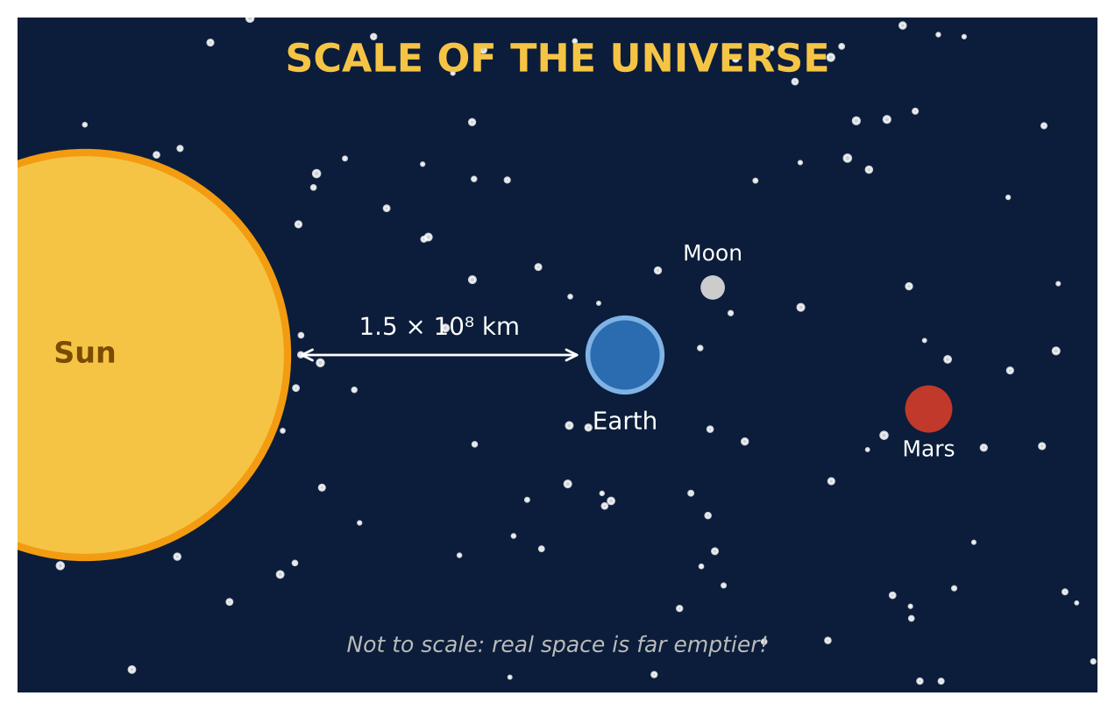
Learning Goals
- I can multiply and divide numbers in scientific notation and write answers correctly.
- I can use exponent rules with negative exponents.
- I can create and use a scale with powers of ten.
Project Timeline
When | What you will do
Day 1 | Big & Small
Day 2 | Light & Travel
Day 3 | Design a Hallway Model
Final | Scale Model Plan + reflection

Part 1: Big & Small
Day 1 · Use the data cards. Write every answer in scientific notation.
1. How many flu viruses would fit side by side across a red blood cell? Across a human hair?
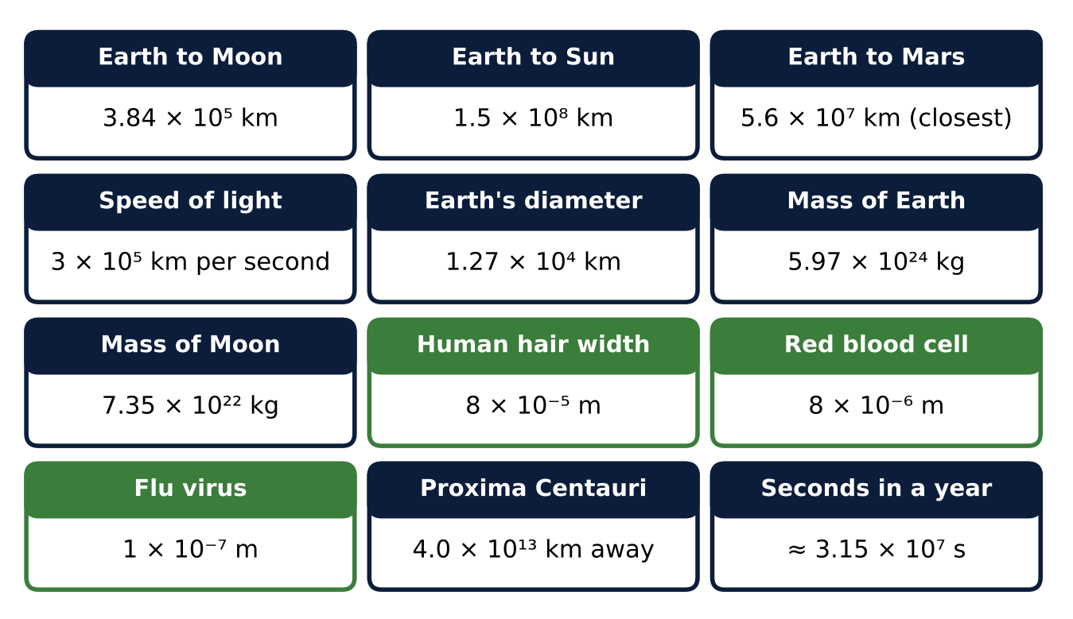

2. How many times larger is Earth's diameter than a human hair? (Convert to the same units first: 1 km = 10³ m.)

3. Simplify (6 × 10⁻³)(4 × 10⁸). Write the answer in scientific notation.

4. Explain why 24 × 10⁵ is not in scientific notation, and fix it.

Part 2: Light & Travel
Day 2 · Light travels 3 × 10⁵ km per second.
5. Find the light travel time from the Sun to Earth and from Earth to Mars (closest). Give each in seconds and minutes.

6. A light-year is the distance light travels in one year. Use 3.15 × 10⁷ seconds per year to find a light-year in km.

7. How many light-years away is Proxima Centauri?

8. A spacecraft travels 6 × 10⁴ km per hour. How many years would it take to reach Proxima Centauri? (1 year ≈ 8.76 × 10³ hours)

Part 3: Design a Hallway Model
Day 3 · Your hallway is about 50 meters long. Choose your own scale.
9. Choose a scale (1 m in the model = ? km) so that the Sun-to-Earth distance fits with room to spare. Write the scale in scientific notation.

10. Mars averages 2.28 × 10⁸ km from the Sun. Find the model distances for Earth and Mars.

11. At your scale, how big would Earth's diameter be? Could you see it? Explain.

Final Product: Scale Model Plan
Your final product must include:
- Size comparisons in scientific notation
- Travel-time calculations including light-years
- Your scale and model distances
- A labeled hallway diagram
- A paragraph explaining what the model shows and what it can't show
Reflection
R1. Explain the rule for dividing powers of ten with the same base. Use an example from the project.

R2. Why does a scale model of space have to choose between showing distances and showing sizes?

Scoring Rubric
Criteria | 4 – Exceeds | 3 – Meets | 2 – Approaching | 1 – Beginning
Mathematical Accuracy | All calculations and solutions are correct; answers include units and are checked. | Nearly all work is correct; minor errors do not change conclusions. | Several errors; some conclusions are affected. | Many errors or missing work.
Reasoning & Justification | Clear, complete explanations connect every answer to the situation; uses precise vocabulary. | Explanations are mostly clear and connected to the situation. | Explanations are brief or partly unclear. | Little or no explanation.
Application & Design | Model fits the chosen space and every scaled distance is calculated correctly. Goes beyond the minimum with a creative, realistic choice. | Model fits the chosen space and every scaled distance is calculated correctly. | Design is incomplete or only partly uses the math from the unit. | Design is missing or unrelated to the unit math.
Communication & Presentation | Scale model plan shows the scale, every converted distance in scientific notation, and a labeled diagram. Polished, organized, and visually engaging. | Scale model plan shows the scale, every converted distance in scientific notation, and a labeled diagram. Organized and easy to follow. | Product is missing required parts or is hard to follow. | Product is mostly missing.

