ALGEBRA 1 · UNIT 7: EXPONENTS AND SCIENTIFIC NOTATION  Scale of the Universe  Use scientific notation and exponent rules from viruses to stars. | CP2  2–3 class periods

Name: ________________________________ Date: ______________ Period: ______
The Scenario
NASA has asked students to help explain space to younger kids. The problem: space is enormous, and the things inside our bodies are tiny. Numbers like 150,000,000 km and 0.00008 m are hard to picture.
You will use scientific notation and exponent rules to compare sizes, compute travel times, and then design a scale model of the solar system for your school hallway.
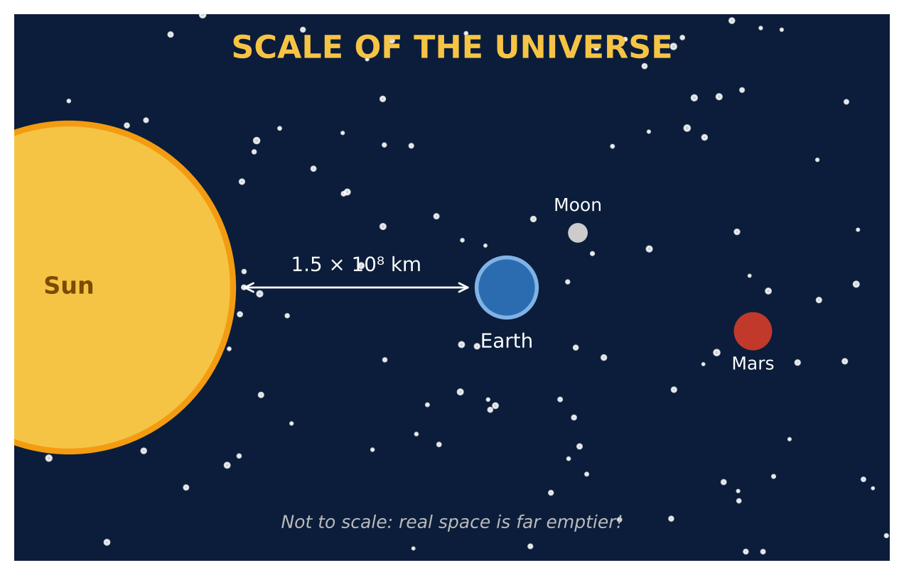
Learning Goals
- I can write numbers in scientific notation and standard form.
- I can compare quantities by dividing powers of ten.
- I can use scientific notation to solve a real problem.
Project Timeline
When | What you will do
Day 1 | Big & Small
Day 2 | Speed of Light
Day 3 | Design a Hallway Model
Final | Scale Model Plan + reflection

Part 1: Big & Small
Day 1 · Use the data cards.
1. Write the Earth-to-Moon distance in standard form. Then write 56,000,000 km in scientific notation.
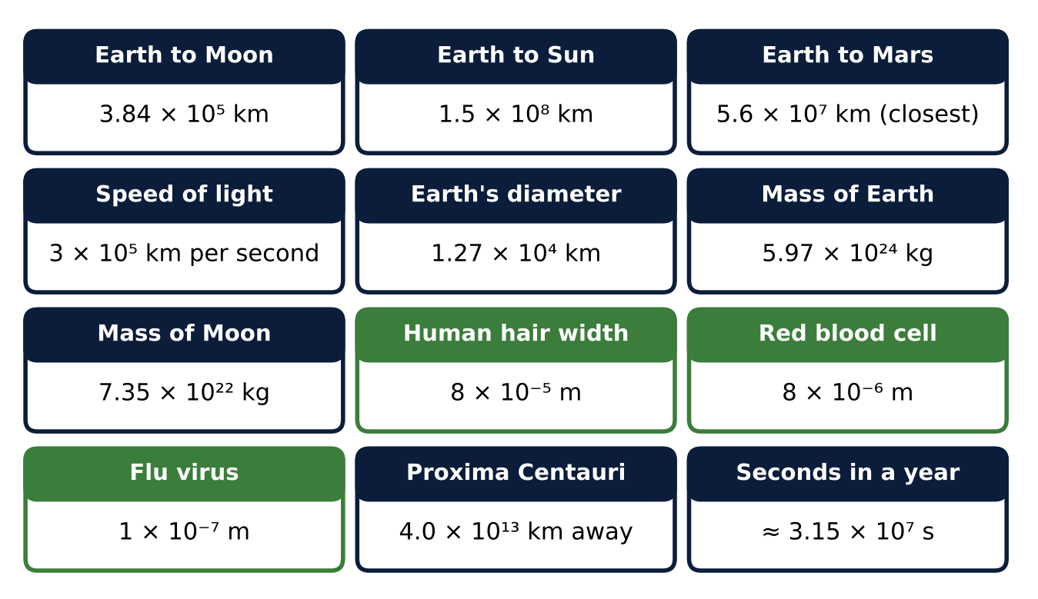

2. Write the width of a red blood cell (8 × 10⁻⁶ m) in standard form.

3. Order these from smallest to largest: human hair, flu virus, red blood cell.

4. How many times wider is a human hair than a red blood cell? Show the division.
Starter: (8 × 10⁻⁵) ÷ (8 × 10⁻⁶) = (8 ÷ 8) × 10⁻⁵ ⁻ ⁽⁻⁶⁾

Part 2: Speed of Light
Day 2 · Time = distance ÷ speed. Light travels 3 × 10⁵ km every second.
5. How many seconds does it take light from the Sun to reach Earth? How many minutes is that?

6. How many seconds does it take light to travel from Earth to the Moon?

7. A spacecraft travels 4 × 10⁴ km per hour. How many hours does it take to reach the Moon?

8. About how many times heavier is Earth than the Moon?

Part 3: Design a Hallway Model
Day 3 · Your hallway is about 50 meters long. Scale: 1 meter in the model = 3 × 10⁶ km in space.
9. How far from the Sun (in meters) should Earth be placed in the model?

10. How far should the Moon be from Earth in the model? Is this easy to show? Explain.

11. Draw a labeled plan of your hallway model.

Final Product: Scale Model Plan
Your final product must include:
- A powers-of-ten chart of the objects from the data cards
- Light travel time calculations
- The scale and each model distance
- A labeled hallway plan
- One surprising fact to share with younger students
Reflection
R1. Why is scientific notation helpful for very large and very small numbers?

R2. What surprised you most about the scale of space?

Scoring Rubric
Criteria | 4 – Exceeds | 3 – Meets | 2 – Approaching | 1 – Beginning
Mathematical Accuracy | All calculations and solutions are correct; answers include units and are checked. | Nearly all work is correct; minor errors do not change conclusions. | Several errors; some conclusions are affected. | Many errors or missing work.
Reasoning & Justification | Clear, complete explanations connect every answer to the situation; uses precise vocabulary. | Explanations are mostly clear and connected to the situation. | Explanations are brief or partly unclear. | Little or no explanation.
Application & Design | Model fits the chosen space and every scaled distance is calculated correctly. Goes beyond the minimum with a creative, realistic choice. | Model fits the chosen space and every scaled distance is calculated correctly. | Design is incomplete or only partly uses the math from the unit. | Design is missing or unrelated to the unit math.
Communication & Presentation | Scale model plan shows the scale, every converted distance in scientific notation, and a labeled diagram. Polished, organized, and visually engaging. | Scale model plan shows the scale, every converted distance in scientific notation, and a labeled diagram. Organized and easy to follow. | Product is missing required parts or is hard to follow. | Product is mostly missing.

