ALGEBRA 1 · UNIT 7: EXPONENTS AND SCIENTIFIC NOTATION  Scale of the Universe  Use scientific notation and exponent rules from viruses to stars. | Honors  2–3 class periods

Name: ________________________________ Date: ______________ Period: ______
The Scenario
NASA has asked students to help explain space to younger kids. The problem: space is enormous, and the things inside our bodies are tiny. Numbers like 150,000,000 km and 0.00008 m are hard to picture.
You will use scientific notation and exponent rules to compare sizes, compute travel times, and then design a scale model of the solar system for your school hallway.
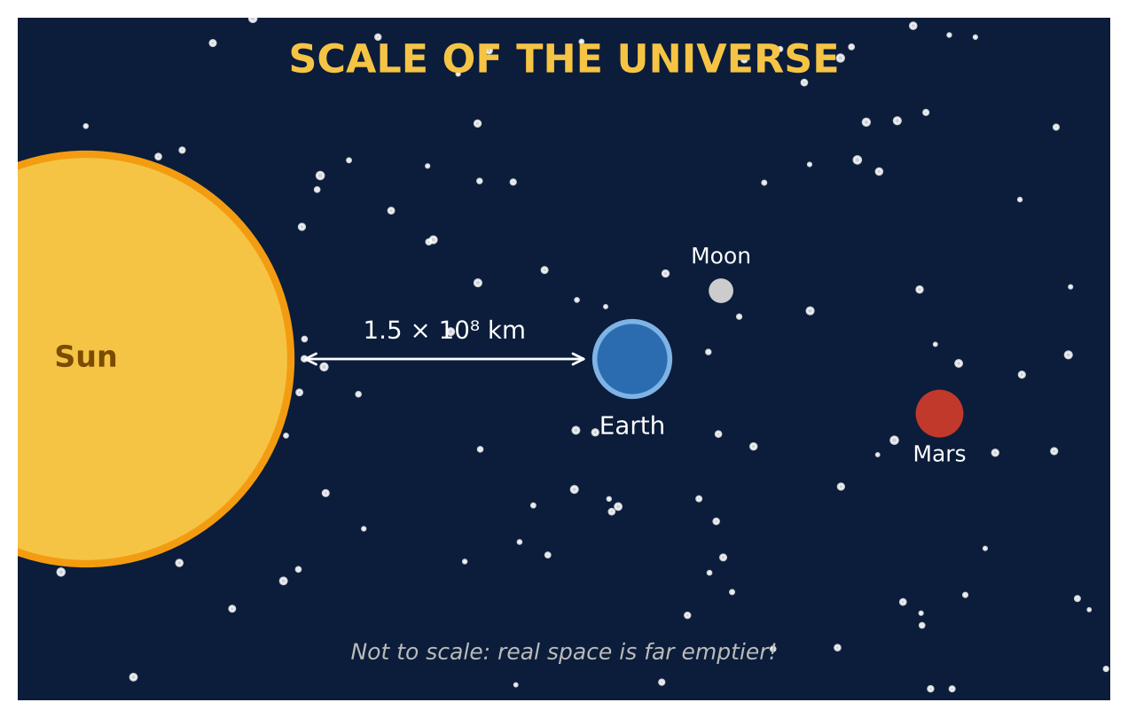
Learning Goals
- I can apply all exponent properties, including powers of products and negative exponents.
- I can place quantities on a logarithmic (powers-of-ten) scale.
- I can design a model using two scales and justify the choice.
Project Timeline
When | What you will do
Day 1 | Powers of Ten
Day 2 | Light & Travel
Day 3 | Design a Two-Scale Exhibit
Final | Scale Model Plan + reflection

Part 1: Powers of Ten
Day 1 · Use the data cards. Convert every length to meters.
1. Place the flu virus, red blood cell, hair, Earth's diameter, Earth-Sun distance, and Proxima distance on the powers-of-ten line (estimate each power).
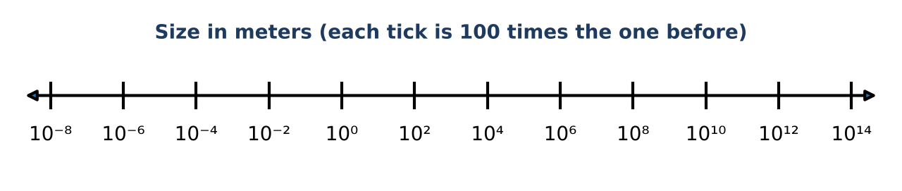

2. Explain why equal spaces on this line represent multiplying by the same number, not adding.

3. Simplify (2 × 10³)³ and (8 × 10⁻⁵)² ÷ (4 × 10⁻⁷). Write answers in scientific notation.

4. A student wrote (3 × 10⁴)(5 × 10⁻⁹) = 15 × 10⁻³⁶. Identify both errors and correct the answer.

Part 2: Light & Travel
Day 2 · Light travels 3 × 10⁵ km per second.
5. Find a light-year in km. Then express the Proxima Centauri distance in light-years.
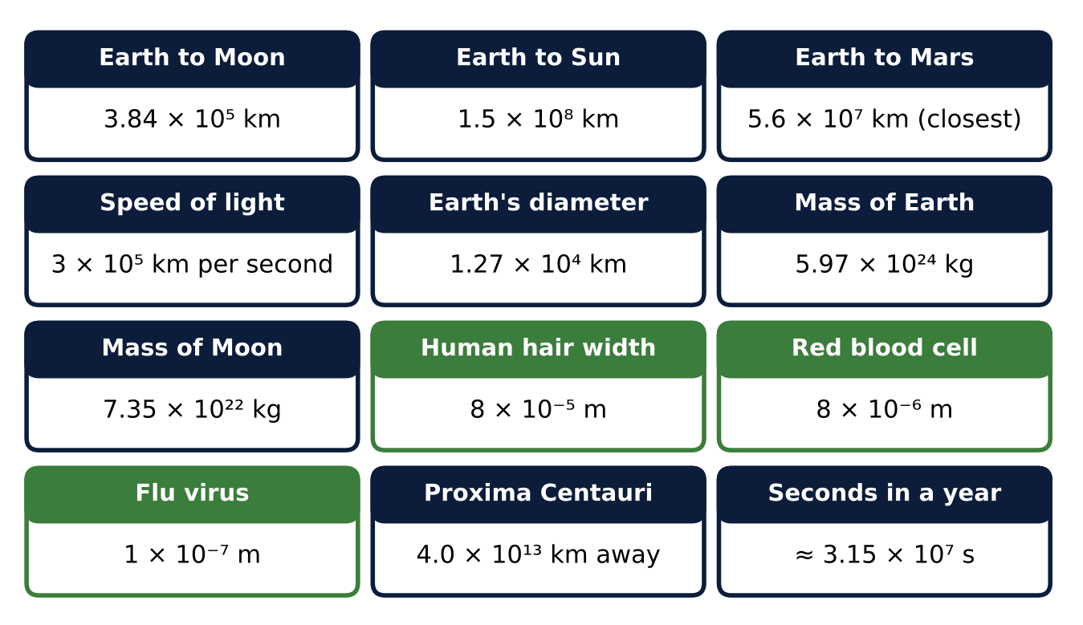

6. Find the volume of a cube-shaped box of side 8 × 10⁻⁶ m (about the size of a blood cell). How many such boxes fit in 1 cubic millimeter (10⁻⁹ m³)?

7. Light from Proxima left the star how many seconds ago? Express it two ways: in seconds and in years.

8. If a probe could travel at 1% of the speed of light, how many years would it take to reach Proxima? Show how the exponent rules make this quick.

Part 3: Design a Two-Scale Exhibit
Day 3 · One scale shows distances in the hallway (50 m). A second scale shows sizes on a table.
9. Choose a distance scale so Mars (2.28 × 10⁸ km from the Sun) is at 45 m or less. Find the model distances for Earth and Mars.

10. Choose a size scale so Earth's diameter is 10 cm. Find the model size of the Moon (diameter 3.47 × 10³ km) and the Sun (diameter 1.39 × 10⁶ km).

11. Explain why one scale cannot show both sizes and distances well. Use the ratio of the two scales.

Final Product: Scale Model Plan
Your final product must include:
- Completed powers-of-ten line
- Exponent-rule simplifications and error analysis
- Light-year and volume calculations
- Two scales with model sizes and distances
- Exhibit plan with explanation of the two scales
Reflection
R1. How do the exponent rules let you estimate huge calculations without a calculator?

R2. Why do scientists often use logarithmic scales for data that spans many powers of ten?

Scoring Rubric
Criteria | 4 – Exceeds | 3 – Meets | 2 – Approaching | 1 – Beginning
Mathematical Accuracy | All calculations and solutions are correct; answers include units and are checked. | Nearly all work is correct; minor errors do not change conclusions. | Several errors; some conclusions are affected. | Many errors or missing work.
Reasoning & Justification | Clear, complete explanations connect every answer to the situation; uses precise vocabulary. | Explanations are mostly clear and connected to the situation. | Explanations are brief or partly unclear. | Little or no explanation.
Application & Design | Model fits the chosen space and every scaled distance is calculated correctly. Goes beyond the minimum with a creative, realistic choice. | Model fits the chosen space and every scaled distance is calculated correctly. | Design is incomplete or only partly uses the math from the unit. | Design is missing or unrelated to the unit math.
Communication & Presentation | Scale model plan shows the scale, every converted distance in scientific notation, and a labeled diagram. Polished, organized, and visually engaging. | Scale model plan shows the scale, every converted distance in scientific notation, and a labeled diagram. Organized and easy to follow. | Product is missing required parts or is hard to follow. | Product is mostly missing.

