ALGEBRA 1 · UNIT 12: STATISTICS AND DATA MODELING  Screen Time Study  Investigate how screen time relates to sleep using real statistical tools. | CP1  2–3 class periods

Name: ________________________________ Date: ______________ Period: ______
The Scenario
The school health council wants to know whether students' screen time is related to how much they sleep. They surveyed two classes and a group of students and asked your team to analyze the data.
You will compare the classes, look for patterns, fit a model, and decide what the data can and cannot prove. Then you will design a survey study of your own.
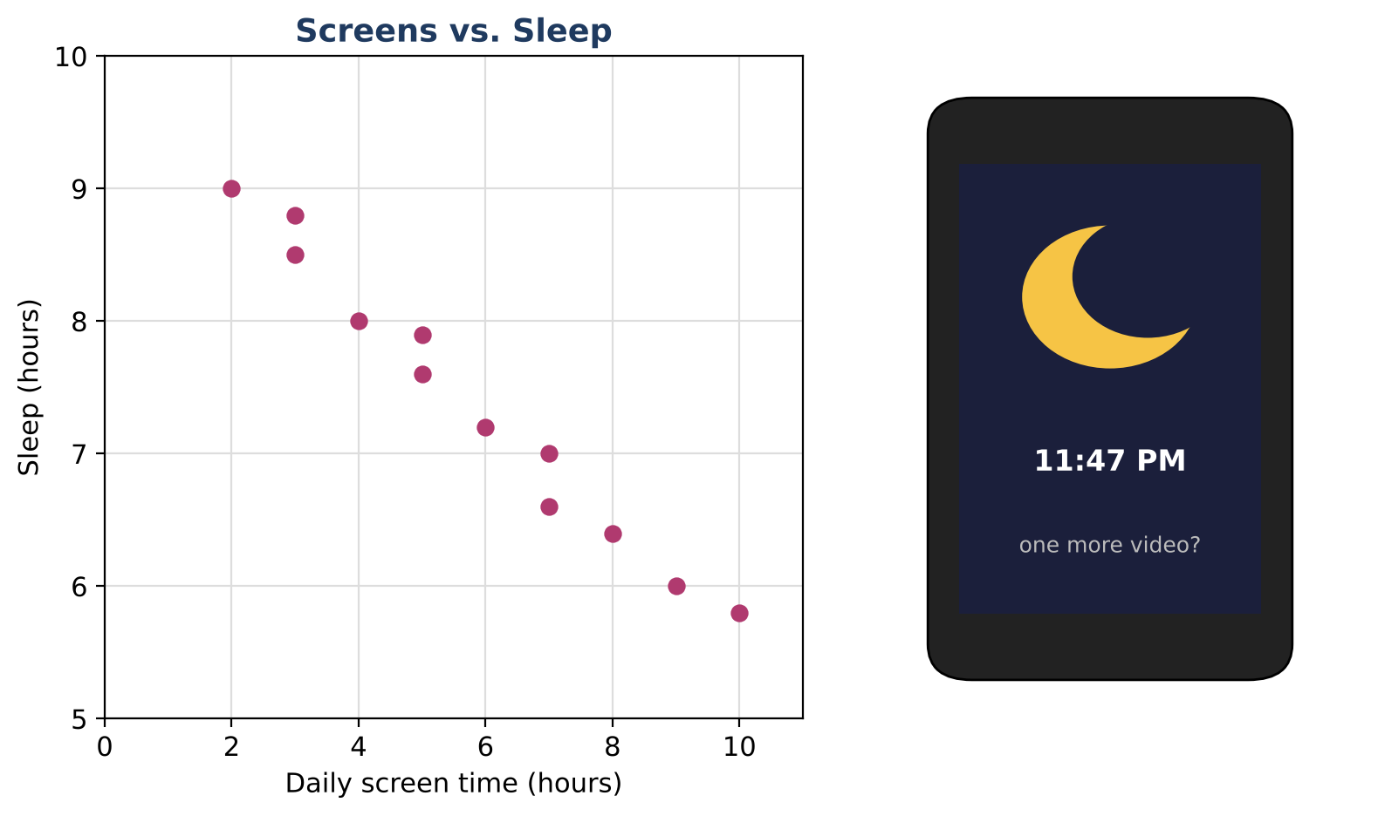
Learning Goals
- I can compare distributions using center, spread, and outliers.
- I can use conditional relative frequencies to look for associations.
- I can write and interpret a line of fit and explain correlation vs. causation.
Project Timeline
When | What you will do
Day 1 | Compare the Classes
Day 2 | Tables & Trends
Day 3 | Conclusions & Your Study
Final | Research Poster + reflection

Part 1: Compare the Classes
Day 1 · Use the screen-time data.
1. Find the mean, median, IQR, and range for each class.
Class | Daily screen time (hours), 15 students each
Class A | 2, 3, 3, 4, 4, 4, 5, 5, 5, 6, 6, 7, 7, 8, 12
Class B | 1, 2, 2, 3, 3, 3, 3, 4, 4, 4, 5, 5, 6, 6, 9

2. Use the 1.5 × IQR rule to find any outliers in each class.

3. Find the mean absolute deviation (MAD) of Class B. Which class is more spread out?

4. Draw both box plots on one scale and write a comparison of shape, center, and spread.
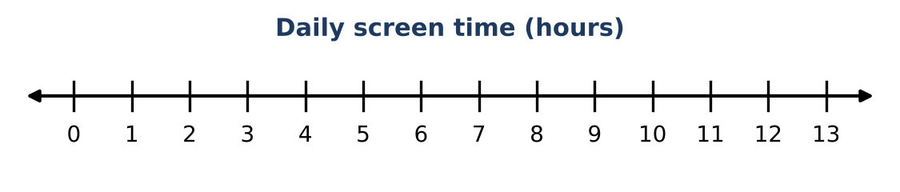

Part 2: Tables & Trends
Day 2 · Use the two-way table and the scatter plot.
5. Complete the table. Find the conditional relative frequency of sleeping less than 8 hours for each screen-time group. Is there an association? Explain.
 | Sleep 8 h or more | Sleep less than 8 h | Total
Screen time 4 h or more | 18 | 52
Screen time less than 4 h | 34 | 16
Total

6. Draw a line of fit through (2, 9.0) and (10, 5.8). Write its equation.
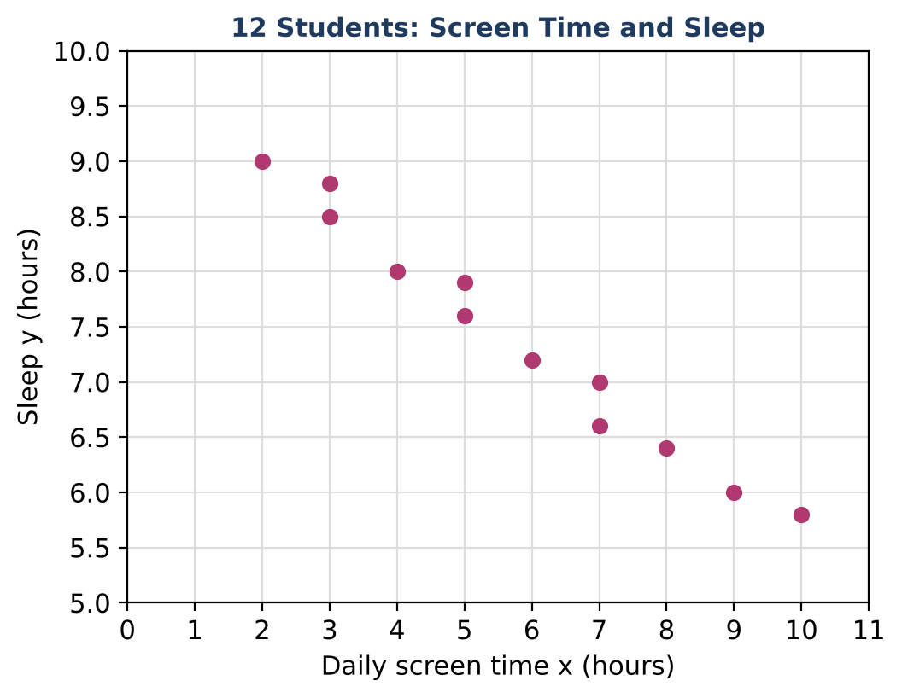

7. Interpret the slope and y-intercept of your line in context.

8. Estimate the correlation coefficient r (choose: −0.99, −0.5, 0, 0.5, 0.99) and explain.

Part 3: Conclusions & Your Study
Day 3 · Write as a researcher would.
9. A news headline says: "Screens Steal Sleep!" Explain whether this data supports that claim.

10. Use your line to predict sleep for 12 hours of screen time. Why is this prediction less reliable than one for 6 hours?

11. Design your own two-variable study: question, sample, data collection, display, and the statistic you'll report.

Final Product: Research Poster
Your final product must include:
- Comparison of the two classes with summary statistics and outliers
- Conditional relative frequencies and a statement about association
- Line of fit with interpreted slope and intercept
- Discussion of correlation vs. causation
- Your study design
Reflection
R1. Why does an outlier affect the mean more than the median?

R2. What would you need to do to show that screens cause less sleep?

Scoring Rubric
Criteria | 4 – Exceeds | 3 – Meets | 2 – Approaching | 1 – Beginning
Mathematical Accuracy | All calculations and solutions are correct; answers include units and are checked. | Nearly all work is correct; minor errors do not change conclusions. | Several errors; some conclusions are affected. | Many errors or missing work.
Reasoning & Justification | Clear, complete explanations connect every answer to the situation; uses precise vocabulary. | Explanations are mostly clear and connected to the situation. | Explanations are brief or partly unclear. | Little or no explanation.
Application & Design | Original study has a clear question, a sensible sampling plan, and appropriate displays and statistics. Goes beyond the minimum with a creative, realistic choice. | Original study has a clear question, a sensible sampling plan, and appropriate displays and statistics. | Design is incomplete or only partly uses the math from the unit. | Design is missing or unrelated to the unit math.
Communication & Presentation | Research poster shows a question, displays with summaries, a model with interpretation, and a conclusion that respects correlation vs. causation. Polished, organized, and visually engaging. | Research poster shows a question, displays with summaries, a model with interpretation, and a conclusion that respects correlation vs. causation. Organized and easy to follow. | Product is missing required parts or is hard to follow. | Product is mostly missing.

