ALGEBRA 1 · UNIT 12: STATISTICS AND DATA MODELING  Screen Time Study  Investigate how screen time relates to sleep using real statistical tools. | CP2  2–3 class periods

Name: ________________________________ Date: ______________ Period: ______
The Scenario
The school health council wants to know whether students' screen time is related to how much they sleep. They surveyed two classes and a group of students and asked your team to analyze the data.
You will compare the classes, look for patterns, fit a model, and decide what the data can and cannot prove. Then you will design a survey study of your own.
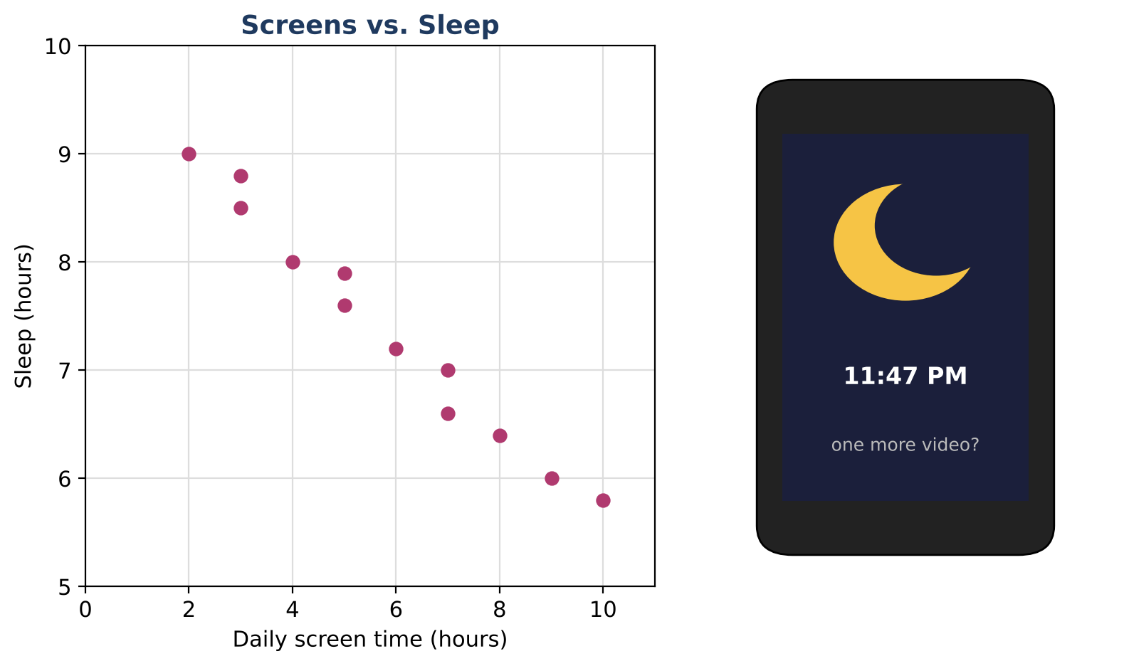
Learning Goals
- I can display and summarize data with dot plots and box plots.
- I can use a two-way table to find totals and percents.
- I can describe an association and make predictions with a line of fit.
Project Timeline
When | What you will do
Day 1 | Compare the Classes
Day 2 | Tables & Trends
Day 3 | Your Own Study
Final | Research Poster + reflection

Part 1: Compare the Classes
Day 1 · Use the screen-time data.
1. Make a dot plot of Class A's data.
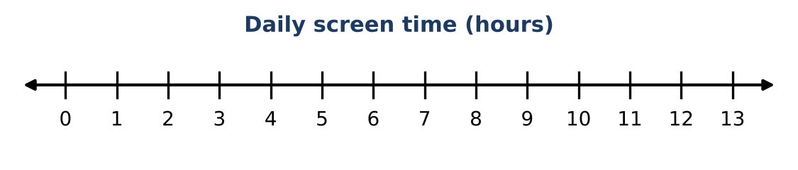
Class | Daily screen time (hours), 15 students each
Class A | 2, 3, 3, 4, 4, 4, 5, 5, 5, 6, 6, 7, 7, 8, 12
Class B | 1, 2, 2, 3, 3, 3, 3, 4, 4, 4, 5, 5, 6, 6, 9

2. Find the mean and the median of each class.

3. Find the five-number summary (minimum, Q1, median, Q3, maximum) of each class and draw both box plots on the same scale.

4. Which class has more screen time overall? Use the medians and the box plots to explain.

Part 2: Tables & Trends
Day 2 · A survey of 120 students was organized in a two-way table.
5. Complete the totals in the table.
 | Sleep 8 h or more | Sleep less than 8 h | Total
Screen time 4 h or more | 18 | 52
Screen time less than 4 h | 34 | 16
Total

6. What percent of all 120 students sleep less than 8 hours?

7. Of the students with 4 or more hours of screen time, what percent sleep less than 8 hours? Of those with less than 4 hours?

8. Describe the association in the scatter plot (direction and strength). Then use the line of fit y = −0.4x + 9.8 to predict the sleep of a student with 6 hours of screen time.
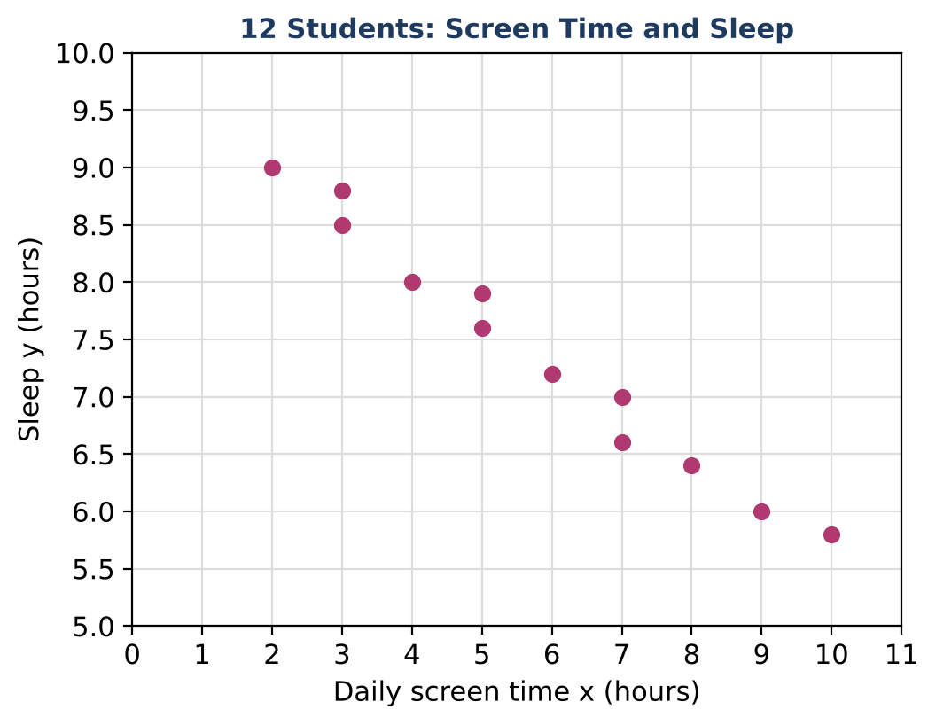

Part 3: Your Own Study
Day 3 · Plan a survey study for your school.
9. Write a statistical question about two variables for students at your school.

10. Describe how you would collect the data and which display you would use. Explain why.

11. Does the screen-time data prove that screens cause less sleep? Give another reason students who use screens more might sleep less.

Final Product: Research Poster
Your final product must include:
- Your research question
- Dot plots or box plots comparing two groups, with medians
- A two-way table with one percent explained
- A scatter plot with the line of fit and one prediction
- A conclusion that does not claim cause and effect
Reflection
R1. Why might the median describe Class A better than the mean?

R2. What is the difference between 'related to' and 'causes'?

Scoring Rubric
Criteria | 4 – Exceeds | 3 – Meets | 2 – Approaching | 1 – Beginning
Mathematical Accuracy | All calculations and solutions are correct; answers include units and are checked. | Nearly all work is correct; minor errors do not change conclusions. | Several errors; some conclusions are affected. | Many errors or missing work.
Reasoning & Justification | Clear, complete explanations connect every answer to the situation; uses precise vocabulary. | Explanations are mostly clear and connected to the situation. | Explanations are brief or partly unclear. | Little or no explanation.
Application & Design | Original study has a clear question, a sensible sampling plan, and appropriate displays and statistics. Goes beyond the minimum with a creative, realistic choice. | Original study has a clear question, a sensible sampling plan, and appropriate displays and statistics. | Design is incomplete or only partly uses the math from the unit. | Design is missing or unrelated to the unit math.
Communication & Presentation | Research poster shows a question, displays with summaries, a model with interpretation, and a conclusion that respects correlation vs. causation. Polished, organized, and visually engaging. | Research poster shows a question, displays with summaries, a model with interpretation, and a conclusion that respects correlation vs. causation. Organized and easy to follow. | Product is missing required parts or is hard to follow. | Product is mostly missing.

