ALGEBRA 1 · UNIT 12: STATISTICS AND DATA MODELING  Screen Time Study  Investigate how screen time relates to sleep using real statistical tools. | Honors  2–3 class periods

Name: ________________________________ Date: ______________ Period: ______
The Scenario
The school health council wants to know whether students' screen time is related to how much they sleep. They surveyed two classes and a group of students and asked your team to analyze the data.
You will compare the classes, look for patterns, fit a model, and decide what the data can and cannot prove. Then you will design a survey study of your own.
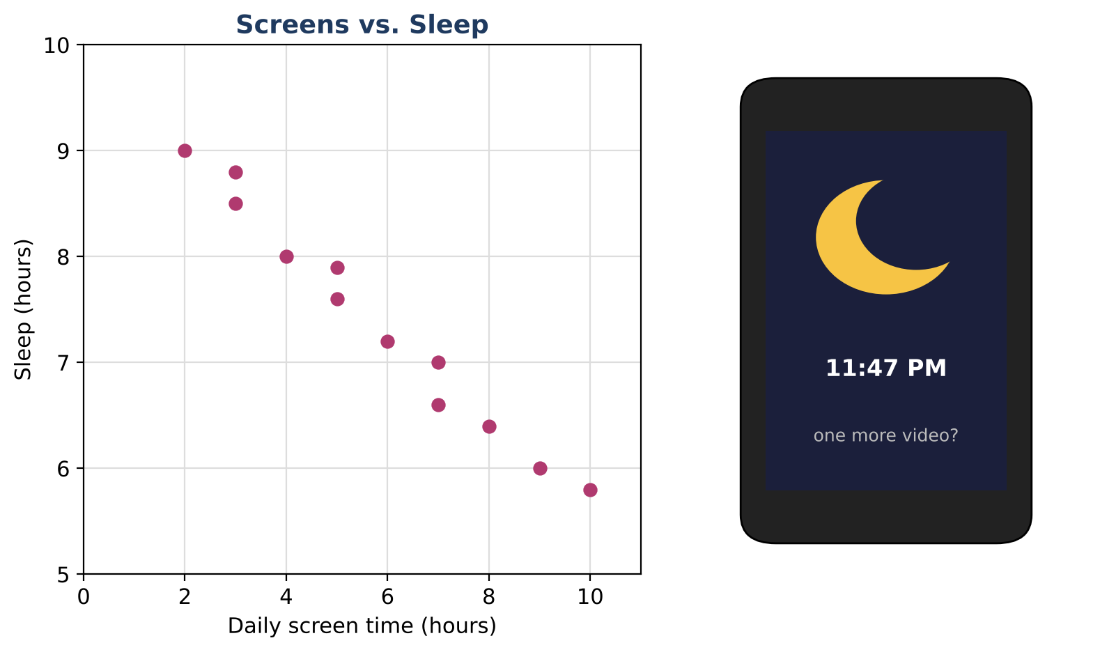
Learning Goals
- I can compare distributions with standard deviation and analyze outliers' effects.
- I can fit and evaluate a regression model with residuals and r.
- I can design a study that addresses lurking variables.
Project Timeline
When | What you will do
Day 1 | Compare the Classes
Day 2 | Model the Relationship
Day 3 | Design a Better Study
Final | Research Poster + reflection

Part 1: Compare the Classes
Day 1 · Use the screen-time data and technology where helpful.
1. Find the mean, median, IQR, and standard deviation of each class (state whether you use σ or s).
Class | Daily screen time (hours), 15 students each
Class A | 2, 3, 3, 4, 4, 4, 5, 5, 5, 6, 6, 7, 7, 8, 12
Class B | 1, 2, 2, 3, 3, 3, 3, 4, 4, 4, 5, 5, 6, 6, 9

2. Identify outliers with the 1.5 × IQR rule. Remove Class A's outlier and recompute the mean and median. What changed and why?

3. Which measures of center and spread are most appropriate for these data? Justify.

4. Write a comparison of the two classes that a non-statistician would understand.

Part 2: Model the Relationship
Day 2 · Use the 12 (screen, sleep) pairs.
5. From the two-way table, find the joint, marginal, and conditional relative frequencies needed to compare sleep for the two screen-time groups. Is there an association?
 | Sleep 8 h or more | Sleep less than 8 h | Total
Screen time 4 h or more | 18 | 52
Screen time less than 4 h | 34 | 16
Total

6. Use technology to find the least-squares regression line and r. Round to the nearest hundredth.
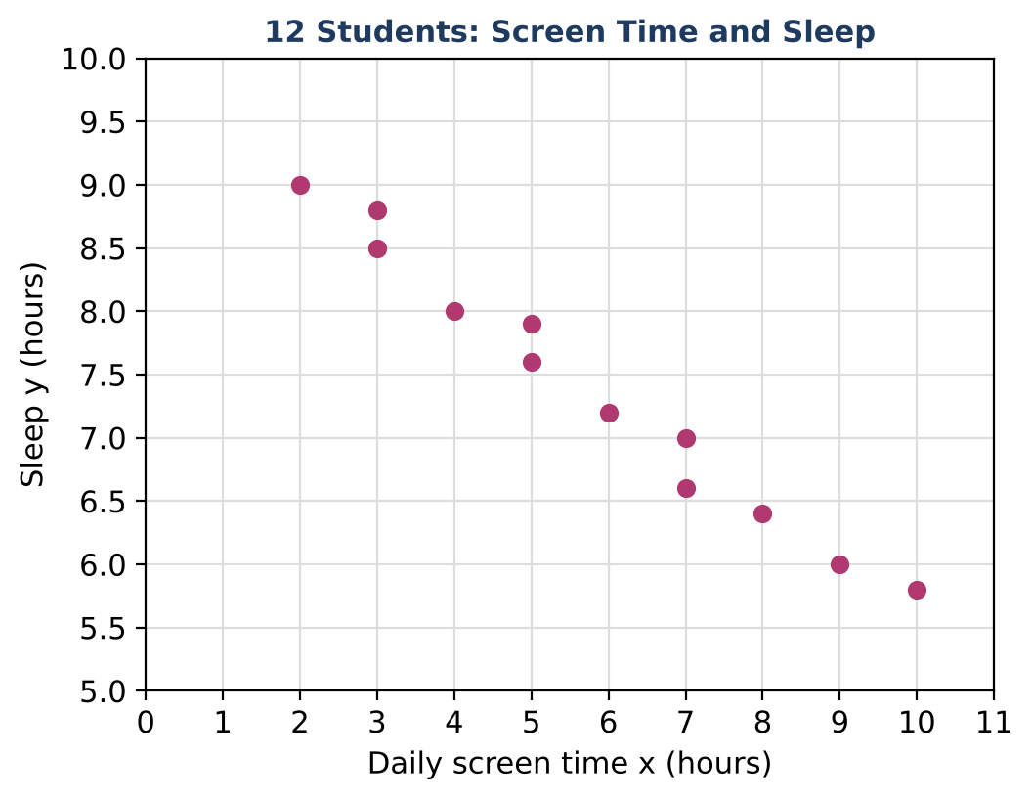
Screen x | 2 | 3 | 3 | 4 | 5 | 5 | 6 | 7 | 7 | 8 | 9 | 10
Sleep y | 9.0 | 8.5 | 8.8 | 8.0 | 7.6 | 7.9 | 7.2 | 7.0 | 6.6 | 6.4 | 6.0 | 5.8

7. Find the residual for the student with 7 hours of screen time and 6.6 hours of sleep. Interpret it.

8. Describe what a residual plot for these data would look like if a linear model is appropriate.

Part 3: Design a Better Study
Day 3 · The health council wants evidence about cause and effect.
9. Explain why the survey cannot establish causation. Name two lurking variables.

10. Design an experiment (with random assignment) that could test whether screen time before bed affects sleep. Address ethics and practicality.

11. Write the conclusion section of your research poster, including the model, r, a residual, and limits of the study.

Final Product: Research Poster
Your final product must include:
- Full comparison of distributions including the outlier analysis
- Two-way table analysis
- Regression model, r, and residual interpretation
- Experiment design with random assignment
- Research poster
Reflection
R1. How can r be very close to −1 even when screen time does not cause less sleep?

R2. Why is random assignment the key to cause-and-effect conclusions?

Scoring Rubric
Criteria | 4 – Exceeds | 3 – Meets | 2 – Approaching | 1 – Beginning
Mathematical Accuracy | All calculations and solutions are correct; answers include units and are checked. | Nearly all work is correct; minor errors do not change conclusions. | Several errors; some conclusions are affected. | Many errors or missing work.
Reasoning & Justification | Clear, complete explanations connect every answer to the situation; uses precise vocabulary. | Explanations are mostly clear and connected to the situation. | Explanations are brief or partly unclear. | Little or no explanation.
Application & Design | Original study has a clear question, a sensible sampling plan, and appropriate displays and statistics. Goes beyond the minimum with a creative, realistic choice. | Original study has a clear question, a sensible sampling plan, and appropriate displays and statistics. | Design is incomplete or only partly uses the math from the unit. | Design is missing or unrelated to the unit math.
Communication & Presentation | Research poster shows a question, displays with summaries, a model with interpretation, and a conclusion that respects correlation vs. causation. Polished, organized, and visually engaging. | Research poster shows a question, displays with summaries, a model with interpretation, and a conclusion that respects correlation vs. causation. Organized and easy to follow. | Product is missing required parts or is hard to follow. | Product is mostly missing.

