ALGEBRA 2 · UNIT 11: PROBABILITY & STATISTICS  Carnival Game Designer  Design a carnival booth that is fun for players and fair (but profitable) for the school. | CP1  2–3 class periods

Name: ________________________________ Date: ______________ Period: ______
The Scenario
The school carnival raises money for clubs, and your team is designing a booth. Players should feel they have a real chance to win, but the booth should still raise money over many plays.
Probability tells you how often players win, and expected value tells you how much the booth earns per play. You will analyze classic games and design your own.
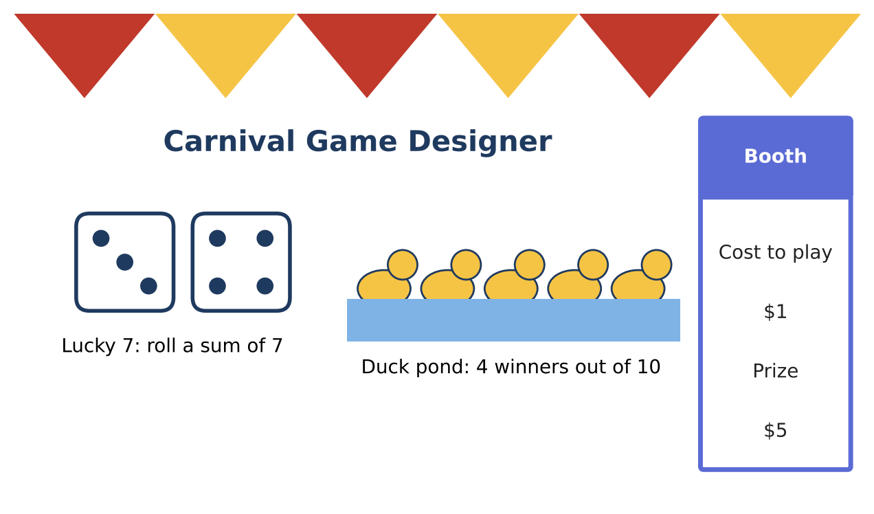
Learning Goals
- I can find conditional probabilities and test independence.
- I can use expected value to design a game.
- I can use the normal distribution.
Project Timeline
When | What you will do
Day 1 | Who Wins?
Day 2 | Expected Value & Normal
Day 3 | Design a Booth
Final | Booth Proposal + reflection

Part 1: Who Wins?
Day 1 · Results from 200 plays of Lucky 7:
1. Use the table to find P(win), P(win | adult), and P(win | student). Are winning and age independent?
 | Win | Lose | Total
Adult | 14 | 66 | 80
Student | 20 | 100 | 120
Total | 34 | 166 | 200

2. Duck pond: 4 winners of 10. Find P(exactly one winner) when picking 2 ducks without replacement.

3. A spinner has 8 equal sections, 2 of them gold. Find P(gold on both of two spins). Are the spins independent?

Part 2: Expected Value & Normal
Day 2 · Use expected value and the normal model.
4. Lucky 7 costs $1. What prize makes the player's expected value exactly −$0.25?

5. The time to play a game is normally distributed with mean 4 min and standard deviation 1 min. What percent of games last between 3 and 5 min? More than 6 min?

6. How many games can the booth run in a 3-hour shift, on average?

Part 3: Design a Booth
Day 3 · Design a game with expected booth earnings of $0.25 per play.
7. Write the rules and the probability model.

8. Choose a cost and prize to hit the target exactly. Show the equation.

9. Predict earnings for a 3-hour shift.

Final Product: Booth Proposal
Your final product must include:
- Two-way table analysis
- Expected value design
- Normal-model timing
- Booth proposal
Reflection
R1. What does independence mean in a carnival game?

R2. How did you use an equation to hit an exact expected value?

Scoring Rubric
Criteria | 4 – Exceeds | 3 – Meets | 2 – Approaching | 1 – Beginning
Mathematical Accuracy | All calculations and solutions are correct; answers include units and are checked. | Nearly all work is correct; minor errors do not change conclusions. | Several errors; some conclusions are affected. | Many errors or missing work.
Reasoning & Justification | Clear, complete explanations connect every answer to the situation; uses precise vocabulary. | Explanations are mostly clear and connected to the situation. | Explanations are brief or partly unclear. | Little or no explanation.
Application & Design | Designed game has a correct probability model, and its expected value meets the target. Goes beyond the minimum with a creative, realistic choice. | Designed game has a correct probability model, and its expected value meets the target. | Design is incomplete or only partly uses the math from the unit. | Design is missing or unrelated to the unit math.
Communication & Presentation | Proposal includes the game rules, probabilities, expected value per play, and predicted earnings. Polished, organized, and visually engaging. | Proposal includes the game rules, probabilities, expected value per play, and predicted earnings. Organized and easy to follow. | Product is missing required parts or is hard to follow. | Product is mostly missing.

