ALGEBRA 2 · UNIT 11: PROBABILITY & STATISTICS  Carnival Game Designer  Design a carnival booth that is fun for players and fair (but profitable) for the school. | CP2  2–3 class periods

Name: ________________________________ Date: ______________ Period: ______
The Scenario
The school carnival raises money for clubs, and your team is designing a booth. Players should feel they have a real chance to win, but the booth should still raise money over many plays.
Probability tells you how often players win, and expected value tells you how much the booth earns per play. You will analyze classic games and design your own.
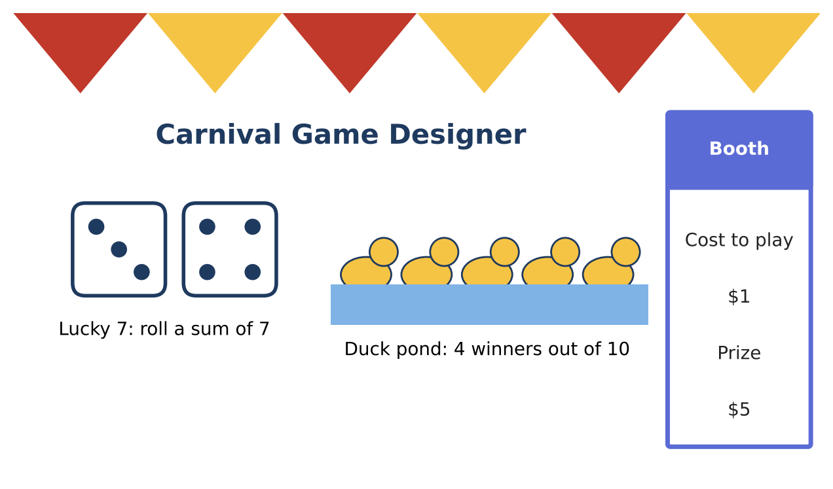
Learning Goals
- I can find probabilities of simple and compound events.
- I can count with permutations and combinations.
- I can compute expected value.
Project Timeline
When | What you will do
Day 1 | Lucky 7 & Ducks
Day 2 | Expected Value
Day 3 | Design a Booth
Final | Booth Proposal + reflection

Part 1: Lucky 7 & Ducks
Day 1 · Lucky 7: roll two dice; you win if the sum is 7.
1. List the ways to roll a sum of 7. What is the probability of winning?

2. Duck pond: 4 of 10 ducks are winners. A player picks 2 ducks without putting the first back. Find the probability both are winners.

3. How many ways can 3 prizes be chosen from 10 different prizes? (combinations)

4. How many ways can 3 of 5 prizes be arranged in a row on a shelf? (permutations)

Part 2: Expected Value
Day 2 · Lucky 7 costs $1 to play and pays $5 to a winner.
5. Complete the table for the player's net gain and find the expected value.
Outcome | Net gain | Probability
Win | $4
Lose | −$1

6. If 300 people play, about how much money does the booth make?

7. Ring toss: P(win) = 0.15, costs $2, pays $10. Find the player's expected value.

Part 3: Design a Booth
Day 3 · Design a game the booth expects to earn $0.20 to $0.50 per play from.
8. Describe the game and find the probability of winning.

9. Choose the cost and prize. Find the expected value for the player.

10. Predict the earnings for 200 plays.

Final Product: Booth Proposal
Your final product must include:
- Game rules
- Probability and expected value calculations
- Earnings prediction
- Booth poster
Reflection
R1. Why do carnival games have a negative expected value for players?

R2. Why does drawing without replacement change the probability?

Scoring Rubric
Criteria | 4 – Exceeds | 3 – Meets | 2 – Approaching | 1 – Beginning
Mathematical Accuracy | All calculations and solutions are correct; answers include units and are checked. | Nearly all work is correct; minor errors do not change conclusions. | Several errors; some conclusions are affected. | Many errors or missing work.
Reasoning & Justification | Clear, complete explanations connect every answer to the situation; uses precise vocabulary. | Explanations are mostly clear and connected to the situation. | Explanations are brief or partly unclear. | Little or no explanation.
Application & Design | Designed game has a correct probability model, and its expected value meets the target. Goes beyond the minimum with a creative, realistic choice. | Designed game has a correct probability model, and its expected value meets the target. | Design is incomplete or only partly uses the math from the unit. | Design is missing or unrelated to the unit math.
Communication & Presentation | Proposal includes the game rules, probabilities, expected value per play, and predicted earnings. Polished, organized, and visually engaging. | Proposal includes the game rules, probabilities, expected value per play, and predicted earnings. Organized and easy to follow. | Product is missing required parts or is hard to follow. | Product is mostly missing.

