ALGEBRA 2 · UNIT 11: PROBABILITY & STATISTICS  Carnival Game Designer  Design a carnival booth that is fun for players and fair (but profitable) for the school. | Honors  2–3 class periods

Name: ________________________________ Date: ______________ Period: ______
The Scenario
The school carnival raises money for clubs, and your team is designing a booth. Players should feel they have a real chance to win, but the booth should still raise money over many plays.
Probability tells you how often players win, and expected value tells you how much the booth earns per play. You will analyze classic games and design your own.
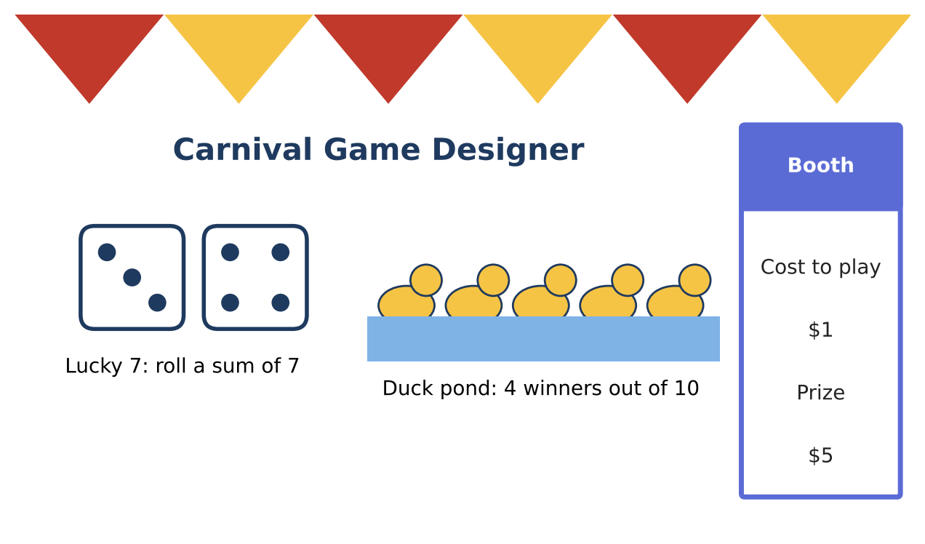
Learning Goals
- I can use binomial probability and expected value.
- I can analyze variability in earnings.
- I can design and justify a game with simulation.
Project Timeline
When | What you will do
Day 1 | Repeated Plays
Day 2 | Profit & Risk
Day 3 | Design & Simulate
Final | Booth Proposal + reflection

Part 1: Repeated Plays
Day 1 · A player plays Lucky 7 five times (P(win) = ⅙ each time).
1. Find the probability of winning at least once.

2. Find the probability of exactly 2 wins.

3. Find the expected number of wins in 5 plays.

Part 2: Profit & Risk
Day 2 · The booth charges $1 and pays $5 for a win.
4. Find the expected booth profit per play and for 300 plays.

5. Find the standard deviation of the booth's profit per play. (Values +$1 or −$4.)

6. Use the normal approximation: about how likely is the booth to lose money over 300 plays? (Total profit has mean 300μ and standard deviation √300 · σ.)

Part 3: Design & Simulate
Day 3 · Design a game with an expected booth profit of $0.25 to $0.50 per play and at least a 20% chance of winning.
7. Write the probability model and expected value.

8. Simulate 50 plays (dice, cards, or a random-number generator). Compare with your model.

9. Write the proposal with the risk analysis.

Final Product: Booth Proposal
Your final product must include:
- Binomial analysis
- Profit mean and standard deviation
- Risk estimate
- Simulated design and proposal
Reflection
R1. Why can a booth with a positive expected value still lose money on a given night?

R2. How does the number of plays affect the risk?

Scoring Rubric
Criteria | 4 – Exceeds | 3 – Meets | 2 – Approaching | 1 – Beginning
Mathematical Accuracy | All calculations and solutions are correct; answers include units and are checked. | Nearly all work is correct; minor errors do not change conclusions. | Several errors; some conclusions are affected. | Many errors or missing work.
Reasoning & Justification | Clear, complete explanations connect every answer to the situation; uses precise vocabulary. | Explanations are mostly clear and connected to the situation. | Explanations are brief or partly unclear. | Little or no explanation.
Application & Design | Designed game has a correct probability model, and its expected value meets the target. Goes beyond the minimum with a creative, realistic choice. | Designed game has a correct probability model, and its expected value meets the target. | Design is incomplete or only partly uses the math from the unit. | Design is missing or unrelated to the unit math.
Communication & Presentation | Proposal includes the game rules, probabilities, expected value per play, and predicted earnings. Polished, organized, and visually engaging. | Proposal includes the game rules, probabilities, expected value per play, and predicted earnings. Organized and easy to follow. | Product is missing required parts or is hard to follow. | Product is mostly missing.

