ALGEBRA 2 · UNIT 5: RADICALS & RATIONAL EXPONENTS  Crash Scene Investigator  Use radical formulas and rational exponents to reconstruct an accident and study motion. | CP1  2–3 class periods

Name: ________________________________ Date: ______________ Period: ______
The Scenario
A car skidded 120 feet on a dry road before stopping in a 45-mph zone. Accident investigators use s = √(30df), where s is speed in mph, d is skid length in feet, and f is the road's friction factor (dry asphalt 0.75, wet asphalt 0.45).
Your lab will estimate speeds, solve for unknowns, and explore other formulas with radicals and rational exponents, then write a report.
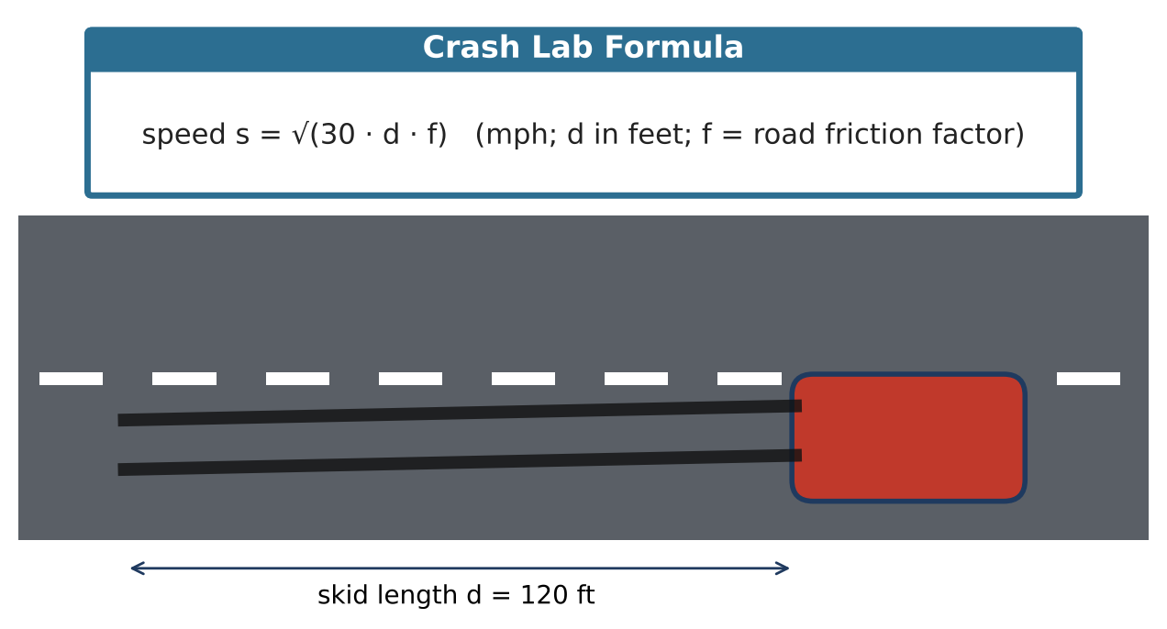
Learning Goals
- I can rewrite between radicals and rational exponents.
- I can solve and rearrange radical formulas.
- I can graph square-root functions as transformations.
Project Timeline
When | What you will do
Day 1 | The Skid Marks
Day 2 | Solve & Graph
Day 3 | Orbits & Report
Final | Investigation Report + reflection

Part 1: The Skid Marks
Day 1 · Use s = √(30df).
1. Find the dry-road speed for a 120-ft skid in simplest radical form. Then write the formula using a rational exponent.

2. Solve the formula for d. Use it to find the skid length at 45 mph and at 60 mph on dry asphalt.

3. A second skid is 4 times as long on the same road. Show algebraically that the speed is 2 times as large.

Part 2: Solve & Graph
Day 2 · Check every solution.
4. Solve √(x + 7) = x − 5 and identify any extraneous solution.

5. Solve ∛(2x − 3) = 3.

6. Describe s(d) = √(22.5d) as a transformation of y = √d. Graph both.

7. On a wet road, s(d) = √(13.5d). Is this graph above or below the dry graph? Why?

Part 3: Orbits & Report
Day 3 · Kepler: T² = a³, where T is the orbit time in years and a is the average distance from the Sun in AU. So T = a¹·⁵.
8. Mars has a = 1.52 AU. Find its orbit time.

9. Saturn's orbit takes 29.5 years. Solve for a (use the ⅔ power) and find a.

10. Write the case report and include one radical and one rational-exponent result.

Final Product: Investigation Report
Your final product must include:
- Skid analysis with a rearranged formula
- Solved radical equations
- Graphs and transformations
- Orbit calculations
- Report
Reflection
R1. Why is a¹·⁵ the same as a√a?

R2. How does the friction factor change the graph?

Scoring Rubric
Criteria | 4 – Exceeds | 3 – Meets | 2 – Approaching | 1 – Beginning
Mathematical Accuracy | All calculations and solutions are correct; answers include units and are checked. | Nearly all work is correct; minor errors do not change conclusions. | Several errors; some conclusions are affected. | Many errors or missing work.
Reasoning & Justification | Clear, complete explanations connect every answer to the situation; uses precise vocabulary. | Explanations are mostly clear and connected to the situation. | Explanations are brief or partly unclear. | Little or no explanation.
Application & Design | Conclusions are supported by correct radical calculations, and any extraneous solutions are identified. Goes beyond the minimum with a creative, realistic choice. | Conclusions are supported by correct radical calculations, and any extraneous solutions are identified. | Design is incomplete or only partly uses the math from the unit. | Design is missing or unrelated to the unit math.
Communication & Presentation | Report includes speed estimates with simplified radicals, solved formulas, a graph, and a conclusion about the case. Polished, organized, and visually engaging. | Report includes speed estimates with simplified radicals, solved formulas, a graph, and a conclusion about the case. Organized and easy to follow. | Product is missing required parts or is hard to follow. | Product is mostly missing.

