ALGEBRA 2 · UNIT 5: RADICALS & RATIONAL EXPONENTS  Crash Scene Investigator  Use radical formulas and rational exponents to reconstruct an accident and study motion. | CP2  2–3 class periods

Name: ________________________________ Date: ______________ Period: ______
The Scenario
A car skidded 120 feet on a dry road before stopping in a 45-mph zone. Accident investigators use s = √(30df), where s is speed in mph, d is skid length in feet, and f is the road's friction factor (dry asphalt 0.75, wet asphalt 0.45).
Your lab will estimate speeds, solve for unknowns, and explore other formulas with radicals and rational exponents, then write a report.
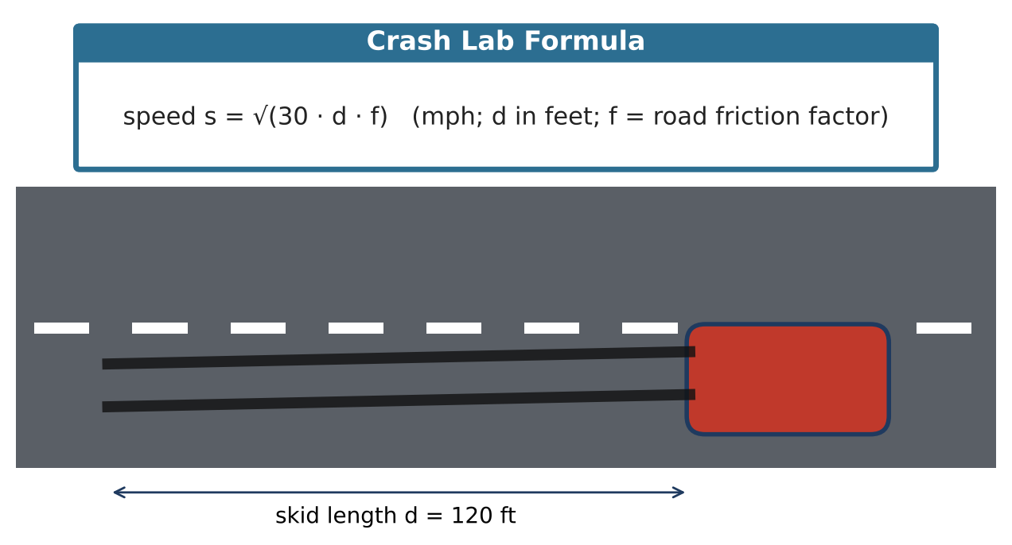
Learning Goals
- I can evaluate and simplify radical expressions.
- I can solve radical equations and check for extraneous solutions.
- I can use radical formulas in science.
Project Timeline
When | What you will do
Day 1 | The Skid Marks
Day 2 | Solve & Check
Day 3 | Pendulums & Report
Final | Investigation Report + reflection

Part 1: The Skid Marks
Day 1 · Use s = √(30df).
1. Find the speed for d = 120 ft on dry asphalt (f = 0.75). Write the exact answer in simplest radical form and as a decimal.

2. Was the driver speeding in the 45-mph zone?

3. Find the speed for the same skid on wet asphalt (f = 0.45). Simplify the radical.

4. How long would the skid be on dry asphalt at exactly 45 mph? Solve 45 = √(22.5d).

Part 2: Solve & Check
Day 2 · Square both sides, then check every answer.
5. Solve √(x + 7) = x − 5. Check both answers and identify any extraneous solution.

6. Explain why squaring both sides can create an answer that doesn't work.

7. Make a table for s(d) = √(22.5d) with d = 0, 40, 90, 160 and sketch the graph.

Part 3: Pendulums & Report
Day 3 · A pendulum's period is T = 2π√(L ÷ 32), with L in feet and T in seconds.
8. Find the period of an 8-ft pendulum.

9. Find the period of a 2-ft pendulum. How does making the pendulum 4 times shorter change the period?

10. Write a short report on the crash case using your answers.

Final Product: Investigation Report
Your final product must include:
- Speed calculations with simplified radicals
- Radical equation with check
- Graph of the speed function
- Case report
Reflection
R1. Why do we have to check answers to radical equations?

R2. Why does a 4-times-longer skid only double the speed?

Scoring Rubric
Criteria | 4 – Exceeds | 3 – Meets | 2 – Approaching | 1 – Beginning
Mathematical Accuracy | All calculations and solutions are correct; answers include units and are checked. | Nearly all work is correct; minor errors do not change conclusions. | Several errors; some conclusions are affected. | Many errors or missing work.
Reasoning & Justification | Clear, complete explanations connect every answer to the situation; uses precise vocabulary. | Explanations are mostly clear and connected to the situation. | Explanations are brief or partly unclear. | Little or no explanation.
Application & Design | Conclusions are supported by correct radical calculations, and any extraneous solutions are identified. Goes beyond the minimum with a creative, realistic choice. | Conclusions are supported by correct radical calculations, and any extraneous solutions are identified. | Design is incomplete or only partly uses the math from the unit. | Design is missing or unrelated to the unit math.
Communication & Presentation | Report includes speed estimates with simplified radicals, solved formulas, a graph, and a conclusion about the case. Polished, organized, and visually engaging. | Report includes speed estimates with simplified radicals, solved formulas, a graph, and a conclusion about the case. Organized and easy to follow. | Product is missing required parts or is hard to follow. | Product is mostly missing.

