ALGEBRA 2 · UNIT 5: RADICALS & RATIONAL EXPONENTS  Crash Scene Investigator  Use radical formulas and rational exponents to reconstruct an accident and study motion. | Honors  2–3 class periods

Name: ________________________________ Date: ______________ Period: ______
The Scenario
A car skidded 120 feet on a dry road before stopping in a 45-mph zone. Accident investigators use s = √(30df), where s is speed in mph, d is skid length in feet, and f is the road's friction factor (dry asphalt 0.75, wet asphalt 0.45).
Your lab will estimate speeds, solve for unknowns, and explore other formulas with radicals and rational exponents, then write a report.
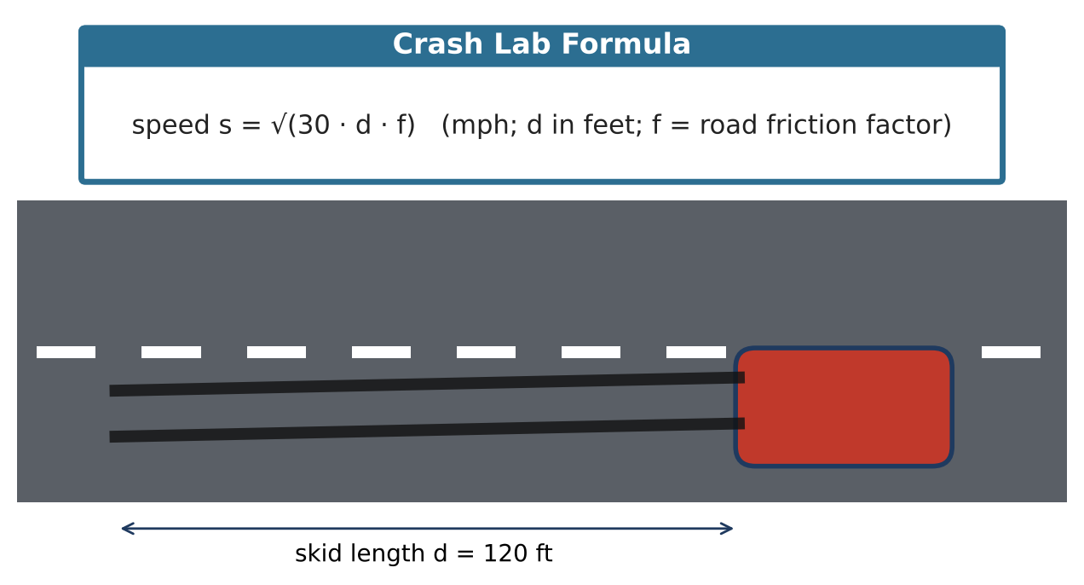
Learning Goals
- I can use properties of rational exponents to rewrite and solve.
- I can solve equations with two radicals.
- I can analyze how measurement error affects a radical model.
Project Timeline
When | What you will do
Day 1 | Evidence Analysis
Day 2 | Harder Equations
Day 3 | Orbits & Report
Final | Investigation Report + reflection

Part 1: Evidence Analysis
Day 1 · Use s = √(30df).
1. If the skid length is measured 10% too short, by what percent is the speed underestimated? Use exponent properties.

2. The driver claims 45 mph. On a road with an unknown friction factor, what f would make the 120-ft skid match the claim?

3. Write s as a power function of d and describe how the speed grows.

Part 2: Harder Equations
Day 2 · Check every solution.
4. Solve √(x + 6) − √(x − 1) = 1.

5. Solve x to the ⅔ power = 9 (that is, the cube root of x², squared form) for real x.

6. Solve √(2x + 1) = x − 1 and identify extraneous solutions.

Part 3: Orbits & Report
Day 3 · T = a¹·⁵ (years, AU).
7. Jupiter's orbit takes 11.86 years. Find a.

8. Show that doubling a multiplies T by about 2.83. Write the exact factor.

9. Write the full report, including the error analysis.

Final Product: Investigation Report
Your final product must include:
- Error analysis
- Solutions to harder radical equations
- Orbit calculations with exact factors
- Report
Reflection
R1. How do rational exponents make error analysis easier?

R2. Why do equations with two radicals often need two squaring steps?

Scoring Rubric
Criteria | 4 – Exceeds | 3 – Meets | 2 – Approaching | 1 – Beginning
Mathematical Accuracy | All calculations and solutions are correct; answers include units and are checked. | Nearly all work is correct; minor errors do not change conclusions. | Several errors; some conclusions are affected. | Many errors or missing work.
Reasoning & Justification | Clear, complete explanations connect every answer to the situation; uses precise vocabulary. | Explanations are mostly clear and connected to the situation. | Explanations are brief or partly unclear. | Little or no explanation.
Application & Design | Conclusions are supported by correct radical calculations, and any extraneous solutions are identified. Goes beyond the minimum with a creative, realistic choice. | Conclusions are supported by correct radical calculations, and any extraneous solutions are identified. | Design is incomplete or only partly uses the math from the unit. | Design is missing or unrelated to the unit math.
Communication & Presentation | Report includes speed estimates with simplified radicals, solved formulas, a graph, and a conclusion about the case. Polished, organized, and visually engaging. | Report includes speed estimates with simplified radicals, solved formulas, a graph, and a conclusion about the case. Organized and easy to follow. | Product is missing required parts or is hard to follow. | Product is mostly missing.

