PRE-ALGEBRA (7TH) · UNIT 10: AREA AND VOLUME  Backyard Pool Makeover  Use area, surface area, and volume to design a backyard with a pool and patio. | Honors  2–3 class periods

Name: ________________________________ Date: ______________ Period: ______
The Scenario
A family hired your design team to redo their backyard. They want a pool, a stone patio, a garden, and a fire pit, and they have a budget.
You will use area, surface area, and volume to choose shapes, calculate materials, and present your design.
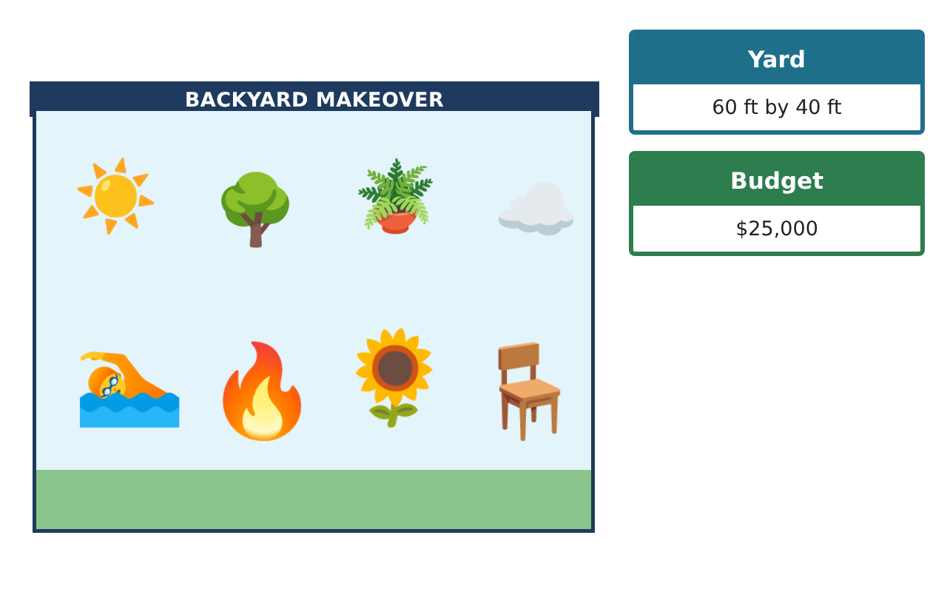
Learning Goals
- I can solve area and volume problems with composite solids.
- I can compare designs using surface area to volume.
- I can optimize a design under a budget.
Project Timeline
When | What you will do
Day 1 | Patio Design
Day 2 | Pool Engineering
Day 3 | Optimize
Final | Backyard Design Proposal + reflection
Part 1: Patio Design
Day 1 · Use π. The yard is 60 ft by 40 ft.
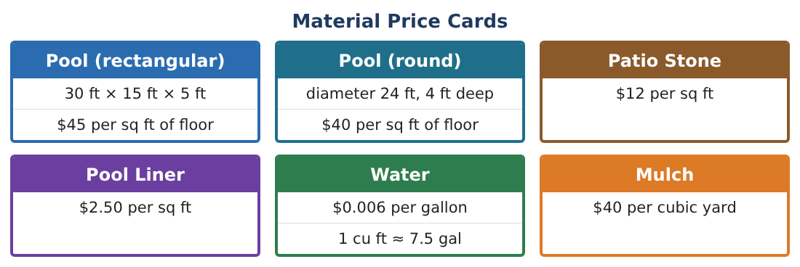
1. The patio is a 20 ft by 16 ft rectangle with a semicircle (diameter 16 ft) on one end. Find its area and cost of stone.

2. Find the perimeter of the patio for edging.

3. A fire pit is a cylinder ring: outer radius 2.5 ft, inner radius 2 ft, height 1.5 ft. Find the volume of stone in the ring.

4. How many cubic yards of concrete is that?

Part 2: Pool Engineering
Day 2 · Compare a rectangular pool (30 × 15 × 5 ft) and a round pool (d = 24 ft, 4 ft deep).
5. A sloped rectangular pool is 3 ft deep at one end and 8 ft at the other (length 30 ft, width 15 ft). Its side is a trapezoid. Find the volume.

6. Find the ratio of liner surface area to volume for the round pool and the flat rectangular pool. Which is more efficient?

7. What diameter would a 4-ft-deep round pool need to hold the same volume as the flat rectangular pool?

8. If every dimension of the round pool were doubled, how would its volume and liner area change?

Part 3: Optimize
Day 3 · Budget $25,000.
9. Write the total cost of a round pool with radius r (4 ft deep) including floor ($40/sq ft) and liner ($2.50/sq ft), as an expression in r.

10. With a $5,046 patio, find the largest whole-foot radius that keeps the total under $25,000.

11. Present your final design and justify each choice with a calculation.

Final Product: Backyard Design Proposal
Your final product must include:
- Composite patio area, perimeter, and cost
- Fire pit ring volume
- Sloped pool volume and efficiency comparison
- Cost expression and optimized radius
- Final proposal
Reflection
R1. Why does doubling every dimension multiply volume by 8?

R2. What trade-offs did you face between pool size and budget?

Scoring Rubric
Criteria | 4 – Exceeds | 3 – Meets | 2 – Approaching | 1 – Beginning
Mathematical Accuracy | All calculations and solutions are correct; answers include units and are checked. | Nearly all work is correct; minor errors do not change conclusions. | Several errors; some conclusions are affected. | Many errors or missing work.
Reasoning & Justification | Clear, complete explanations connect every answer to the situation; uses precise vocabulary. | Explanations are mostly clear and connected to the situation. | Explanations are brief or partly unclear. | Little or no explanation.
Application & Design | Areas, surface areas, and volumes are computed correctly and used to price and compare designs. Goes beyond the minimum with a creative, realistic choice. | Areas, surface areas, and volumes are computed correctly and used to price and compare designs. | Design is incomplete or only partly uses the math from the unit. | Design is missing or unrelated to the unit math.
Communication & Presentation | Proposal includes a labeled drawing, calculations, a cost table, and a recommendation. Polished, organized, and visually engaging. | Proposal includes a labeled drawing, calculations, a cost table, and a recommendation. Organized and easy to follow. | Product is missing required parts or is hard to follow. | Product is mostly missing.

